Supplemental Digital Content 1. Standard definitions used to diagnose single organ complications
Complication | Definition used in the study
Diarrhea | Presence of 3 or more liquid or loose stools in 24 hours  Acute diarrhea lasting < 7 days, prolonged diarrhea lasting 7-14 days, or chronic diarrhea lasting > 14 days
Pneumonia | Signs and symptoms of pneumonia, including high respiratory rate according to age, signs of respiratory distress, altered oxygen saturation and /or chest auscultation and a chest X-ray demonstrating lower respiratory infection.
Hepatitis | Defined by the increase of at least 2-times higher referral values according to age
Pancreatitis | Defined by the increase of by 3 or more times of lipase and/or amylase values based on Atlanta Criteria [Bai HX, Lowe ME, Husain SZ. What have we learned about acute pancreatitis in children? J Pediatr Gastroenterol Nutr. 2011;52(3):262-70.].
Myocarditis | ECG and echocardiographic abnormalities compatible with acute myocarditis in concomitance with alteration of blood enzymes suggestive of myocardial cytolysis (myoglobin, troponin I, CK-MB, total CK)
Leukopenia | Leukocyte absolute count below normal values according to age: < 6000 (1-3 years), < 5.500 (4-7 years), < 4.500 (8-13 years), < 4000 adolescents and adults
Lymphocytopenia | Lymphocyte absolute count below normal values according to age: < 3500 (1-2 years), < 2300 (3-6 years), < 1500/ul (> 6 years) [Shearer WT, Rosenblatt HM, Gelman RS, Oyomopito R, Plaeger S, Stiehm ER, Wara DW, Douglas SD, Luzuriaga K, McFarland EJ, Yogev R, Rathore MH, Levy W, Graham BL, Spector SA; Pediatric AIDS Clinical Trials Group. Lymphocyte subsets in healthy children from birth through 18 years of age: the Pediatric AIDS Clinical Trials Group P1009 study. J Allergy Clin Immunol. 2003 Nov;112(5):973-80]
Neutropenia | Neutrophil absolute count < 1500/ul in children of Caucasian or Asian ethnicity and < 1200/ul in children of African origin
Thrombocytopenia | Thrombocyte count < 150.000 cells/ul

Supplemental Digital Content 2. Flow chart diagram
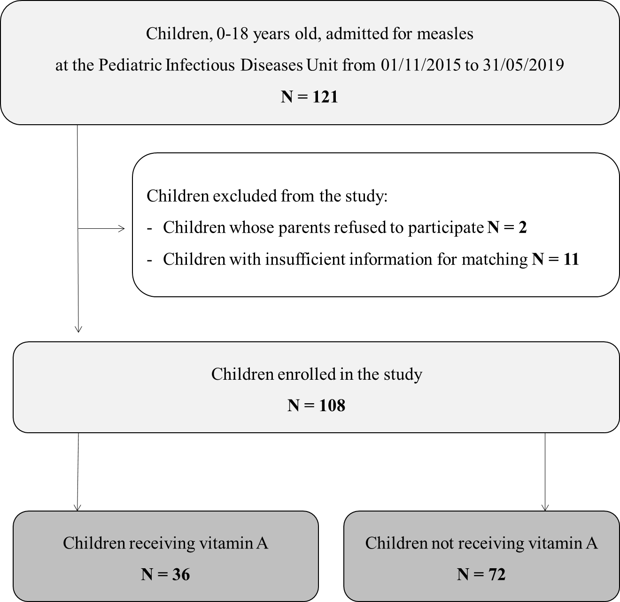
Supplemental Digital Content 3. Distribution of single complications according to study group
Complications | Total  (n=108) | Vitamin A supplementation  (n=36) | Standard care  (n=72) | p
Pneumonia | 51 (47.2) | 21 (58.3) | 30 (41.7) | 0.10
Lobar pneumonia | 36 (33.3) | 14 (38.9) | 22 (30.6) | 0.38
Interstitial pneumonia | 20 (18.5) | 9 (25) | 11 (15.3) | 0.22
Diarrhea | 19 (17.6) | 10 (27.8) | 9 (12.5) | 0.05
Respiratory failure/need of O₂ therapy | 10 (9.3) | 2 (5.6) | 8 (11.1) | 0.34
Hepatitis | 10 (9.3) | 4 (11.1) | 6 (8.3) | 0.63
Otitis | 8 (7.4) | 2 (5.6) | 6 (8.3) | 0.60
Laryngitis/Croup | 6 (5.6) | 1 (2.8) | 5 (6.9) | 0.37
Pancreatitis | 4 (3.7) | 0 (0.0) | 4 (5.6) | 0.15
Thrombophlebitis | 2 (1.9) | 0 (0.0) | 2 (2.8) | 0.31
Encephalitis | 1 (0.9) | 0 (0.0) | 1 (1.4) | 0.47
Myocarditis | 1 (0.9) | 0 (0.0) | 1 (1.4) | 0.47
Thrombocytopenia | 10 (9.3) | 3 (8.3) | 7 (9.7) | 0.81
Neutropenia | 25 (23.1) | 7 (19.4) | 18 (25.0) | 0.51
Lymphocytopenia | 35 (32.4) | 9 (25.0) | 26 (36.1) | 0.24

Supplemental Digital Content 4. Antibiotic and supportive treatments of children hospitalized for measles.

Drug prescription | Total  (n=108) | Vitamin A supplementation  (n=36) | Standard care  (n=72) | p
Oral antibiotics, n (%) | 43 (39.8)* | 17 (47.2)* | 26 (36.1)* | 0.37
Amoxicillin-Clavulanate | 18 (16.6) | 6 (16.6) | 12 (16.6)
Amoxicillin | 12 (11.1) | 7 (19.4) | 5 (6.9)
Clarithromycin | 11 (10.1) | 7 (19.4) | 4 (5.5)
Ciprofloxacin | 4 (3.7) | 1 (2.7) | 3 (4.1)
Third generation cephalosporins | 2 (1.8) | 0 (0) | 2 (2.7)
Azithromycin | 1 (0.9) | 0 (0) | 1 (1.4)
TMP/SMX | 1 (0.9) | 0 (0) | 1 (1.4)
Intravenous antibiotics, n (%) | 25 (23.1)* | 10 (27.7)* | 15 (20.8)* | 0.57
Ceftriaxone | 14 (12.9) | 5 (13.8) | 9 (12.5)
Ceftazidime | 7 (6.4) | 3 (8.3) | 4 (5.5)
Ciprofloxacin | 2 (1.8) | 1 (2.7) | 1 (1.4)
Meropenem | 1 (0.9) | 0 (0) | 1 (1.4)
Vancomycin | 1 (0.9) | 0 (0) | 1 (1.4)
Piperacillin- Tazobactam | 1 (0.9) | 1 (2.7) | 0 (0)
Oral steroids, n (%) | 6 (5.5) | 3 (8.3) | 3 (4.1) | 0.40
Intravenous Immunoglobulins, n (%) | 5 (4.6) | 2 (5.5) | 3 (4.1) | 1.00
*The number does not correspond to the sum of single antibiotic classes prescribed since some children received association of one or more antibiotics

