Supplemental Digital Content 1. Growth of Brucella abortus on blood (A) and chocolate (B) agar plates from our patient’s blood culture bottles
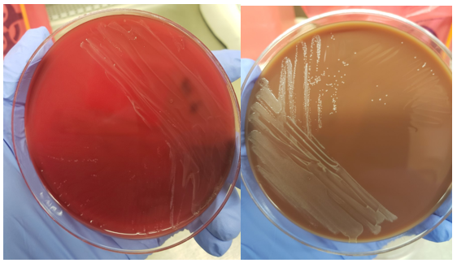
A B BB

