Supplemental Digital Content 1. Modeling of pneumonia, sinusitis and influenza illness visits over time, Panel A shows illness visits for (s)OP (grey line) vs NOP (black line). P value by linear regression <0.0001 comparing the 2 cohorts after controlling for various demographic and risk factor covariates. Panels B, C and D model pneumonia, sinusitis and influenza illness visits based on panel A cohort classification, controlling for various demographic and risk factor covariates. sOP shown in grey lines with + showing estimate of frequency of physician diagnosed cases, x showing estimate of frequency allowing for possible missed cases and o showing estimate of incidence allowing for possible mis-diagnosis.
Method. The association between number of illness visits Y and sOP/NOP status was estimated using the linear model log(Y) = OP * YEAR, where OP is a dichotomous factor, and YEAR is year of subject participation, also represented as a factor. All interactions were included. The response Y was modeled as a Poisson random variable, and fit using generalized estimating equations with the log link function, and subject level dependence estimated using the exchangeable correlation model (Liang & Zeger, 1986). The models were fit using the R package geepack (Højsgaard et al, 2006). To control for demographic and risk covariates, each was added to the model, taken to be additive with respect to YEAR, but allowed to interact with OP: log(Y) = OP * (RISK + YEAR). In each case the significance of the contribution of RISK and OP to the model was assessed by controlling for the remaining predictors using the Wald test.
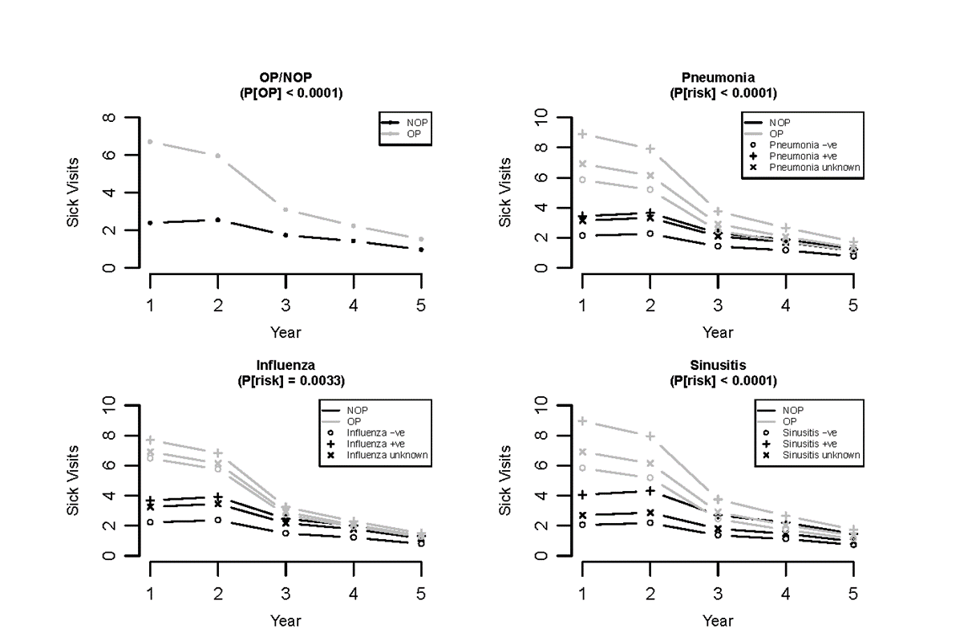

References
Højsgaard, S., Halekoh, U. & Yan J. (2006) The R Package geepack for Generalized Estimating Equations Journal of Statistical Software, 15, 2, pp1--11
Liang, K.Y. and Zeger, S.L. (1986) Longitudinal data analysis using generalized linear models. Biometrika, *73* 13-22.

Supplemental Digital Content 2. Comparison of physician diagnosed, medically-attended viral URI visit frequency of sOP versus NOP child cohorts. # p<0.0001. *p<0.05.

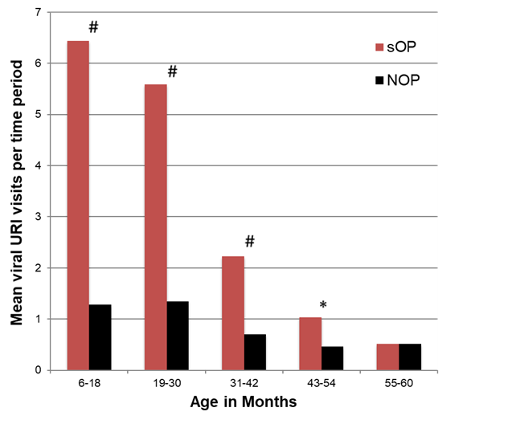

Supplemental Digital Content 3. Presentation of respiratory illnesses during regularly scheduled well child visits. The proportion of scheduled well-child visits at 6, 9, 12, 15, 18, 24, and 36 months of age where a child presented with a respiratory illness (respiratory illness fraction) is shown. Data are mean +/- 95% confidence interval. * = p<0.01 comparing sOP and NOP.

