Supplemental Digital Content 1. Baseline and clinical characteristics of 208 children with recurrent respiratory tract infections
Child characteristics
Age at first visit, median (range) |  | 2.2 y (2 m – 16 y)
Male sex, n (%) |  | 111/208 (53.4%)
Smoking parent, n (%) |  | 40/119 (19.2%)
Day-care attendance, n (%) |  | 78/94 (37.5%)
Clinical presentation
Alarming symptoms, n (%) |  | 30/208 (14.4%)
 | Failure to thrive | 15/79 (7.2%)
 | Chronic diarrhoea | 4/95 (1.9%)
 | Medical history of severe infection(s) | 13/208 (6.3%)
Antibiotic prescriptions year before presentation, median (range) |  | 2 (0-15)
Type of recurrent respiratory tract infections
 | Upper | 189 (90.9%)
 | Lower | 9 (4.3%)
 | Both | 10 (4.8%)
Healthcare characteristics
Referral by, n (%)
 | General practitioner | 139/200 (66.8%)
 | Other health care professional | 35/200 (16.8%)
 | Follow-up care with new clinical presentation | 26/200 (12.5%)
Treating physician
 | General paediatrician | 166/208 (79.8%)
 | Paediatric pulmonologist | 40/208 (19.2%)
 | Paediatric immunologist | 2/208 (1.0%)
Percentages are based on the total study population

Supplemental Digital Content 2. Proportion of children with recurrent respiratory tract infections with at least one diagnostic test during their visits to the paediatric outpatient clinic
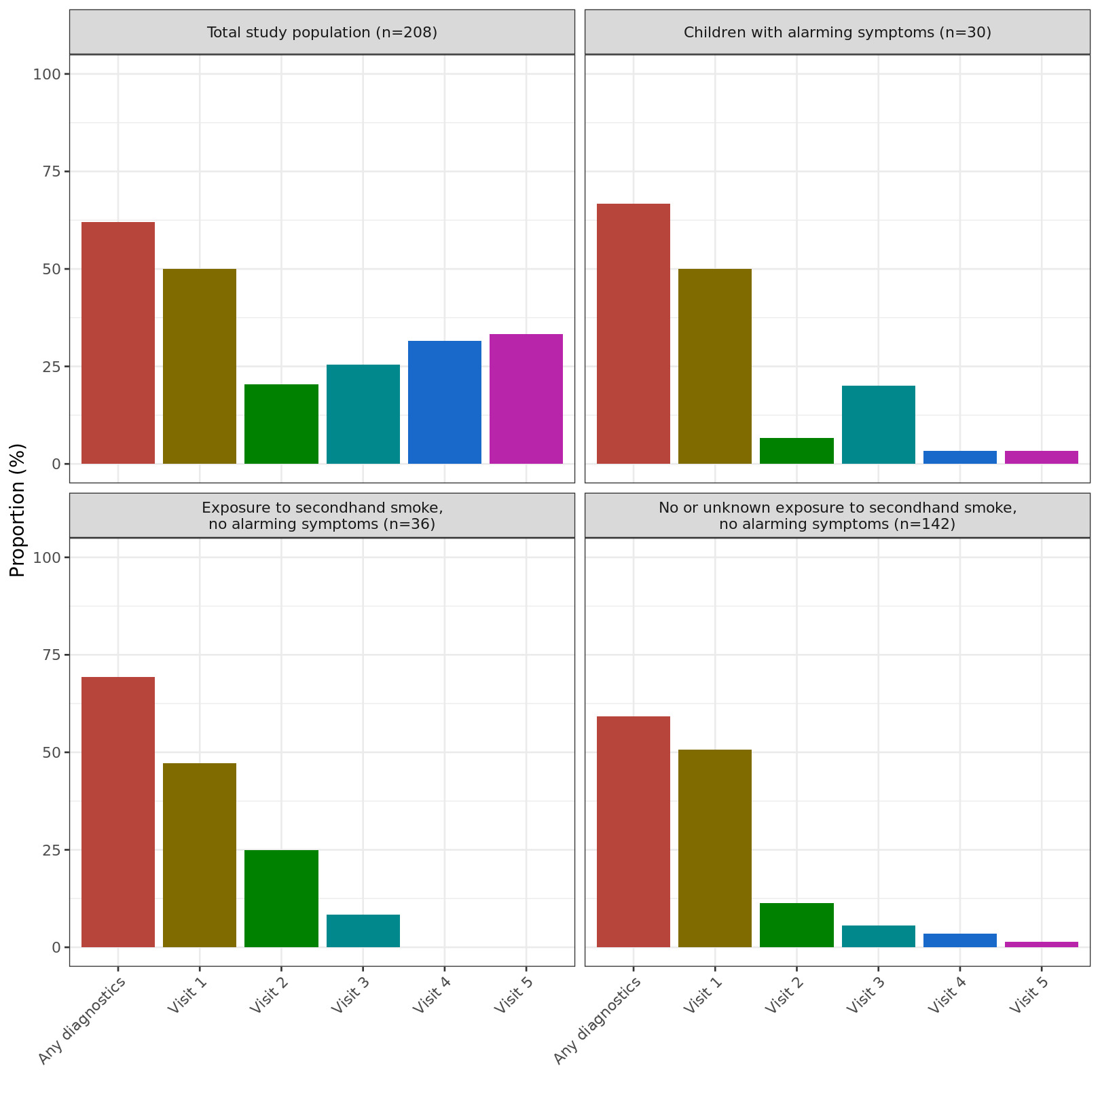

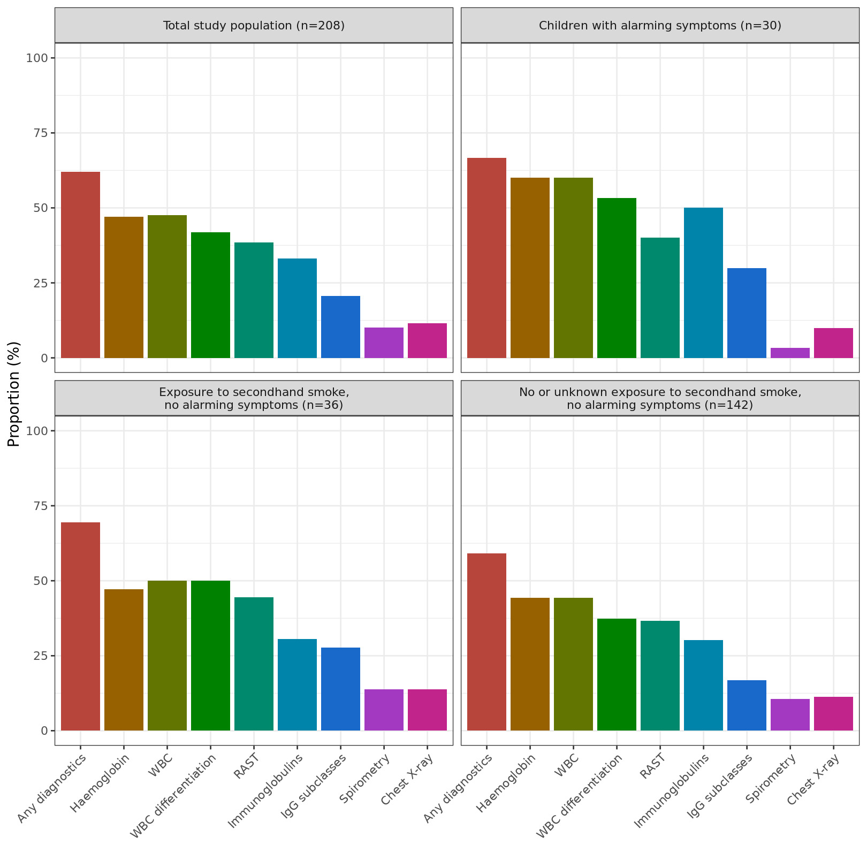
Supplemental Digital Content 3. Choice of diagnostic tests in children with recurrent respiratory infections visiting the paediatric outpatient clinic

