Supplement Digital Content 1. Our institutional protocol for treatment of patients with acute left ventricular systolic dysfunction or cardiogenic shock associated with MIS C.

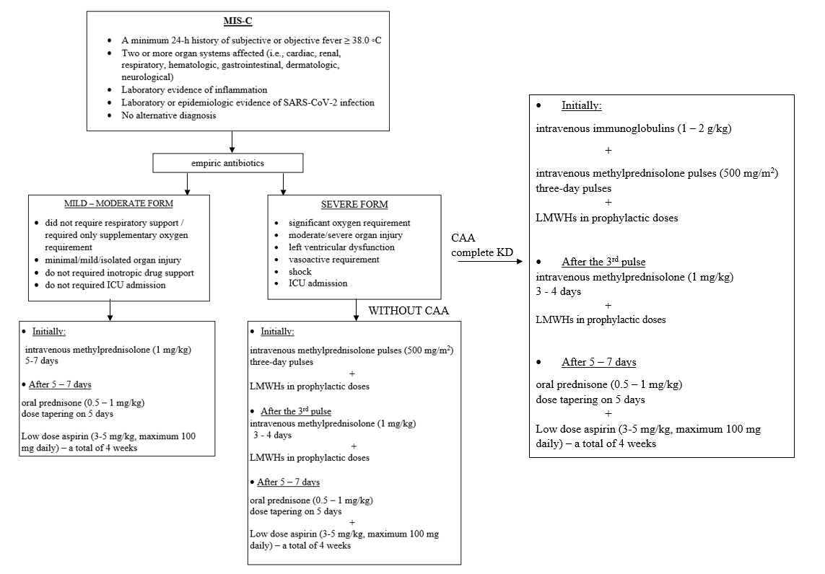

Abbreviations: MIS-C – multisystem inflammatory syndrome in children; ICU – intensive care unit; KD – Kawasaki disease; CAA – coronary artery disease; LMWH – low molecular weight heparin

