Supplemental Digital Content 2. Clinical presentation depending on initial treatment and treatment failure

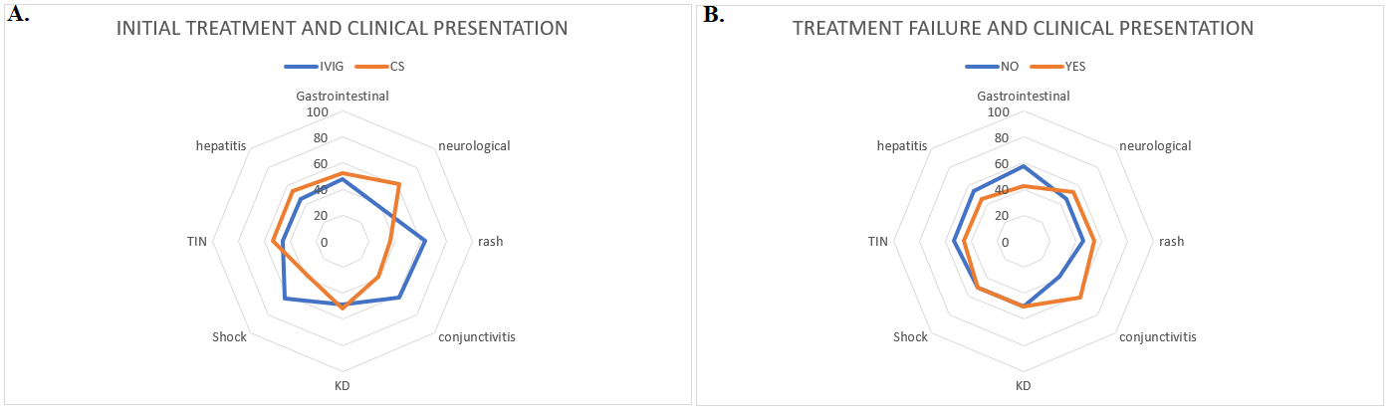Abbreviations: IVIG – intravenous immunoglobulin; CS – corticosteroid; KD – Kawasaki disease; TIN – tubulointerstitial nephritis

