Supplemental Digital Content 1A. The concentration of infliximab at birth in relation to the number of gestational weeks between last maternal use of infliximab and birth. Spearman correlation showed a significant correlation between less exposure free weeks and a higher concentration of infliximab at birth.
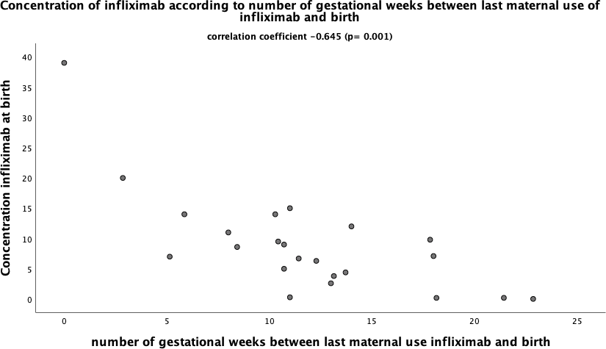

Supplemental Digital Content 1B. The concentration of adalimumab at birth in relation to the number of gestational weeks between last maternal use of adalimumab and birth. Spearman correlation showed no significant correlation between the number of exposure free weeks and the concentration of adalimumab at birth.
