Supplemental Digital Content 5. Multivariant model for step 1 to differentiate viral from bacterial community-acquired pneumonia.
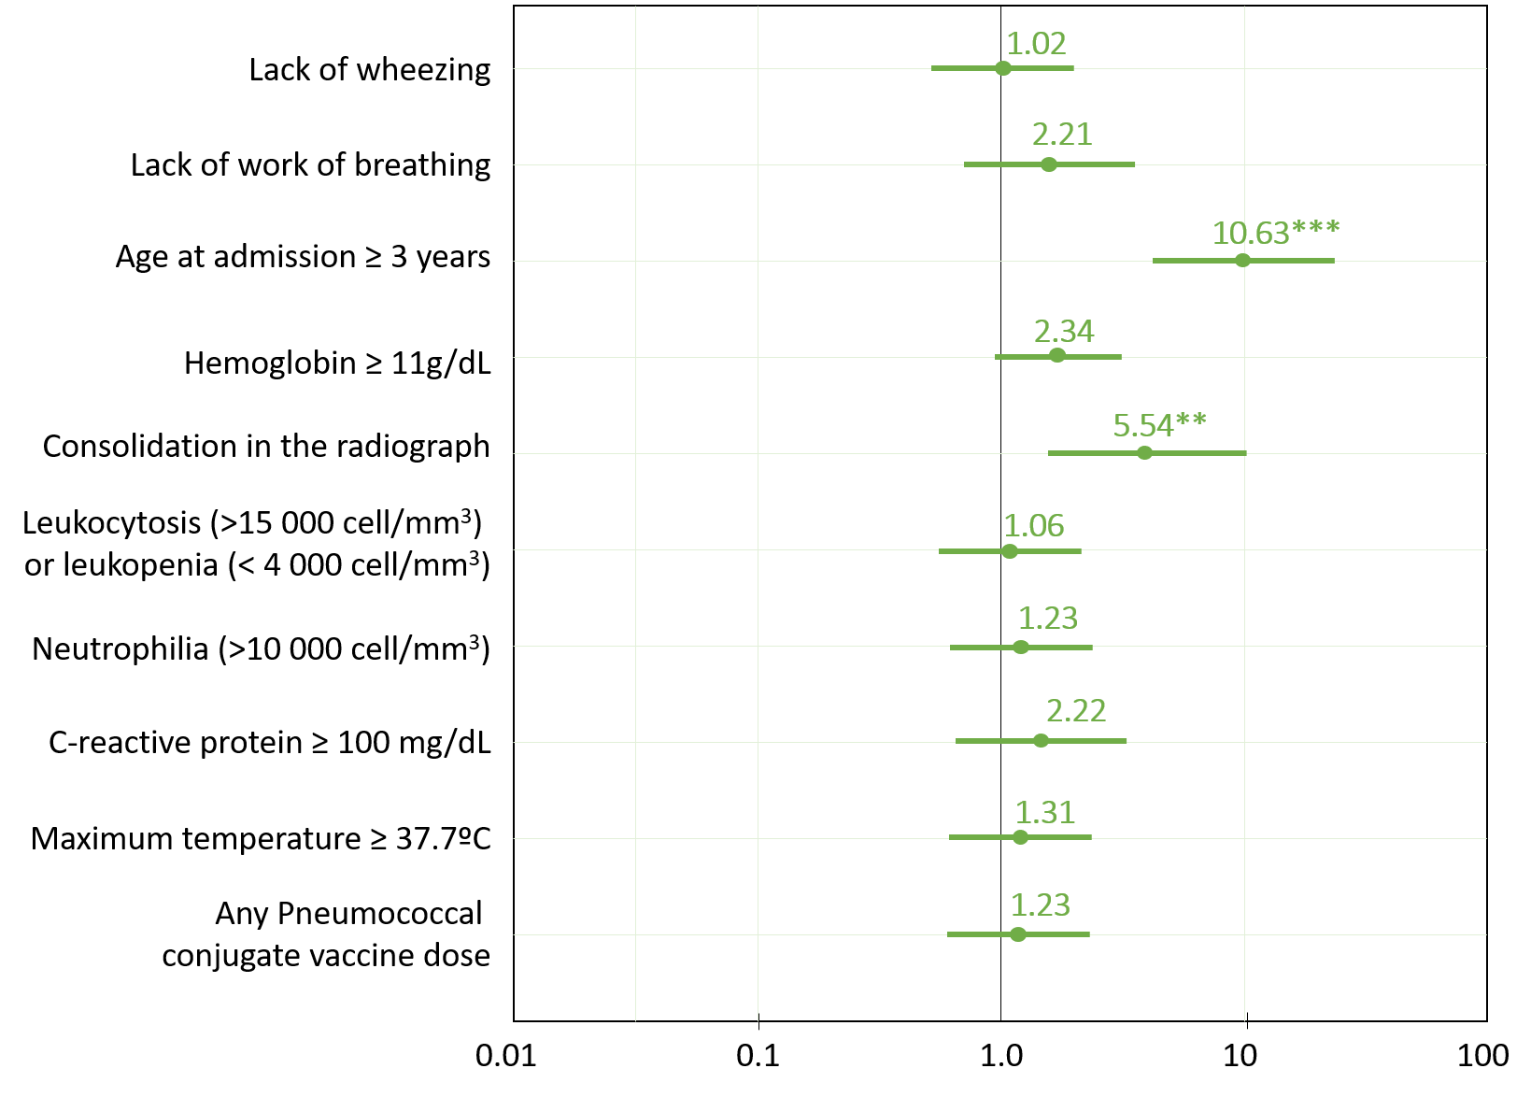

* p<0.050; ** p<0.01; ***p<0.001.

