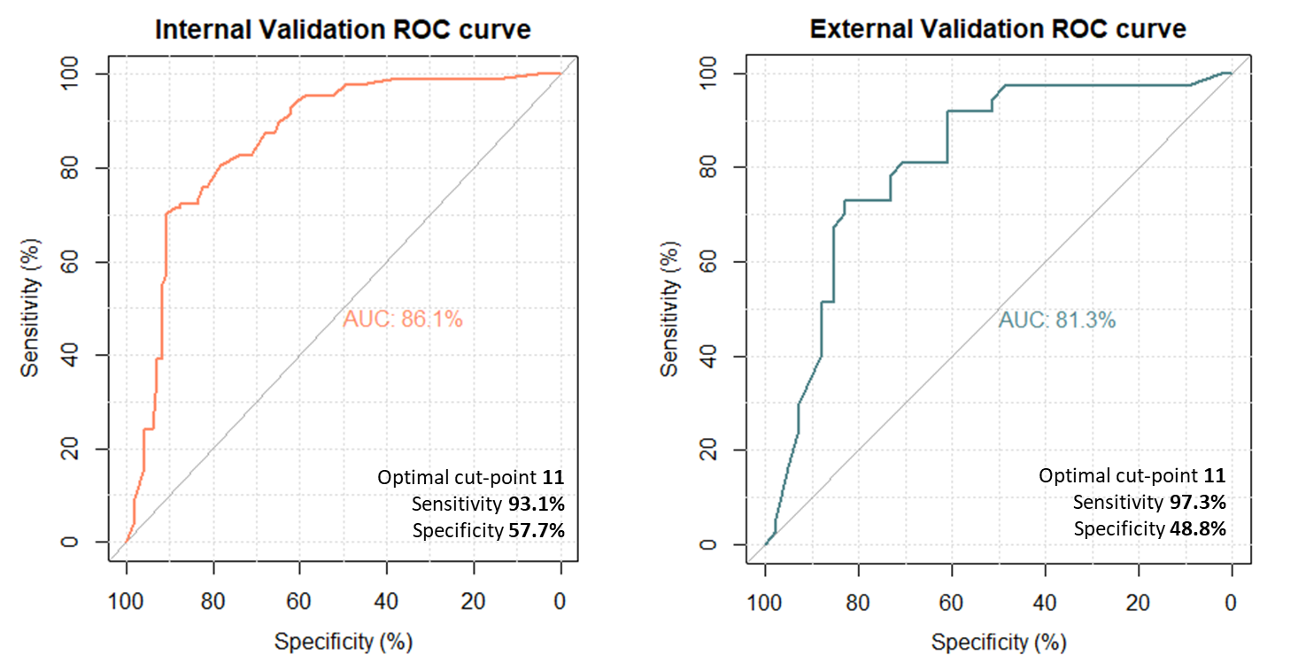
Supplemental Digital Content 6. Validation of step 1. External validation refers to the testing set, after internal validation in the training set. AUC: Area under the curve.

