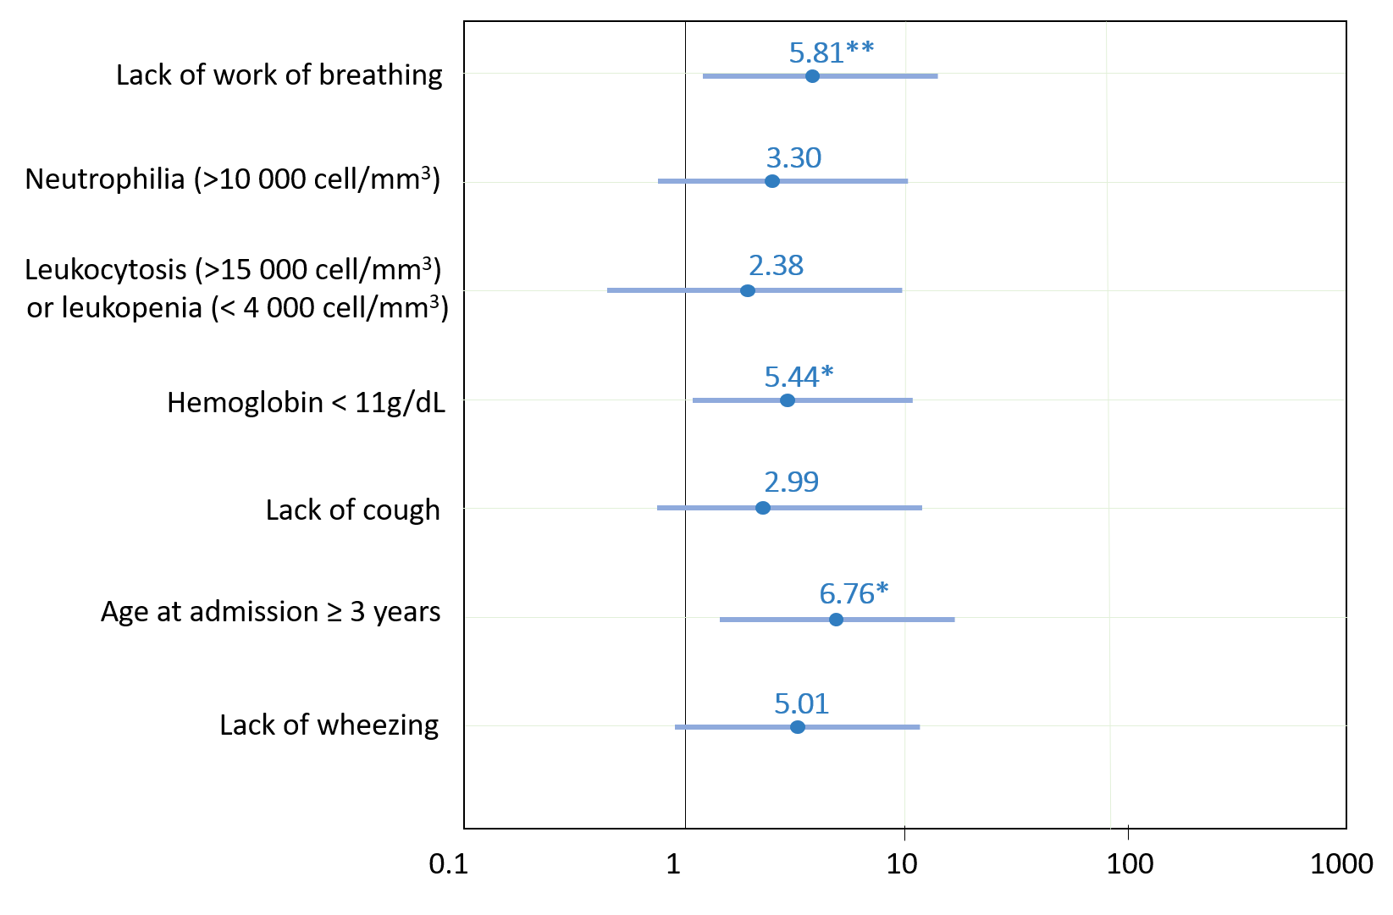
Supplemental Digital Content 7. Multivariant model for step 2 to differentiate typical bacterial from atypical bacterial community-acquired pneumonia. C-reactive protein, influenza vaccine, and consolidation in the radiograph were excluded in the model because of their large odds ratio with a wide confidence interval (CI95%) to avoid sparse data bias (see results for the odds ratio and CI95% of C-reactive protein, influenza vaccine and consolidation in the radiograph).

* p<0.050; ** p<0.01; ***p<0.001.

