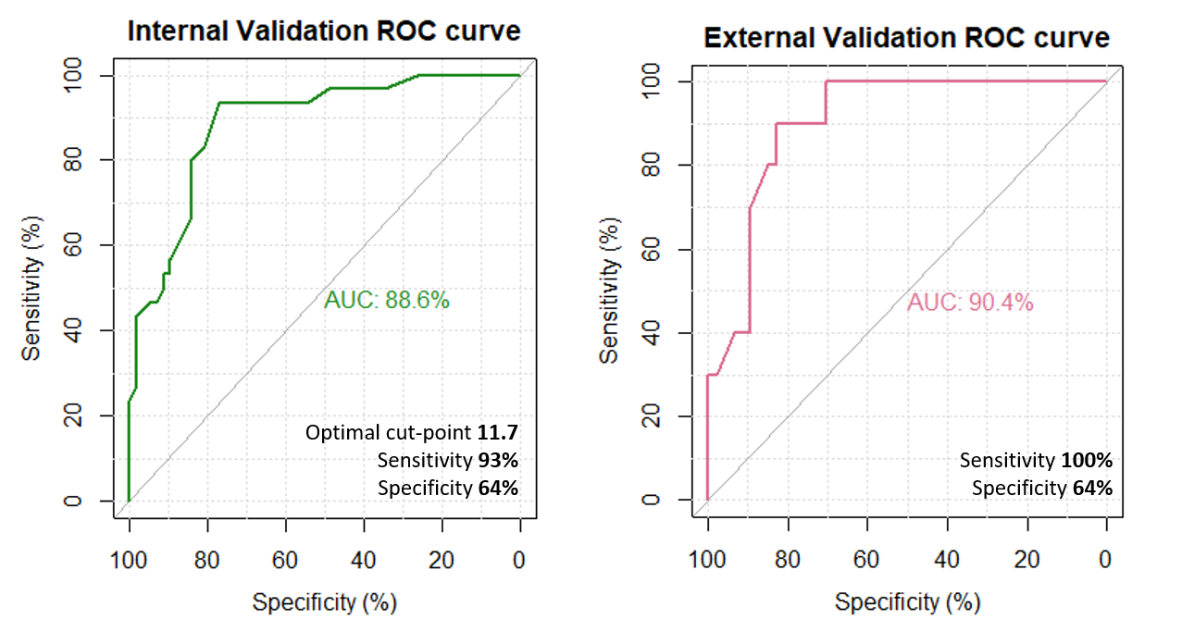
Supplemental Digital Content 8. Validation of Step 2. External validation refers to the testing set, after internal validation in the training set. AUC: Area under the curve.

