Supplement Digital Content

SDC 1. Annual number of otitis media (OM) visits and the ratio of OM visits to all visits.
Year | Number of OM visits | Ratio of OM  visits to all visits
2014  2015  2016  2017  2018  2019  2020 | 46,202  47,603  54,588  62,450  60,108  60,187  26,252 | 21.5 %  21.9 %  22.8 %  24.4 %  22.8 %  22.8 %  15.2 %

SDC 2. Description of the study population and the patients excluded due to concomitant lower respiratory tract infection warranting antibiotic treatment. OM, otitis media
 | Study population |  | Excluded patients
 | All OM included in the study, number (%) | Antibiotics prescribed for OM, number (%) | OM with LRTI excluded from the study, number
All | 357,390 | 160,271 (44,8) | 27,047
Age (years)
< 2 | 115,836 | 51,082 (44.1) | 11,667
2-4.9 | 132,705 | 58,765 (44.2) | 9,765
5-11.9 | 89,488 | 41,847 (46.8) | 4,651
12-17.9 | 19,361 | 8,577 (44.3) | 964
Sex
Boy | 197,136 (55.2) | 87,459 (54.7) | 16,065
Speciality
PED | 118,777 | 46,142 (38.8) | 16,361
GP | 127,124 | 68,657 (54.0) | 61,92
ENT | 100,346 | 39,979 (39.8) | 1,834
Others | 11,143 | 5,493 (49.3) | 2,660
P <0.0001 for the difference between children with and without antibiotics prescribed, in relation to age, sex and speciality, respectively (Chi-squared test)
P <0.0001 for the difference between OM group included the study and OM with LRTI excluded from the study, in relation to age, sex and speciality, respectively (Chi-squared test)

SDC 3. Antibiotic prescription rates for acute otitis media in different hospital districts with more than 10,000 visits (n = 357,390)
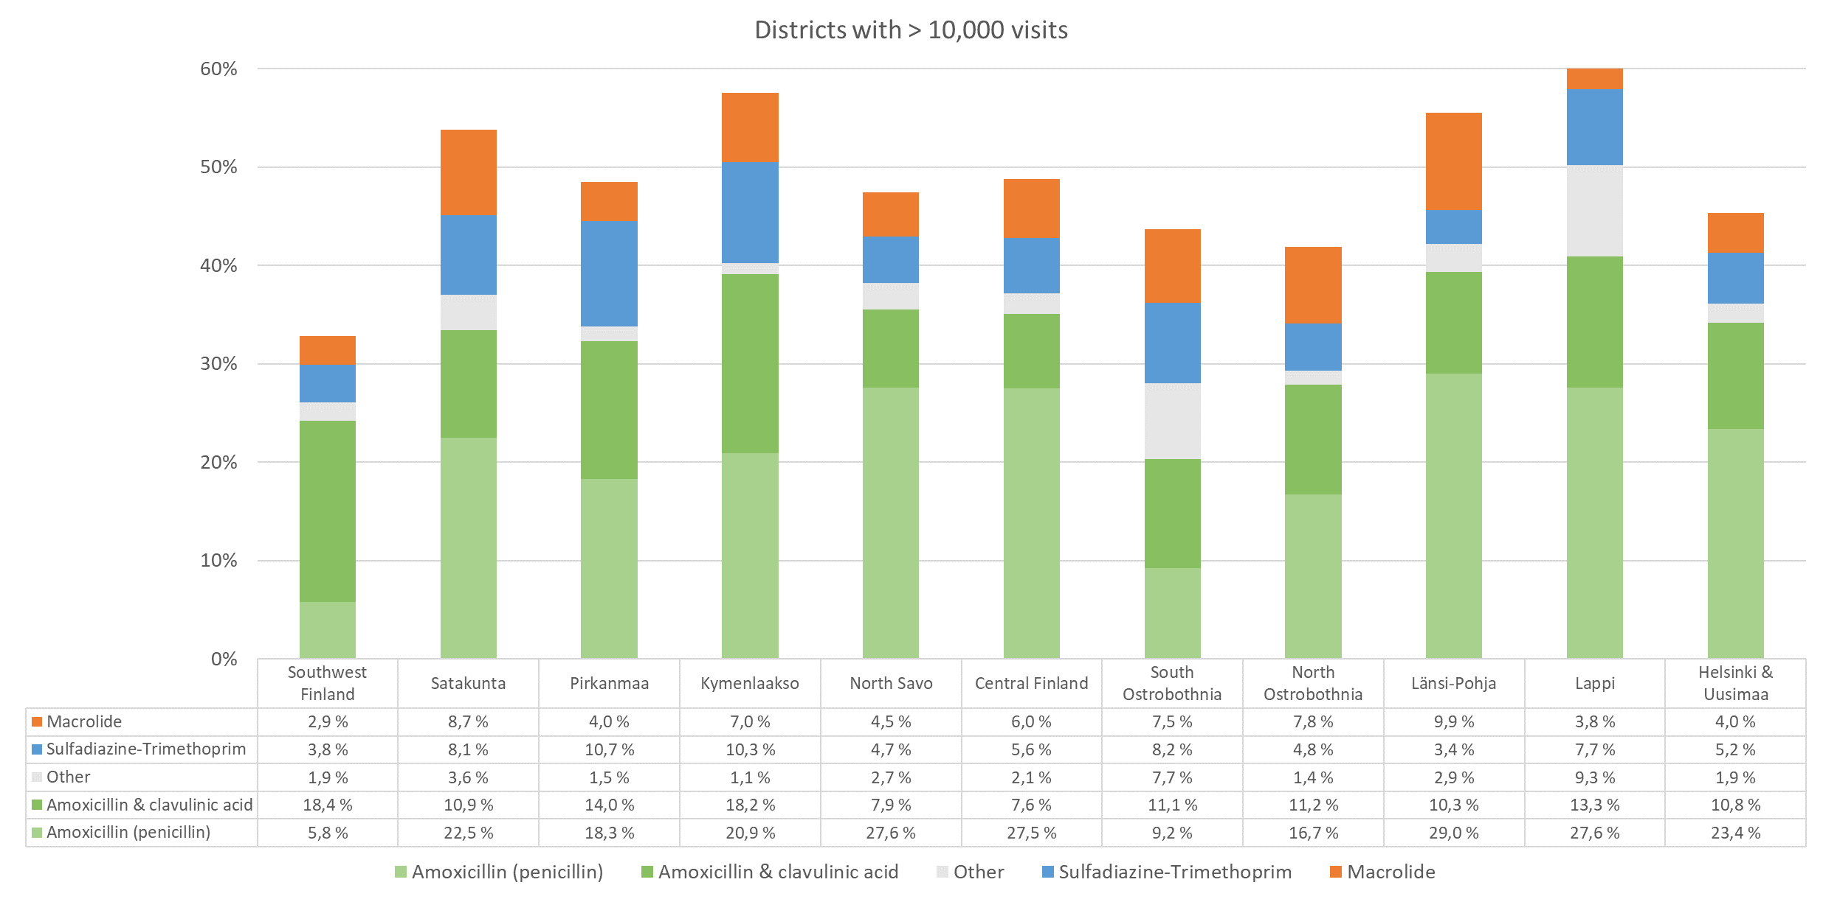

SDC 4. Children with OM who were prescribed antibiotics by age groups (n = 160,271)

