Supplemental Digital Content 2. Therapy Options for High-Risk Patients*

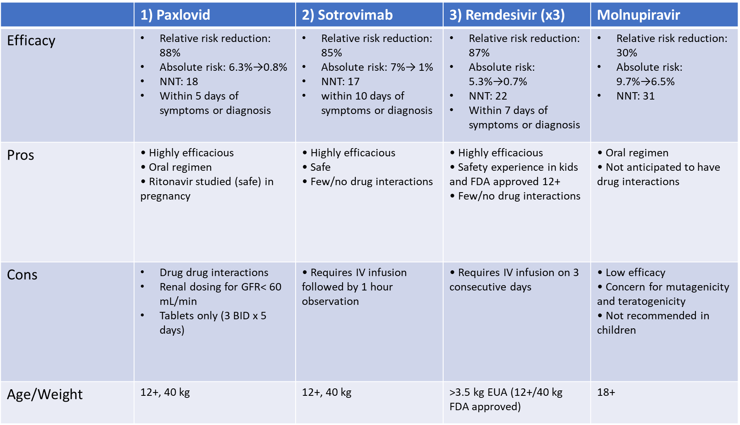

*Adapted from Gandhi RT, Malani PN, del Rio C [1]

