SDC 1. Components of Hex-IH and Hex-V
Hex-IH |  |  | Hex-V
Component | Dose | Additional information | Component | Dose | Additional Information
Diphtheria toxoid | Not less than 20 international units (IU) | Absorbed onto aluminum hydroxide | Diphtheria toxoid | Not less than 20 international units (IU) | Absorbed onto aluminum phosphate
Tetanus toxoid | Not less than 40 international units (IU) |  | Tetanus toxoid | Not less than 40 international units (IU)
Bordetella pertussis antigens |  |  | Bordetella pertussis antigens
- Pertussis toxoid (PT) | 25 micrograms | Absorbed onto aluminum hydroxide | - Pertussis toxoid (PT) | 20 micrograms | Absorbed onto aluminum phosphate
- Filamentous Haemagglutinin  (FHA) | 25 micrograms |  | - Filamentous Haemagglutinin  (FHA) | 20 micrograms
- Pertactin (PRN) | 8 micrograms |  | - Pertactin (PRN) | 3 micrograms
 |  |  | - Fimbriae Types 2 and 3 (FIM) | 5 micrograms
Hepatitis B surface antigen | 10 micrograms | - Produced in yeast cells (Saccharomyces cerevisiae) by recombinant DNA technology - absorbed on aluminum phosphate (AIPO₄) | Hepatitis B surface antigen | 10 micrograms | - Produced in yeast cells (Saccharomyces cerevisiae) by recombinant DNA technology - Absorbed onto aluminum hydroxyphosphate sulfate
Poliovirus (inactivated) IPV |  |  | Poliovirus (inactivated) IPV
- Type 1 (Mahoney strain) | 40 D-antigen unit | Propagated in VERO cells | - Type 1 (Mahoney strain) | 40 D-antigen unit | Propagated in VERO cells
- Type 2 (MEF-1 strain) | 8 D-antigen unit |  | - Type 2 (MEF-1 strain) | 8 D-antigen unit
- Type 3 (Saukett strain) | 32 D-antigen unit |  | - Type 3 (Saukett strain) | 32 D-antigen unit
Hemophilus influenzae type b polysaccharide  .-.conjugated to tetanus toxoid | 10 micrograms | Absorbed on aluminum phosphate (AIPO₄) | Hemophilus influenzae type b polysaccharide  - conjugated to meningococcal protein | 3 micrograms  50 micrograms | Absorbed onto aluminum hydroxyphosphate sulfate

SDC 2. Study visit schedule

Visit |  | Visit 1 | Visit 2 | Visit 3 | Visit 4 | Visit 5 | Visit 6
Age of participant |  | 2 months | 3 months | 4 months | 5 months | 12 months | 13 months
Visit windows |  | 8 – 13 weeks of age | 28-42 days after visit 1 | 28-42 days after visit 2 | 28-42 days after visit 3 | 12 months of age (+28 days) | 28-42 days after visit 5
Relaxed visit windows |  | N/A | 21-49 days after visit 1 | 21-49 days after visit 2 | 21-49 days after visit 3 | 350-406 days of age | 21-49 days after visit 5
Median of observed visit windows [IQR] (range)* |  | 60 [58-64] (56-94) days of age | 30 [28-33] (28-45) days after visit 1 | 32 [28-35] (26-55) days after visit 2 | 34 [28-41] (26-118) days after visit 3 | 372 [370-377] (367-428) days of age | 34 [29-40] (26-86) days after visit 5
Group | Hex-IH | 6 in 1(Hex-IH)  4CMenB  Rotavirus | 6 in 1(Hex-IH)  Rotavirus  PCV13 | 6 in 1(Hex-IH)  4CMenB | Blood sampling | Hib-MenC-TT  PCV13 MMR  4CMenB | Blood sampling
 | Hex-V | 6 in 1(Hex-V)  4CMenB  Rotavirus | 6 in 1(Hex-V)  Rotavirus  PCV13 | 6 in 1(Hex-V)  4CMenB

*In participants included in the primary mITT analysis.

SDC 4. Correlates of protection used

Vaccine antigen |  | Assay | Level required for protection†
Hemophilus influenzae b (Hib) |  | ELISA (anti-PRP IgG) | ≥0.15 µg/ml (short term)
 |  |  | ≥1.0 µg/ml (long term)
Diphtheria |  | ELISA (IgG to toxoid) | ≥0.1 IU/ml
Tetanus |  | ELISA (IgG to toxoid) | ≥0.1 IU/ml
Hepatitis B |  | ELISA (anti-HBs IgG) | ≥10 IU/ml
Group B meningococcus (MenB): | 44/76-SL | SBA (human complement) | ≥4 hSBA titer
 | 5/99
 | NZ98/254
Group C meningococcus (MenC) |  | SBA (rabbit complement) | ≥8 rSBA titer
Polio |  | Neutralization | ≥1/8 titer
Pneumococcus |  | ELISA | ≥0.35 µg/ml

SDC 5. Proportion of participants achieving prespecified antibody concentrations/titers (defined correlates of protection) at 5 and 13 months of age, following vaccination with Hex-V or Hex-IH
Antigen | Component/serotype | Threshold | 5 months |  |  | 13 months
 |  |  | Hex-V,  n (%) | Hex-IH,  n (%) | Difference in proportions (95% CI) | Hex-V,  n (%) | Hex-IH,  n (%) | Difference in proportions (95% CI)
Hib |  | ≥0.15 µg/ml | 83 (97.65%) | 81 (93.10%) | 4.54% (-2.84%, 11.93%) | 79 (100.00%) | 84 (100.00%) | 0.00% (-)
 |  | ≥1.0 µg/ml | 78 (91.76%) | 43 (49.43%) | 42.34% (29.15%, 55.52%)* | 79 (100.00%) | 81 (96.43%) | 3.57% (-1.63%, 8.77%)
MenB | NZ98/254 | ≥4 hSBA titer | 65 (98.48%) | 63 (92.65%) | 5.84% (-2.52%, 14.20%) | 62 (92.54%) | 67 (90.54%) | 2.00% (-8.59%, 12.59%)
 | 44/76-SL | ≥4 hSBA titer | 65 (100.00%) | 63 (96.92%) | 3.08% (-2.66%, 8.81%) | 68 (100.00%) | 77 (100.00%) | 0.00% (-)
 | 5/99 | ≥4 hSBA titer | 68 (100.00%) | 66 (100.00%) | 0.00% (-) | 70 (100.00%) | 79 (100.00%) | 0.00% (-)
MenC |  | ≥8 rSBA titer | 6 (8.33%) | 4 (5.48%) | 2.85% (-6.77%, 12.48%) | 74 (100.00%) | 78 (97.50%) | 2.50% (-2.22%, 7.22%)
Diphtheria |  | ≥0.1 IU/ml | 67 (78.82%) | 83 (95.40%) | -16.58% (-27.48%, -5.68%)* | 76 (96.20%) | 82 (97.62%) | -1.42% (-7.97%, 5.14%)
Tetanus |  | ≥0.1 IU/ml | 85 (100.00%) | 87 (100.00%) | 0.00% (-) | 79 (100.00%) | 84 (100.00%) | 0.00% (-)
HepB |  | ≥10 IU/ml | 50 (96.15%) | 53 (100.00%) | -3.85% (-10.98%, 3.29%) | 55 (91.67%) | 58 (93.55%) | -1.88% (-12.81%, 9.05%)
Pneumococcus | 1 | ≥0.35 µg/ml | 34 (54.84%) | 39 (57.35%) | -2.51% (-21.13%, 16.10%) | 67 (100.00%) | 69 (100.00%) | 0.00% (-)
 | 3 | ≥0.35 µg/ml | 40 (66.67%) | 44 (67.69%) | -1.03% (-18.53%, 16.48%) | 62 (95.38%) | 63 (91.30%) | 4.08% (-5.79%, 13.95%)
 | 4 | ≥0.35 µg/ml | 32 (49.23%) | 44 (62.86%) | -13.63% (-31.72%, 4.47%) | 67 (100.00%) | 69 (100.00%) | 0.00% (-)
 | 5 | ≥0.35 µg/ml | 19 (31.67%) | 16 (24.24%) | 7.42% (-9.83%, 24.68%) | 66 (100.00%) | 69 (100.00%) | 0.00% (-)
 | 6A | ≥0.35 µg/ml | 3 (5.00%) | 3 (4.55%) | 0.45% (-7.46%, 8.37%) | 67 (100.00%) | 69 (100.00%) | 0.00% (-)
 | 6B | ≥0.35 µg/ml | 2 (2.90%) | 0 (0.00%) | 2.90% (-2.48%, 8.28%) | 68 (98.55%) | 70 (97.22%) | 1.33% (-4.73%, 7.39%)
 | 7F | ≥0.35 µg/ml | 43 (71.67%) | 56 (83.58%) | -11.92% (-27.94%, 4.11%) | 67 (100.00%) | 69 (100.00%) | 0.00% (-)
 | 9V | ≥0.35 µg/ml | 9 (14.52%) | 18 (26.87%) | -12.35% (-27.67%, 2.97%) | 64 (96.97%) | 69 (100.00%) | -3.03% (-8.65%, 2.59%)
 | 14 | ≥0.35 µg/ml | 50 (84.75%) | 57 (86.36%) | -1.62% (-15.58%, 12.34%) | 66 (100.00%) | 69 (100.00%) | 0.00% (-)
 | 18C | ≥0.35 µg/ml | 16 (26.67%) | 26 (39.39%) | -12.73% (-30.57%, 5.12%) | 65 (97.01%) | 69 (100.00%) | -2.99% (-8.53%, 2.56%)
 | 19A | ≥0.35 µg/ml | 33 (48.53%) | 41 (56.94%) | -8.42% (-26.33%, 9.50%) | 68 (100.00%) | 72 (100.00%) | 0.00% (-)
 | 19F | ≥0.35 µg/ml | 45 (75.00%) | 46 (69.70%) | 5.30% (-11.88%, 22.48%) | 67 (100.00%) | 67 (100.00%) | 0.00% (-)
 | 23F | ≥0.35 µg/ml | 2 (3.08%) | 1 (1.43%) | 1.65% (-4.87%, 8.17%) | 66 (98.51%) | 67 (97.10%) | 1.41% (-4.91%, 7.72%)
Note that pertussis has been omitted from this table due to no defined correlate of protection for this pathogen.
*Statistically significant

SDC 6. Breakdown of maximum severity of solicited systemic adverse events over days 0-5 following each dose of study vaccination
Visit | Symptom | Arm | None | Mild | Moderate | Severe | Any
1 | Fever | Hex-IH | 78 (81%, 72%-88%) | 17 (18%, 11%-27%) | 1 (1%, 0%-6%) | 0 (0%, 0%-4%) | 18 (19%, 12%-28%)
 |  | Hex-V | 76 (81%, 71%-88%) | 13 (14%, 8%-22%) | 5 (5%, 2%-12%) | 0 (0%, 0%-4%) | 18 (19%, 12%-29%)
 | Eating changes | Hex-IH | 45 (46%, 36%-56%) | 39 (40%, 30%-50%) | 13 (13%, 7%-22%) | 1 (1%, 0%-6%) | 53 (54%, 44%-64%)
 |  | Hex-V | 36 (38%, 28%-48%) | 48 (50%, 40%-60%) | 11 (11%, 6%-20%) | 1 (1%, 0%-6%) | 60 (62%, 52%-72%)
 | Drowsiness | Hex-IH | 21 (21%, 14%-31%) | 55 (56%, 46%-66%) | 17 (17%, 10%-26%) | 5 (5%, 2%-12%) | 77 (79%, 69%-86%)
 |  | Hex-V | 26 (27%, 19%-37%) | 43 (45%, 35%-55%) | 25 (26%, 18%-36%) | 2 (2%, 0%-7%) | 70 (73%, 63%-81%)
 | Vomiting | Hex-IH | 61 (62%, 52%-72%) | 33 (34%, 24%-44%) | 3 (3%, 1%-9%) | 1 (1%, 0%-6%) | 37 (38%, 28%-48%)
 |  | Hex-V | 64 (67%, 56%-76%) | 30 (31%, 22%-42%) | 2 (2%, 0%-7%) | 0 (0%, 0%-4%) | 32 (33%, 24%-44%)
 | Diarrhea | Hex-IH | 55 (56%, 46%-66%) | 35 (36%, 26%-46%) | 6 (6%, 2%-13%) | 2 (2%, 0%-7%) | 43 (44%, 34%-54%)
 |  | Hex-V | 56 (58%, 48%-68%) | 37 (39%, 29%-49%) | 2 (2%, 0%-7%) | 1 (1%, 0%-6%) | 40 (42%, 32%-52%)
 | Irritability | Hex-IH | 23 (23%, 15%-33%) | 40 (41%, 31%-51%) | 32 (33%, 24%-43%) | 3 (3%, 1%-9%) | 75 (77%, 67%-85%)
 |  | Hex-V | 18 (19%, 12%-28%) | 34 (35%, 26%-46%) | 41 (43%, 33%-53%) | 3 (3%, 1%-9%) | 78 (81%, 72%-88%)
2 | Fever | Hex-IH | 78 (82%, 73%-89%) | 13 (14%, 7%-22%) | 3 (3%, 1%-9%) | 1 (1%, 0%-6%) | 17 (18%, 11%-27%)
 |  | Hex-V | 75 (85%, 76%-92%) | 11 (12%, 6%-21%) | 2 (2%, 0%-8%) | 0 (0%, 0%-4%) | 13 (15%, 8%-24%)
 | Eating changes | Hex-IH | 51 (53%, 42%-63%) | 35 (36%, 27%-46%) | 11 (11%, 6%-19%) | 0 (0%, 0%-4%) | 46 (47%, 37%-58%)
 |  | Hex-V | 48 (52%, 42%-63%) | 33 (36%, 26%-47%) | 10 (11%, 5%-19%) | 1 (1%, 0%-6%) | 44 (48%, 37%-58%)
 | Drowsiness | Hex-IH | 40 (41%, 31%-52%) | 34 (35%, 26%-45%) | 22 (23%, 15%-32%) | 1 (1%, 0%-6%) | 57 (59%, 48%-69%)
 |  | Hex-V | 41 (45%, 34%-55%) | 38 (41%, 31%-52%) | 11 (12%, 6%-20%) | 2 (2%, 0%-8%) | 51 (55%, 45%-66%)
 | Vomiting | Hex-IH | 68 (70%, 60%-79%) | 27 (28%, 19%-38%) | 2 (2%, 0%-7%) | 0 (0%, 0%-4%) | 29 (30%, 21%-40%)
 |  | Hex-V | 68 (74%, 64%-83%) | 20 (22%, 14%-32%) | 4 (4%, 1%-11%) | 0 (0%, 0%-4%) | 24 (26%, 17%-36%)
 | Diarrhea | Hex-IH | 62 (64%, 54%-73%) | 30 (31%, 22%-41%) | 4 (4%, 1%-10%) | 1 (1%, 0%-6%) | 35 (36%, 27%-46%)
 |  | Hex-V | 53 (58%, 47%-68%) | 34 (37%, 27%-48%) | 3 (3%, 1%-9%) | 2 (2%, 0%-8%) | 39 (42%, 32%-53%)
 | Irritability | Hex-IH | 19 (20%, 12%-29%) | 36 (37%, 28%-48%) | 35 (36%, 27%-46%) | 7 (7%, 3%-14%) | 78 (80%, 71%-88%)
 |  | Hex-V | 17 (18%, 11%-28%) | 36 (39%, 29%-50%) | 29 (32%, 22%-42%) | 10 (11%, 5%-19%) | 75 (82%, 72%-89%)
3 | Fever | Hex-IH | 70 (73%, 63%-81%) | 5 (5%, 2%-12%) | 20 (21%, 13%-30%) | 1 (1%, 0%-6%) | 26 (27%, 19%-37%)
 |  | Hex-V | 67 (76%, 66%-85%) | 15 (17%, 10%-27%) | 6 (7%, 3%-14%) | 0 (0%, 0%-4%) | 21 (24%, 15%-34%)
 | Eating changes | Hex-IH | 54 (56%, 45%-66%) | 36 (37%, 28%-48%) | 7 (7%, 3%-14%) | 0 (0%, 0%-4%) | 43 (44%, 34%-55%)
 |  | Hex-V | 47 (52%, 41%-62%) | 33 (36%, 26%-47%) | 11 (12%, 6%-21%) | 0 (0%, 0%-4%) | 44 (48%, 38%-59%)
 | Drowsiness | Hex-IH | 42 (43%, 33%-54%) | 32 (33%, 24%-43%) | 19 (20%, 12%-29%) | 4 (4%, 1%-10%) | 55 (57%, 46%-67%)
 |  | Hex-V | 31 (34%, 24%-45%) | 44 (48%, 38%-59%) | 16 (18%, 10%-27%) | 0 (0%, 0%-4%) | 60 (66%, 55%-76%)
 | Vomiting | Hex-IH | 71 (73%, 63%-82%) | 23 (24%, 16%-33%) | 2 (2%, 0%-7%) | 1 (1%, 0%-6%) | 26 (27%, 18%-37%)
 |  | Hex-V | 68 (75%, 65%-83%) | 21 (23%, 15%-33%) | 2 (2%, 0%-8%) | 0 (0%, 0%-4%) | 23 (25%, 17%-35%)
 | Diarrhea | Hex-IH | 63 (65%, 55%-74%) | 28 (29%, 20%-39%) | 6 (6%, 2%-13%) | 0 (0%, 0%-4%) | 34 (35%, 26%-45%)
 |  | Hex-V | 61 (67%, 56%-77%) | 26 (29%, 20%-39%) | 3 (3%, 1%-9%) | 1 (1%, 0%-6%) | 30 (33%, 23%-44%)
 | Irritability | Hex-IH | 18 (19%, 11%-28%) | 43 (44%, 34%-55%) | 31 (32%, 23%-42%) | 5 (5%, 2%-12%) | 79 (81%, 72%-89%)
 |  | Hex-V | 21 (23%, 15%-33%) | 31 (34%, 24%-45%) | 33 (36%, 26%-47%) | 6 (7%, 2%-14%) | 70 (77%, 67%-85%)

SDC 7. Maximum severity of solicited local and systemic adverse events over days 0-5 following vaccinations with Hex-V (V) or Hex-IH (IH) (severity scales for induration, erythema, and swelling according to trial protocol)
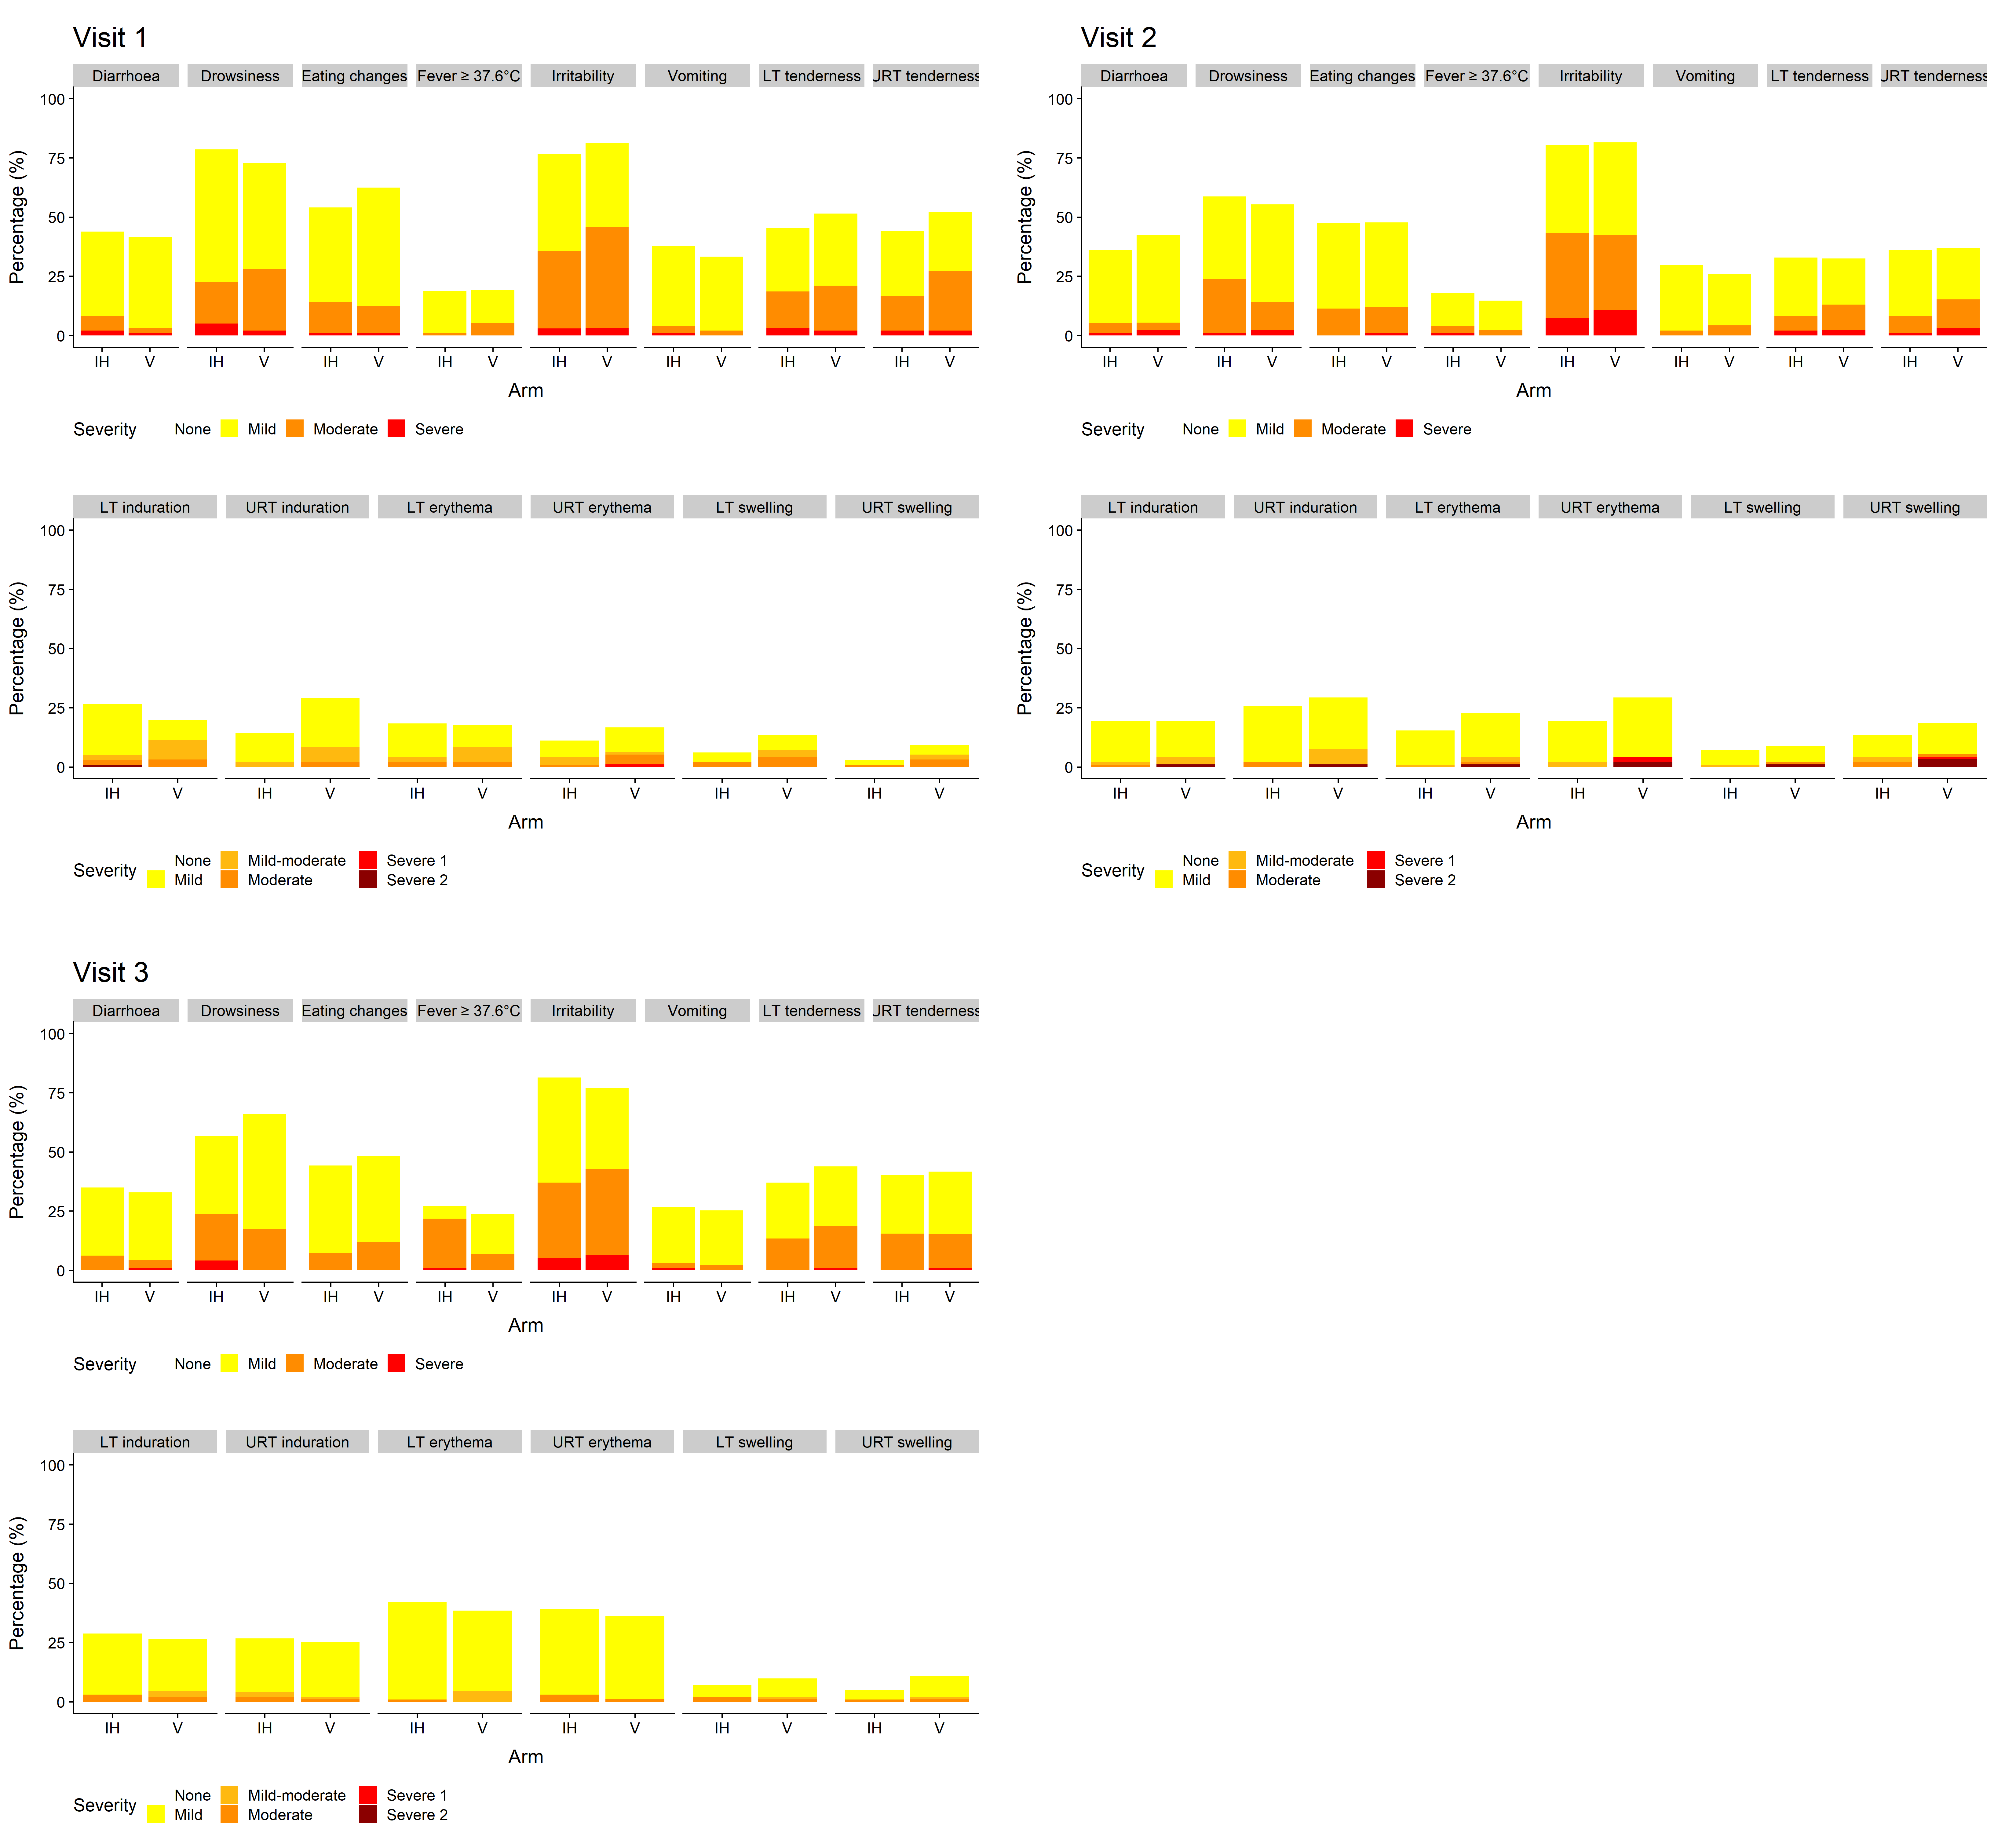

6 in 1 vaccine was given in the upper right thigh (URT) at all visits. MenB vaccine was given in the left anterolateral thigh (LT) at visits 1 and 3. PCV13 vaccine was given in the LT at visit 2.
SDC 8. Solicited local and systemic adverse events on days 0-5 following first vaccination with Hex-V or Hex-IH
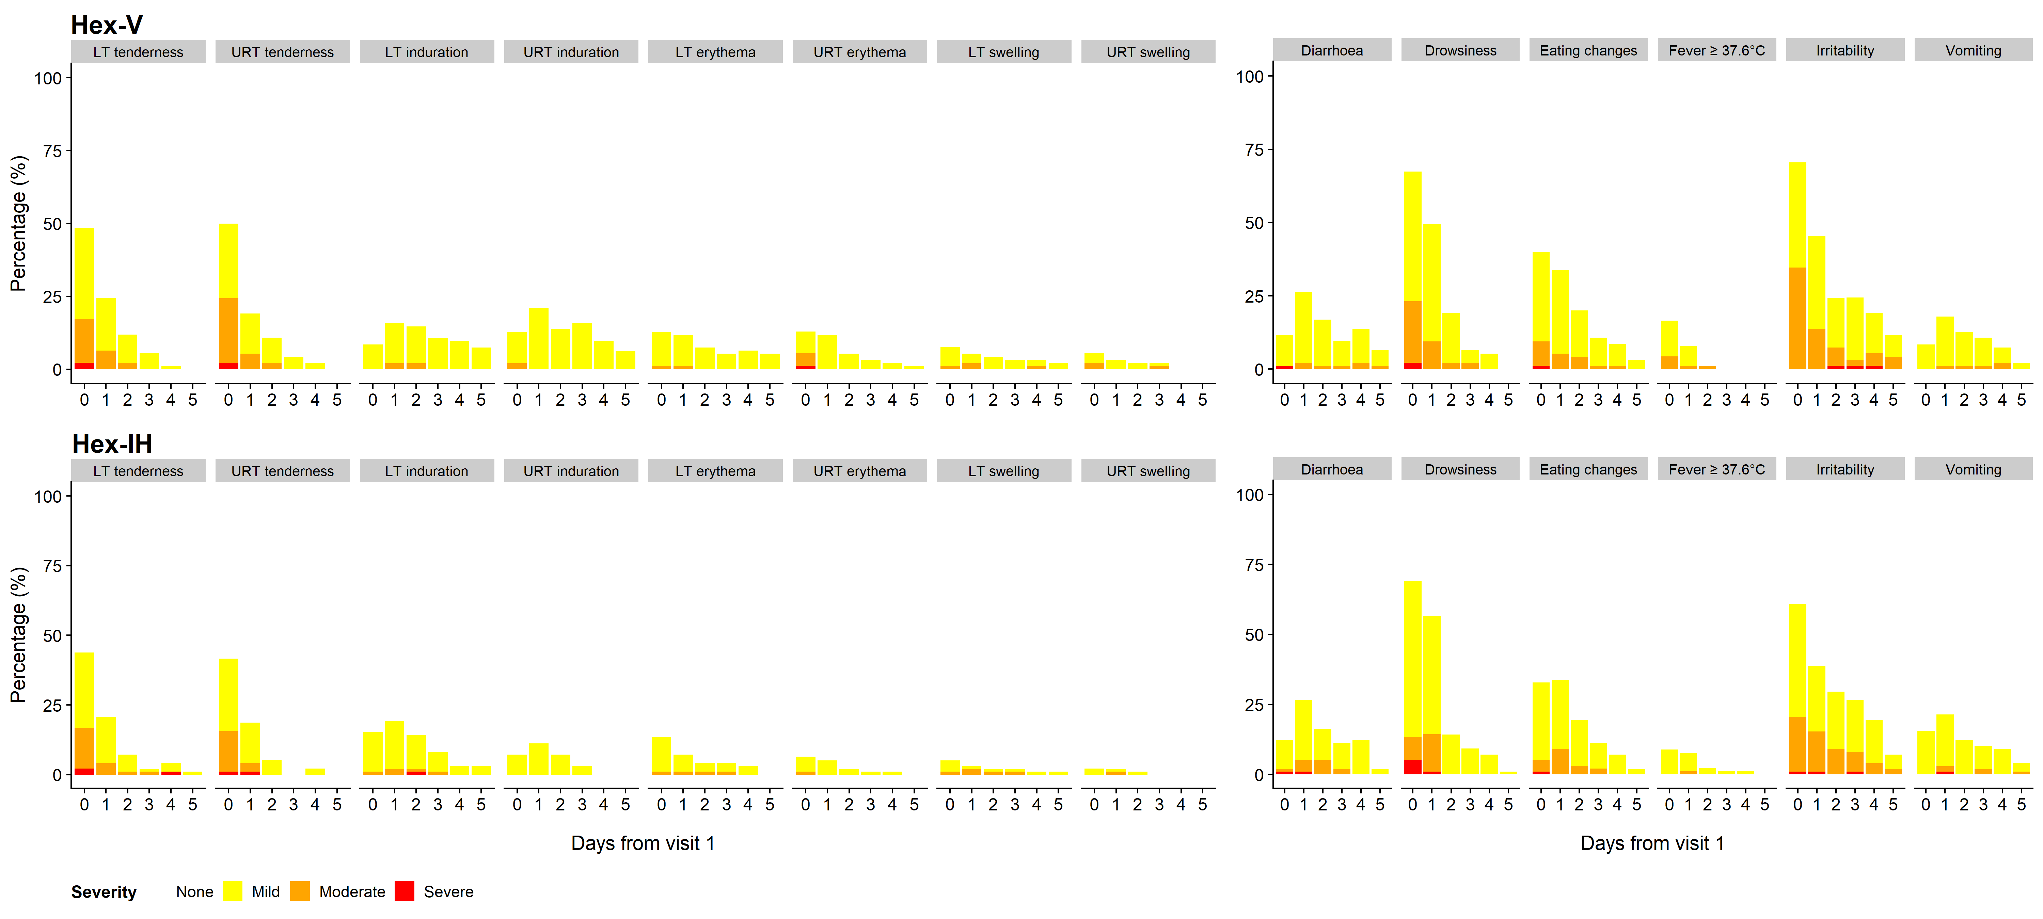

6 in 1 vaccine was given in the upper right thigh (URT) and Men B vaccine was given in the left anterolateral thigh (LT).

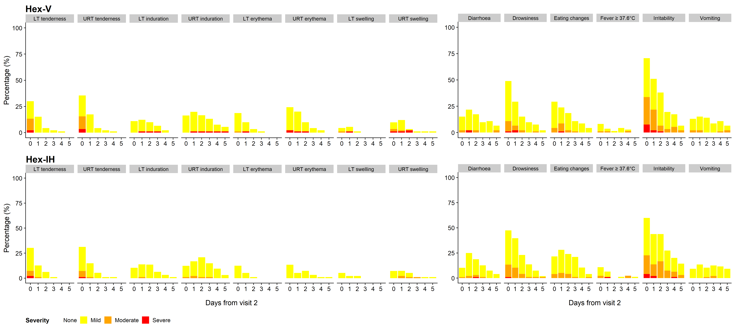
SDC 9. Solicited local and systemic adverse events on days 0-5 following second vaccination with Hex-V or Hex-IH

6 in 1 vaccine was given in the upper right thigh (URT) and PCV13 vaccine was given in the left anterolateral thigh (LT).

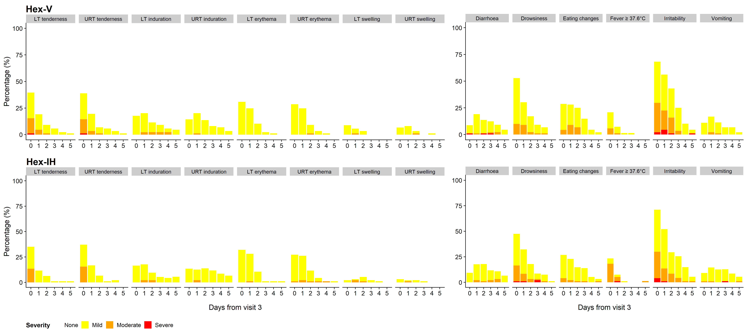
SDC 10. Solicited local and systemic adverse events on days 0-5 following third vaccination with Hex-V or Hex-IH

6 in 1 vaccine was given in the upper right thigh (URT) and Men B vaccine was given in the left anterolateral thigh (LT).

SDC 11. SAE, SAR and SUSAR line listing

ID | Arm | Duration of event (days) | Description | Severity | Related to vaccine administration | Expected (if related) | Classification
1 | Hex-IH | 3 | Bronchiolitis | Moderate | Unrelated |  | SAE
2 | Hex-IH | 3 | Bronchiolitis | Mild | Unrelated |  | SAE
2 | Hex-IH | 1 | Bronchiolitis | Mild | Unrelated |  | SAE
3 | Hex-V | 5 | Urinary tract infection with unilateral ureteric dilatation | Moderate | Unrelated |  | SAE
4 | Hex-IH | 2 | Viral infection | Moderate | Unrelated |  | SAE
5 | Hex-V | 9 | Bronchiolitis | Mild | Unrelated |  | SAE
5 | Hex-V | 1 | Head injury and respiratory tract infection | Moderate | Unrelated |  | SAE
6 | Hex-V | 17 | Respiratory tract infection | Mild | Unrelated |  | SAE
7 | Hex-IH | 1 | Post immunization pyrexia | Severe | Related | Yes | SAR
8 | Hex-IH | - | Tonsillitis and gastro-esophageal reflux disease | Mild | Unrelated |  | SAE
9 | Hex-V | 4 | Bronchiolitis | Severe | Unrelated |  | SAE
10 | Hex-V | 7 | Bronchiolitis | Mild | Unrelated |  | SAE
11 | Hex-V | 3 | Croup | Moderate | Unrelated |  | SAE
12 | Hex-IH | 4 | Bronchiolitis | Moderate | Unrelated |  | SAE
13 | Hex-V | - | Bronchiolitis and laryngomalacia | Severe | Unrelated |  | SAE
14 | Hex-V | 32 | Respiratory tract infection | Mild | Unrelated |  | SAE

