Supplemental Digital Content 1. Overview of Studies Included in the PopPK and TA Analyses
Phase | Study ID | Study Design | Age Cohort | n | n_{obs}/  Patient | Dose/Treatment/Schedule*
1 | A8841004  (NCT00678106)²³ | OL, SD study investigating PK, safety, and tolerability of dalbavancin in hospitalized patients receiving standard IV anti-infective treatment for bacterial infections | 12–17 y | 10 | 13 | Patients weighing  >60 kg: 1000 mg  <60 kg: 15 mg/kg
1 | DUR001-106 (NCT01946568)²⁴ | PK study of dalbavancin after IV SD dalbavancin | ≥5 y | 33 | 6 | 15 mg/kg (≤1000 mg)
 |  |  | 2–<5 y |  |  | 25 mg/kg (≤1000 mg)
 |  |  | 3 mo–<2 y |  |  | 10 mg/kg (≤1000 mg)
1 | DUR001-107  (DAL-PK-02)  (NCT02688790) | SD PK study of safety and tolerability in neonates and infants with known or suspected bacterial infection | 0‒ ≤3 mo | 8 | 6 | 22.5 mg/kg
3 | DUR001-306  (DAL-MD-02)  (NCT02814916) | MC, OL, R, AC trial of safety and efficacy of dalbavancin in patients with ABSSSI |  | 86 (SD)  75 (2D)
 |  |  | 0‒<3 mo† | 5 | 5 | SD: 22.5 mg/kg (≤1500 mg)
 |  |  | ≥3 mo‒<2 y | 8 | 5 | SD: 22.5 mg/kg (≤1500 mg)
 |  |  |  | 6 | 5 | 2D: 15 mg/kg (D1 ≤1000 mg), 7.5 mg/kg (D8 ≤500 mg)
 |  |  | ≥2‒<6 y | 19 | 5 | SD: 22.5 mg/kg (≤1500 mg)
 |  |  |  | 16 | 5 | 2D: 15 mg/kg (D1 ≤1000 mg), 7.5 mg/kg (D8 ≤500 mg)
 |  |  | ≥6‒12 y | 25 | 5 | SD: 18 mg/kg (≤1500 mg)
 |  |  |  | 24 | 5 | 2D: 12 mg/kg (D1 ≤1000 mg), 6 mg/kg (D8 ≤500 mg)
 |  |  | ≥12‒ ≤17 y | 29 | 5 | SD: 18 mg/kg (≤1500 mg)
 |  |  |  | 29 | 5 | 2D: 12 mg/kg (D1 ≤1000 mg), 6 mg/kg (D8 ≤500 mg)

2D, two-dose regimen; ABSSSI, acute bacterial skin and skin structure infections; AC, active comparator; DX, Day X; IV, intravenous; MC, multicenter; OL, open-label; PK, pharmacokinetics; R, randomized; SD, single-dose regimen.
Supplemental Digital Content 2. Parameter Estimates of the Final PopPK Model*
Parameter | Description (Units) | Estimate | Bootstrap 95% CI
θ₁ | CL (L/h) | 0.0578 | 0.0549 to 0.0609
θ₂ | V (L) | 4.58 | 4.27 to 4.92
θ₃ | V₂ (L) | 6.1 | 5.59 to 6.55
θ₄ | Q (L/h) | 0.794 | 0.702 to 0.887
θ₅ | Q2 (L/h) | 0.00996 | 0.00909 to 0.0113
θ₆ | V₃ (L) | 5.57 | 4.5 to 7.25
θ₈ | F1, ALB | 0.385 | 0.151 to 0.578
θ₉ | CL, eGFR | 0.167 | 0.0406 to 0.27
θ₁₀ | CL, CrCLN | 0.0681 | ‒0.0396 to 0.175
ω1.1 | IIV, CL (SD [CV%]) | 0.319 (32.8) | 0.257 to 0.397
ω2.1 | Corr, CL-V | 0.821 | —
ω2.2 | IIV, V (SD [CV%]) | 0.454 (47.8) | 0.305 to 0.588
ω3.1 | Corr, CL-V₂ | 0.854 | —
ω3.2 | Corr, V-V₂ | 0.683 | —
ω3.3 | IIV, V₂ (SD [CV%]) | 0.321 (32.9) | 0.248 to 0.416
σ1.1 | PropErr (SD) | 0.123 | 0.0925 to 0.156
σ3.3 | PropErr-PhIII (SD) | 0.173 | 0.142 to 0.2
ALB, albumin; CL, clearance; Corr, correlation; CrCLN, creatinine clearance normalized; CV, covariant; eGFR, estimated glomerular filtration rate; Err, exposure-response relationship; IIV, interindividual variability; Prop, proportional; Q, intercompartmental clearances; V, central volume of distribution; V_{X}, volume of distribution for the X peripheral compartment.
*The standardized reference WT of 70 kg was used in the allometric scaling of all disposition parameters, with fixed exponents of 0.75 for all clearances and 1 for all volumes. w_{X}: variance of the IIV of parameter X, IIV as a %CV was derived from variance according to $\sqrt{e^{ω_{X}^{2}}-1}⋅100$. Covariances are reported as correlations between the indicated parameters. Median and 95% CIs were calculated from a 1000-sample bootstrap, with 952 successful minimizations.

Supplemental Digital Content 3. Diagram of the PopPK Structural Model
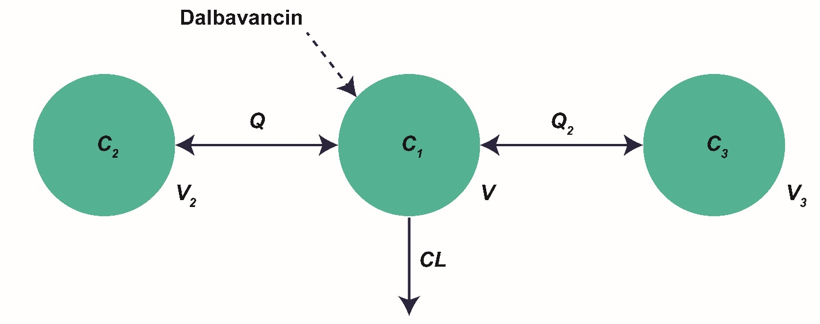

C, Concentrations inside the compartments; CL, clearance; Q, intercompartmental clearances; V, volumes of distribution. Final model parameters are presented in Supplemental Digital Content 2 (table).

