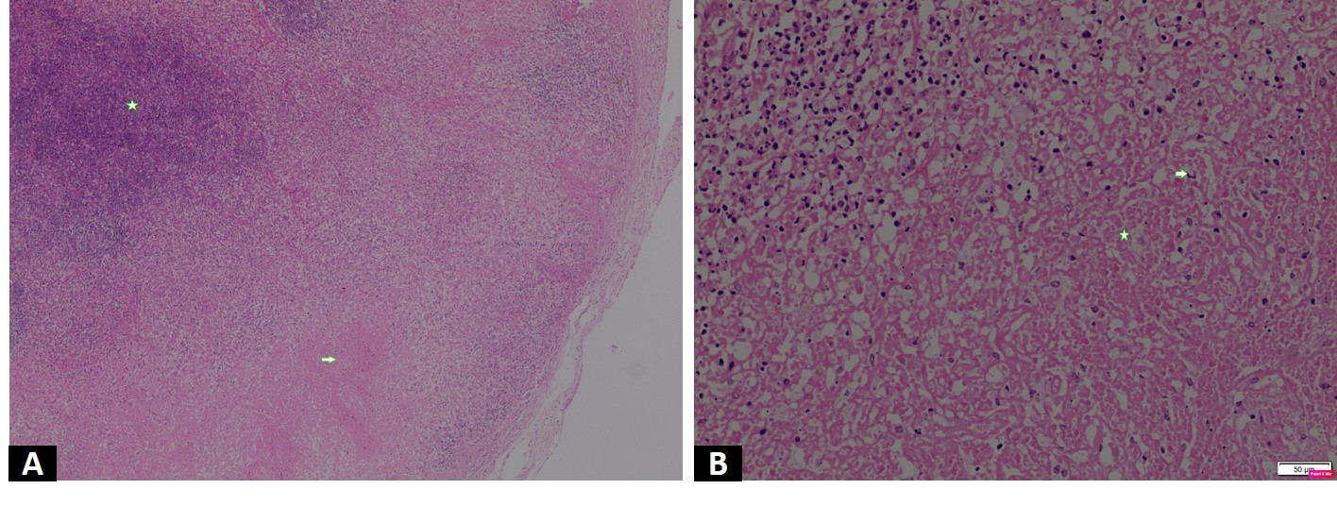
Legend
eFigure_1: A: Low power microphotograph depicting necrosis (arrow) bordered by inflammatory cells. Note the preserved lymphoid tissue (asterisk) in the upper left corner (X20; Hematoxylin and eosin). B: High power magnification shows necrotic tissue (asterisk) and degenerated inflammatory cells (arrow). A relative paucity of neutrophils is also evident. (X200; Hematoxylin and eosin)

