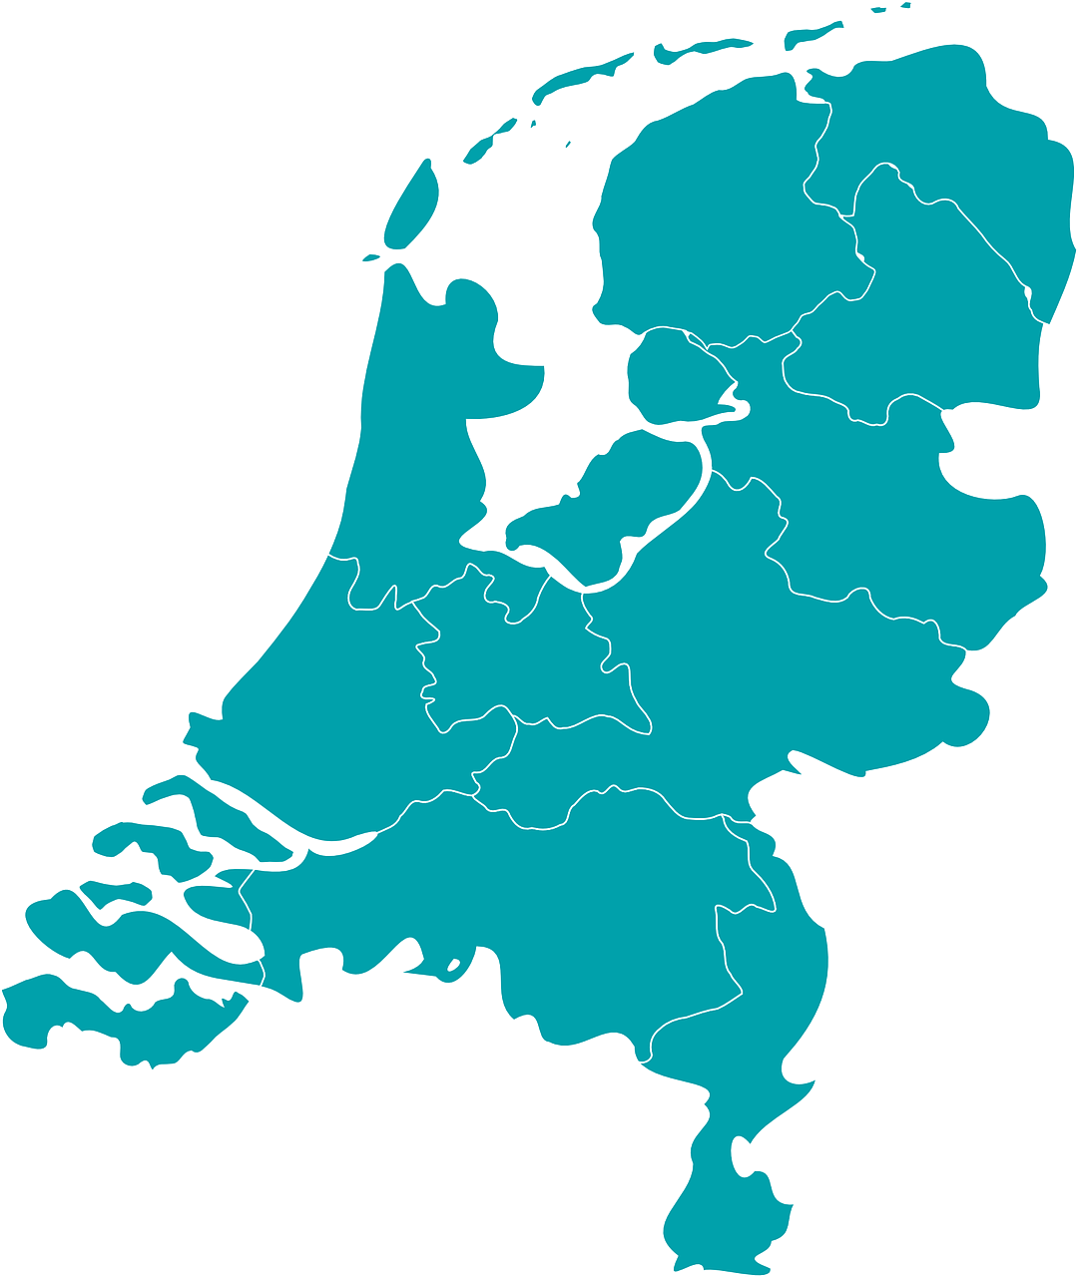
Supplemental digital content Figure 1: Geographical location of the participating hospitals, as well as total number of hospitals with a Pediatric Intensive Care Unit
Indicate location of participating regional hospitals
Indicate location of participating hospitals with Pediatric Intensive Care Unit
Indicate location of hospital with Pediatric Intensive Care Unit

