Supplemental Digital Content 1. A bladder ultrasonography demonstrating a thickened bladder wall associated with pseudo-polyp (blood clots) in an 18-year-old male adolescent patient with urinary schistosomiasis from Schistosoma hematobium.
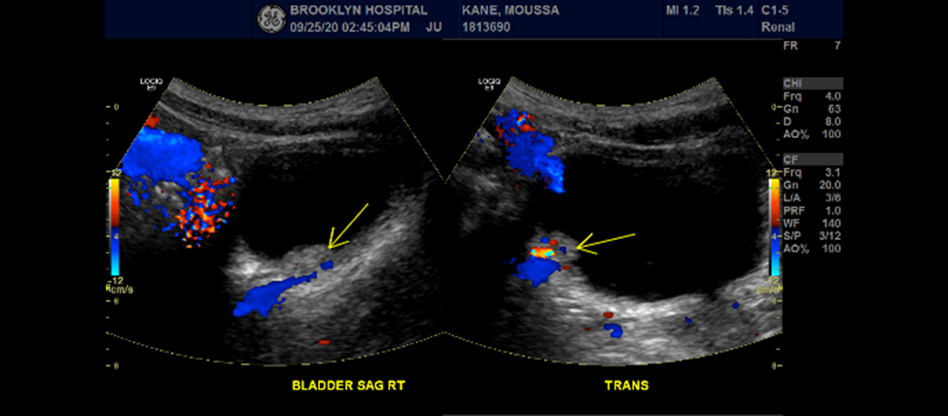
Bladder Ultrasonography with pseudo-polyp from lateral wall blood clot (yellow arrow annotation) due to urinary schistosomiasis.

