Supplemental Digital Content 2. Age stratification
ROC analysis stratified by age groups. The children were divided into two groups at age cut-offs 5 and 10 years. Age stratified ROC analysis for the diagnostic performance of the ratios for TB disease compared to exposed and TB infection was precluded by small sample size.
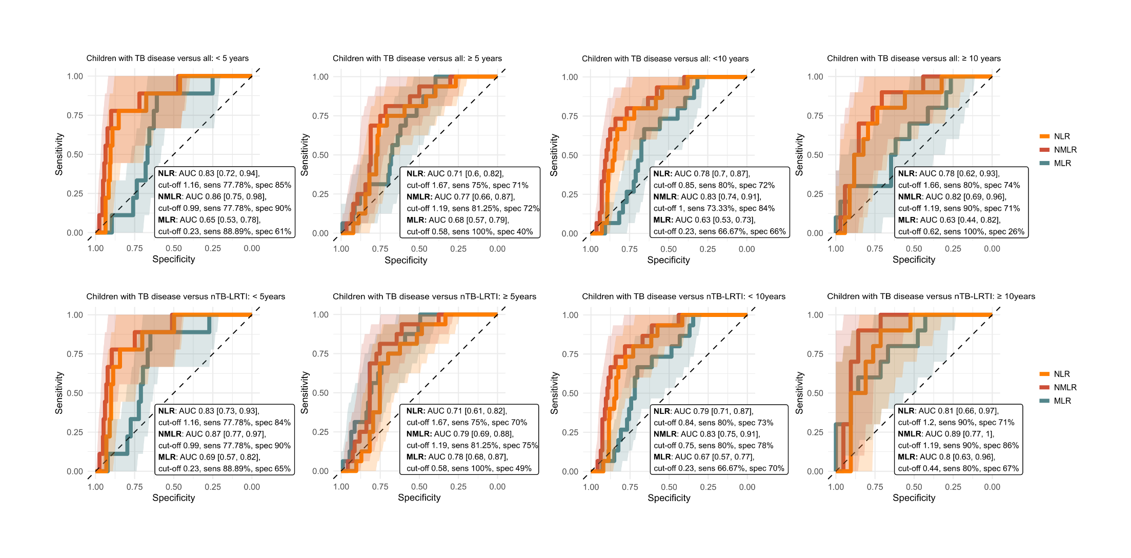

Supplemental Digital Content 3. ROC curve neutrophils
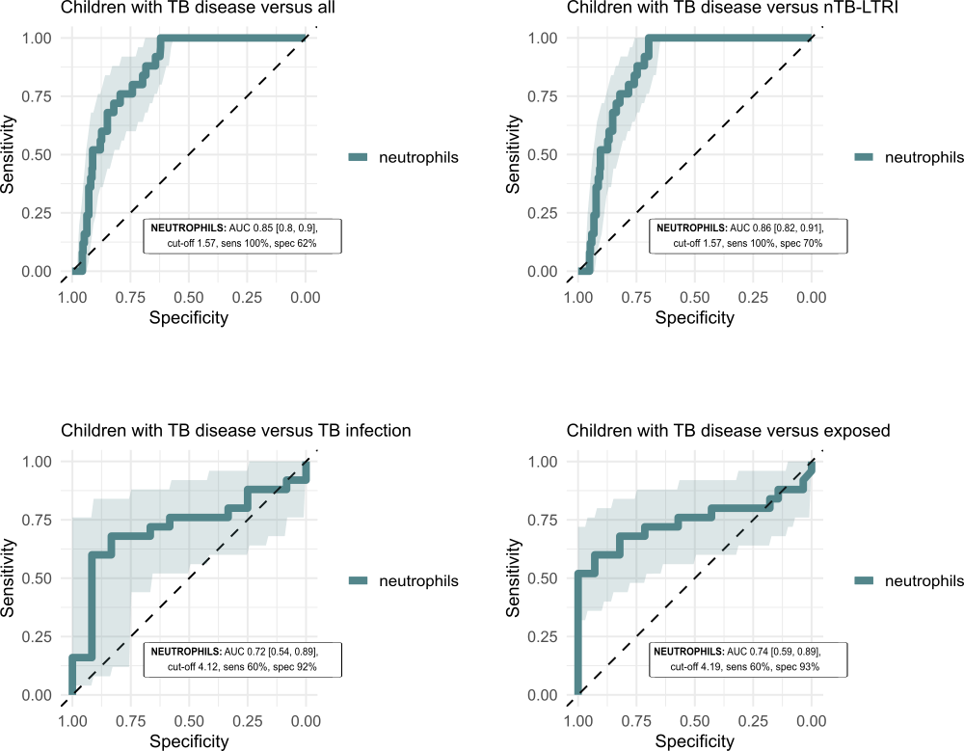
ROC analysis of the netrophils, revealed a high sensitivity in the comparison of children with TB disase to all other groups and children with nTB-LRTI, but low specificity, which limits the clinical usefulness as diagnostic biomarker.

