Supplemental Digital Content: Methods and Results of a Previously Unreported Study on Mechanical Testing of Cerclage Wire
Abraham Theodore Appleton, MD, * Cai Debenham, † Taylor N Sandoval, † Qikun Wang, † and Christopher J Hernandez, PhD †
* From the Department of Surgery, Division of Orthopedics, Guthrie Clinic, Sayre, PA 18840; and † Sibley School of Mechanical and Aerospace Engineering, Cornell University, Ithaca, NY 14853.

With intent to compare the performance of various wire tensioning devices, techniques, and cerclage configurations, cerclage wiring experiments were performed under the supervision of CJ Hernandez, PhD, in the Cornell University Department of Biomedical Engineering. Twelve different wire tensioning instruments were employed to produce either a symmetric twist (ST), a knot twist (KT), an eyelet bend-back (EBB), or a doubled symmetric twist (DST), and the generated compression was measured.
METHODS
A testing apparatus similar to that developed by Bostrom et al.¹ was used to assess wire tension. It consisted of two half-cylinders machined from half-inch, half-round aluminum stock, with a combined outer diameter of 2.5 cm. Two arch frames were constructed from half-inch thick rectangular aluminum tube stock, and each was connected to one of the half-cylinders. The apparatus was secured within a materials testing device (Minibionix, MTS, Eden Prairie, MN). Load was measure with a 1000 lb. load cell connected to the bottom support, beneath the lower fixture. The other fixture was connected to an upper stationary support, with a symmetric 9 mm gap between the flat surfaces of the two half cylinders (SDC Figure 1). Force data was collected at 105 Hz.
FIGURE 1. The split cylinder MTS testing apparatus we used is shown here.
________________________________________________________________________
Sixty-six trials were performed by the four participants, representing various levels of operator proficiency: three engineering students who received instruction but had no prior experience with wire tensioning, and one orthopedic surgeon. The techniques described in the manuscript associated with this SDC were used with eight devices and forty wires, to form symmetric twists (ST); with three devices and twelve wires, to form knot twists (KT); with one device and eight wires, for eyelet bend-backs (EBB); and with one device and six wires for doubled symmetric twists (DST).

RESULTS
Results were tabulated by device, wire diameter, method of locking tension, pattern, and final compression achieved (Table 1) and are represented in graphs (see Figs. 2 and 4).
TABLE 1. This table lists results of all sixty-six trials.
Device/Trial | Wire Diameter | Method | Pattern | Final Compression (Newtons)
WTC/1 | 1.0 mm | ST | WAO | 138
WTC/2 | 1.0 mm | ST | WAO | 168
WTC/3 | 1.0 mm | ST | WAO | 60
WTC/4 | 1.0 mm | ST | WAO | 57
PD/1 | 1.0 mm | ST | WAO | 159
PD/2 | 1.0 mm | ST | WAO | 29
PD/3 | 1.0 mm | ST | WAO | 71
PD/4 | 1.0 mm | ST | WAO | 111
RJ/1 | 1.0 mm | ST | WAO | 146
RJ/2 | 1.0 mm | ST | WAO | 123
RJ/3 | 1.0 mm | ST | WAO | 108
RJ/4 | 1.0 mm | ST | WAO | 79
DM/1 | 1.0 mm | ST | WAO | 84
DM/2 | 1.0 mm | ST | WAO | 47
DM/3 | 1.0 mm | ST | WAO | 187
DM/4 | 1.0 mm | ST | WAO | 147
LH/1 | 1.0 mm | ST | WAO | 109
LH/2 | 1.0 mm | ST | WAO | 120
LH/3 | 1.0 mm | ST | WAO | 174
LH/4 | 1.0 mm | ST | WAO | 24
RHPD/1 | 1.0 mm | ST | WAO | 127
RHPD/2 | 1.0 mm | ST | WAO | 151
RHPD/3 | 1.0 mm | ST | WAO | 171
RHPD/4 | 1.0 mm | ST | WAO | 74
IB/1 | 1.0 mm | ST | WAO | 83
IB/2 | 1.0 mm | ST | WAO | 120
IB/3 | 1.0 mm | ST | WAO | 217
IB/4 | 1.0 mm | ST | WAO | 119
IB/5 | 1.25 mm | ST | WAT | 309
IB/6 | 1.25 mm | ST | WAT | 336
BL/1 | 1.0 mm | ST | WAO | 156
BL/2 | 1.0 mm | ST | WAO | 133
BL/3 | 1.0 mm | ST | WAO | 172
BL/4 | 1.0 mm | ST | WAO | 177
BL/5 | 1.0 mm | ST | WAT | 421
BL/6 | 1.0 mm | ST | WAT | 319
BL/7 | 1.0 mm | ST | WAT | 339
BL/8 | 1.0 mm | ST | WAT | 421
BL/9 | 1.25 mm | ST | WAT | 504
BL/10 | 1.25 mm | ST | WAT | 497
ASIFHP/1 | 1.0 mm | EBB | WAO | 104
ASIFHP/2 | 1.0 mm | EBB | WAO | 88
ASIFHP/3 | 1.0 mm | EBB | WAO | 63
ASIFHP/4 | 1.0 mm | EBB | WAO | 133
ASIFHP/5 | 1.0 mm | EBB | WAT | 340
ASIFHP/6 | 1.0 mm | EBB | WAT | 148
ASIFHP/7 | 1.0 mm | EBB | WAT | 187
ASIFHP/8 | 1.0 mm | EBB | WAT | 285
RHPD/1 | 1.0 mm | DST | DST | 205
RHPD/2 | 1.0 mm | DST | DST | 184
RHPD/3 | 1.0 mm | DST | DST | 182
RHPD/4 | 1.0 mm | DST | DST | 157
RHPD/5 | 1.25 mm | DST | DST | 413
RHPD/6 | 1.25 mm | DST | DST | 378
FT/1 | 1.0 mm | KT | WAO | 67
FT/2 | 1.0 mm | KT | WAO | 136
FT/3 | 1.0 mm | KT | WAO | 67
FT/4 | 1.0 mm | KT | WAO | 16
KB/1 | 1.0 mm | KT | WAO | 75
KB/2 | 1.0 mm | KT | WAO | 82
KB/3 | 1.0 mm | KT | WAO | 32
KB/4 | 1.0 mm | KT | WAO | 78
HK/1 | 1.0 mm | KT | WAO | 61
HK/2 | 1.0 mm | KT | WAO | 38
HK/3 | 1.0 mm | KT | WAO | 91
HK/4 | 1.0 mm | KT | WAO | 117

Devices: WTC-wire twister clamps, PD-power drill, RJ-Richards Jet, DM-Dall-Miles, LH-Luque hook, RHPD-Rush hook in power drill, IB-Innomed-Browner, BL-Bowen-Loute, ASIFHP-ASIF handle with pegs, FT-Synthes Fastight, KB-Kirschner Bow, Harris knotter.
Method: ST symmetric twist, KT knot twist, EBB-eyelet bend-back, DST-doubled symmetric twist
Pattern: WAO-wrapped around once, WAT-wrapped around twice.

The effect of a finishing twist was evaluated, employing a two-step method for the symmetric twist. Eight devices {wire clamps; a power drill; a Richards Jet wire twister (Richards Medical, Memphis, TN); a Dall-Miles cable tensioner (Howmedica, Mahwah, NJ); a Luque hook wire twister (Zimmer, Warsaw, IN); the hook end of a 3/16” Rush Pin (Rush Pin LLC, Meridian, MS) on a power drill; a Browner wire tightener (Innomed, Savannah, GA); and a Bowen-Loute wire tightener (Bowen and Company, Inc., Rockville, MD)} symmetrically twisted thirty-two Synthes 1 mm stainless steel cerclage wires, and a clamp or locking pliers applied a finishing twist to each specimen. After initial twisting of each wire, a peak tension was generated which settled to a plateau with a mean of 30 N. After final tightening with a finishing twist, a second peak was generated and settled to a plateau with a mean of 120 N. Thus, the finishing twist tripled the mean tension, increasing it by an average of 90 ± 17 N (mean ± SD), without breaking any of the wires (SDC Figure 2).
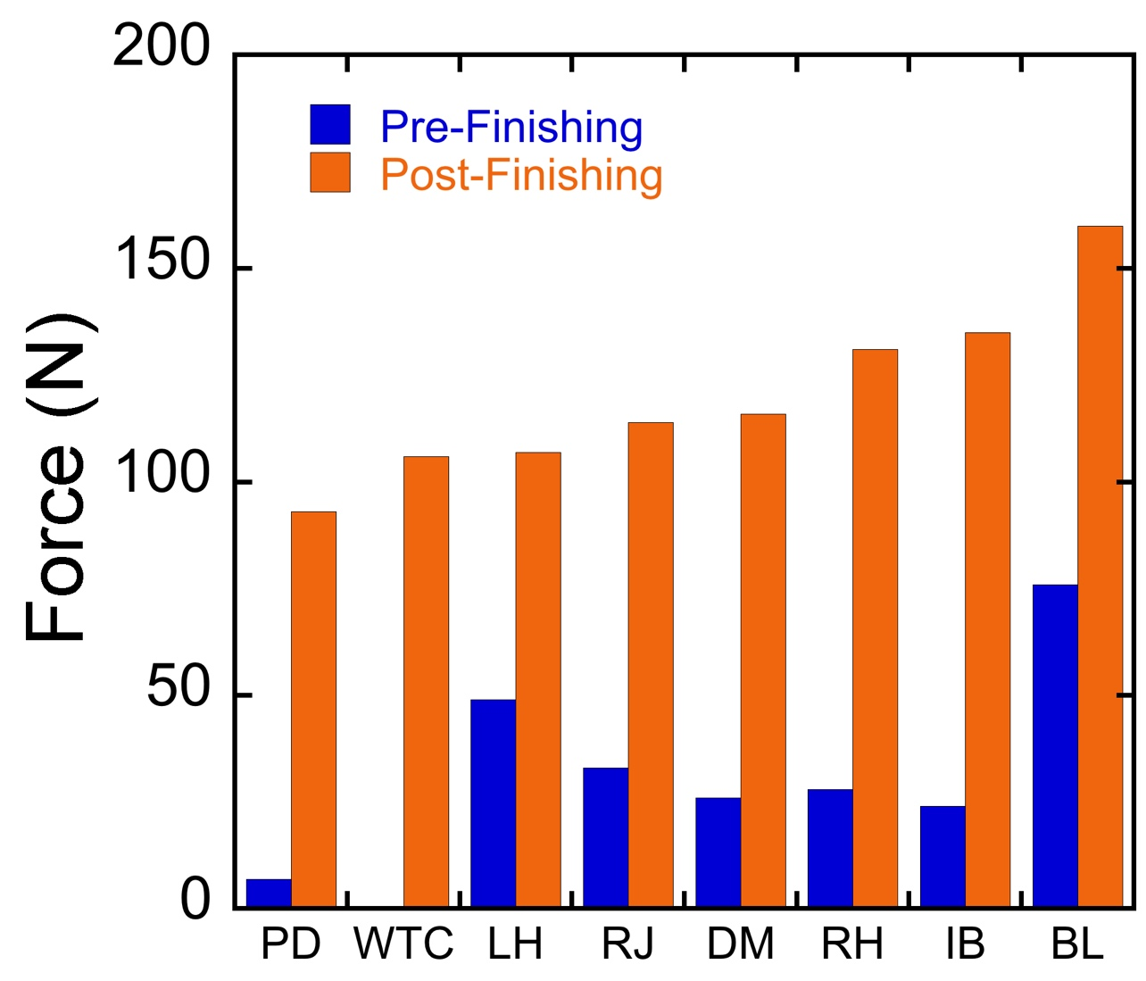
FIGURE 2. The tensile force generated by 1 mm wire is shown here, using the finishing twist technique after initial twisting with eight different devices.
PD = Power Drill, WTC = Wire Twister Clamps, LH = Luque Hook, RJ = Richards Jet, DM = Dall-Miles, RH = Rush Pin Hook on a power drill, IB = Innomed-Browner, and BL = Bowen-Loute.
1 N = 0.1 Kg = 0.22 lbs.
______________________________________________________________________________

Data for trials with symmetrically twisted 1 mm wire wrapped around once using the Bowen-Loute device followed by locking pliers for the finishing twist produced the highest average final compression with least variation amongst operators. It averaged 160 N final compression with 1 mm wire wrapped around once, 375 N when wrapped around twice (SDC Figure 3), and 500.5 N when used with 1.25 mm wires wrapped around twice. Each of the other seven devices generated at least one reading over 130 N for wrapped around once symmetric twist configurations, and no wire broke at the base of a twist. This suggests that with proper two-step technique, any of the devices tested is capable of safely generating clinically acceptable compression.
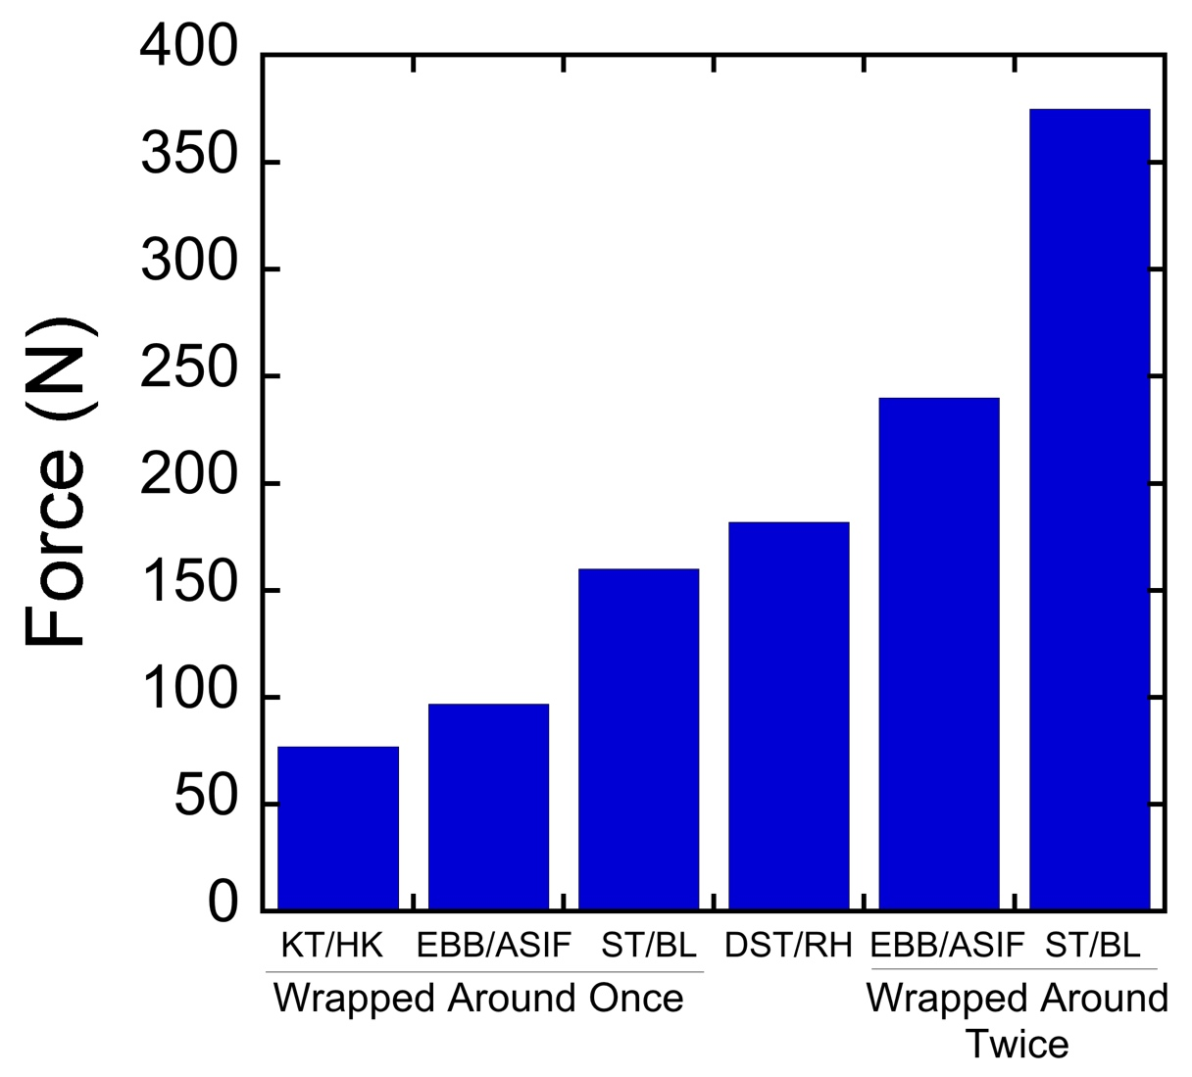FIGURE 4.
FIGURE 3. The forces generated by symmetric twist, knot twist, eyelet bend-back, and doubled symmetric twist tension-locking methods on 1 mm wire is shown in this bar graph.
WAO = wrapped around once, WAT = wrapped around twice, KT = knot twist, ST = symmetric twist, EBB = eyelet bend-back, DST = doubled symmetric twist.
HK = Harris knotter, ASIF = ASIF handle with peg, BL = Bowen-Loute, RH = Rush hook in a power drill.
______________________________________________________________________________

We observed a typical pattern of force over time, during the symmetric twisting of cerclage wire using the two-step procedure described above (SDC Figure 4).

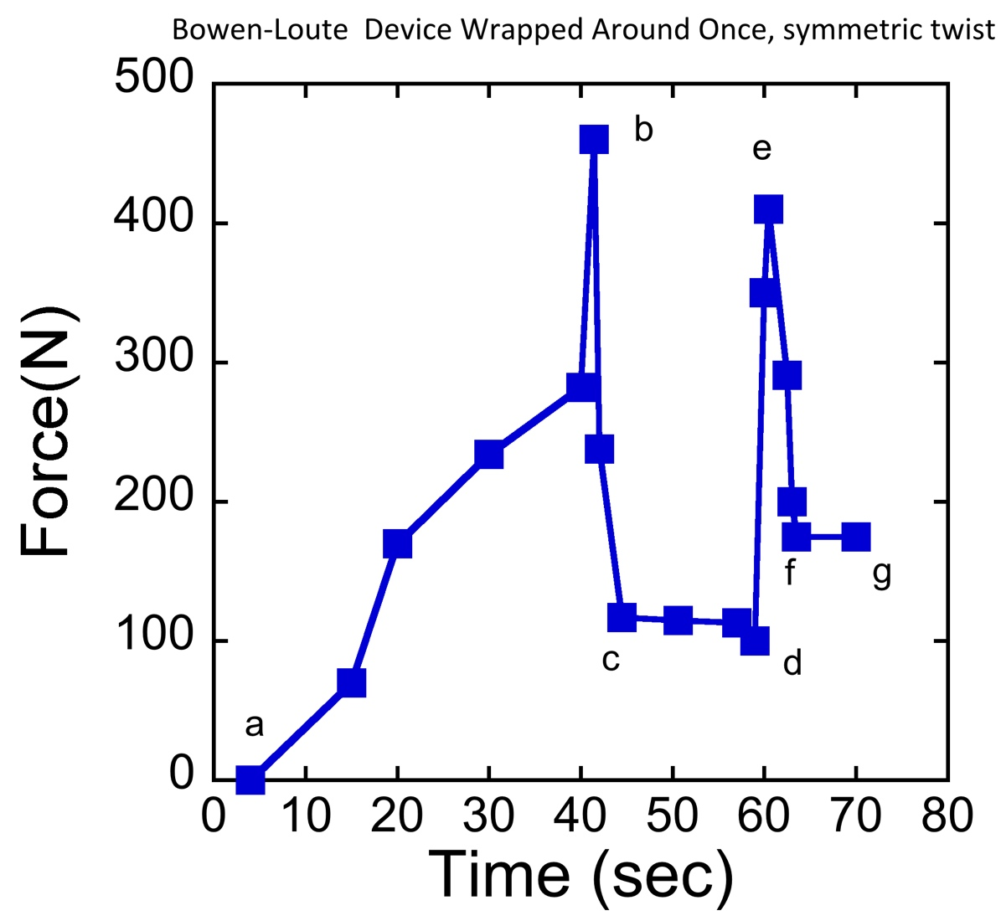

FIGURE 4. This graph represents forces recorded during a representative trial using the Bowen-Loute (BL) device followed by locking pliers, to produce a wrapped around once (WAO) symmetric twist (ST) configuration with 1mm wire.
a-b: The wire is captured, the tensioning wheel is tightened, and the instrument is rotated until the twist spontaneously breaks close to its midpoint (at 460 N).
b-d: Wire tension decreases and plateaus (at 112 N).
d-e: The base of the twist is gripped with locking pliers and a finishing twist is applied, resulting in a second peak (350 N).
e-g: The wire is released from the pliers; tension decreases and settles to the final plateau (175 N).

Knot twists were formed to tension and lock twelve 1 mm wires wrapped once around the split cylinder using three different crossed-wire tensioners (FasTight wire tensioner (Synthes, Paoli, PA); a Kirschner Bow (Zimmer, Warsaw, IN), and a Harris knotter (Downs Surgical, Sheffield, England) with a mean final retained compression of 75 N (SDC Figure 3).

A mean of 97 N final retained compression was generated using the ASIF handle with peg (Synthes, Paoli, PA) for eyelet bend-back tensioning and locking of four 1 mm eyelet wires wrapped once around the split cylinder. The mean retained compression increased to 240 N when four 1 mm eyelet wires were wrapped around the split cylinder twice and tensioned with the eyelet bend-back technique (SDC Figure 3).

Doubled symmetric twists were formed with folded 1mm wire loops wrapped around the split cylinder and twisted with a 3/16” Rush Pin hook on a power drill. Spinning was discontinued when a secondary twist developed, at which point there was negligible retained compression. A finishing twist was applied with locking pliers and retained compression settled to a mean of 182 N for four trials (SDC Figure 3). For reference, four trials of a Rush Pin hook on a power drill used with 1 mm wire loops to form non-doubled symmetric twists achieved a mean retained compression of 28 N; after finishing those twists with a wire clamp, the mean retained compression increased to 131 N. Two trials were carried out with 1.25 mm wire loops formed into doubled symmetric twists by the Rush Pin hook on a power drill and finished off with locking pliers. Prior to the finishing twist, a mean of 30 N compression registered; after the finishing twist, retained compression settled at 395N. Thus, the contribution of the finishing twist to the final retained compression was even more significant for the doubled symmetric twist than for the standard symmetric twist (•).
______________________________________________________________________________
REFERENCES
1 Bostrom MPG, Asnis SE, Ernberg JJ, et al. Fatigue Testing of Cerclage Stainless Steel Wire Fixation. J Orthop Trauma 1994;5:422-428

