A
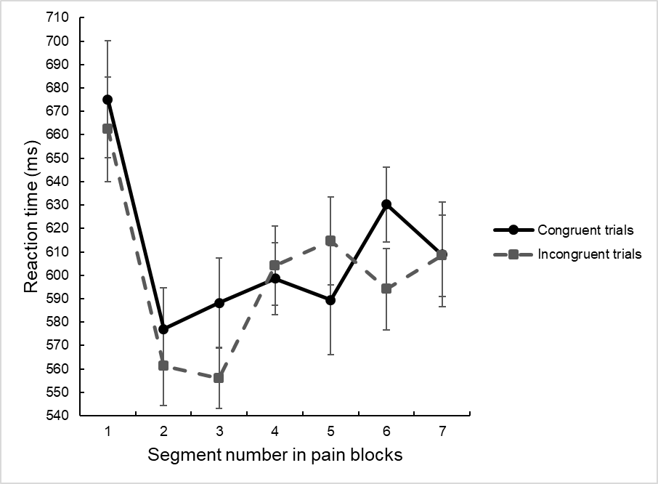
B
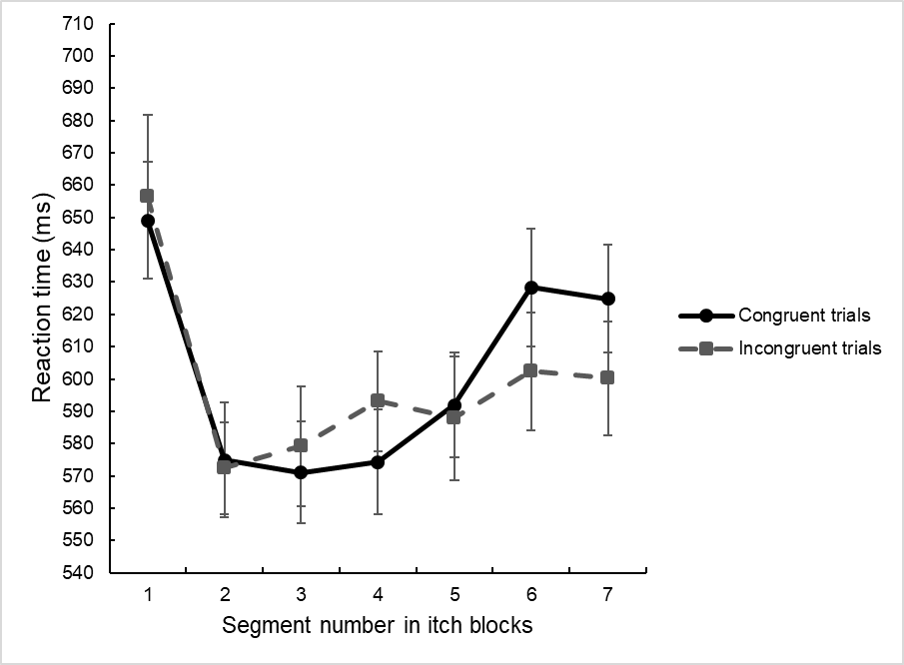
C
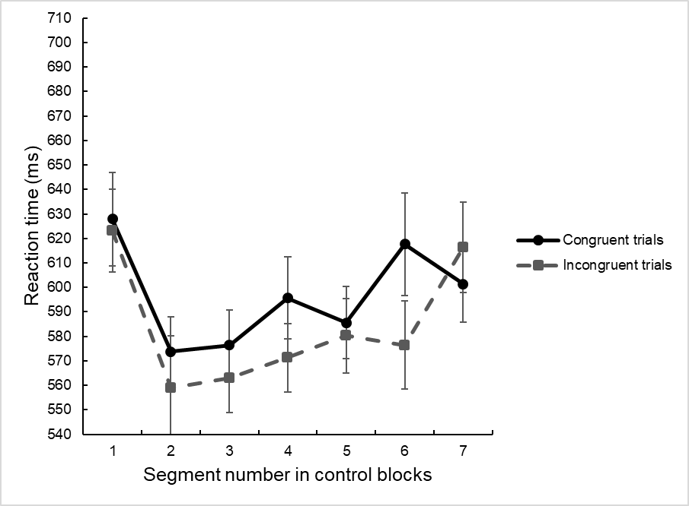

Fig S2. Mean reaction times for congruent and incongruent trials per time segment in the pain (A), itch (B) and control blocks (C) of the SAT (n = 43). Error bars represent ± 1 standard error of the mean.

