 | Table 1. Top 20 Fractures, Total Fractures, and Total Emergency Department Visits per Year
 | Year | Age (Avg) | Top 20 Fractures | All Factures | All Fracture Percentage | Total Visits
 | 2000 | 80.4 | 6382 | 8087 | 26 | 31135
 | 2001 | 80.3 | 6421 | 8290 | 25 | 32915
 | 2002 | 80.5 | 6804 | 8692 | 25 | 34542
 | 2003 | 80.1 | 7244 | 8824 | 26 | 34132
 | 2004 | 80.3 | 7708 | 9371 | 26 | 35822
 | 2005 | 80.3 | 7697 | 9402 | 25 | 37256
 | 2006 | 80.3 | 7969 | 9706 | 25 | 38204
 | 2007 | 80.4 | 8127 | 9964 | 25 | 39942
 | 2008 | 80.5 | 8448 | 10400 | 25 | 42225
 | 2009 | 80.2 | 8709 | 10757 | 24 | 45483
 | 2010 | 80.4 | 9002 | 11018 | 24 | 46747
 | 2011 | 80.2 | 8490 | 10608 | 23 | 45434
 | 2012 | 80.3 | 8546 | 10725 | 23 | 46196
 | 2013 | 80 | 8897 | 11243 | 24 | 47629
 | 2014 | 80 | 9297 | 11607 | 23 | 49398
 | 2015 | 80.1 | 9839 | 12259 | 24 | 51688
 | 2016 | 79.9 | 10248 | 12887 | 23 | 55157
 | 2017 | 79.8 | 10855 | 13882 | 23 | 60814
 | 2018 | 79.6 | 11100 | 14112 | 23 | 61799
 | 2019 | 79.6 | 11774 | 14823 | 23 | 64900
 | Total | 80.1 | 173557 | 216657 | 24 | 901418

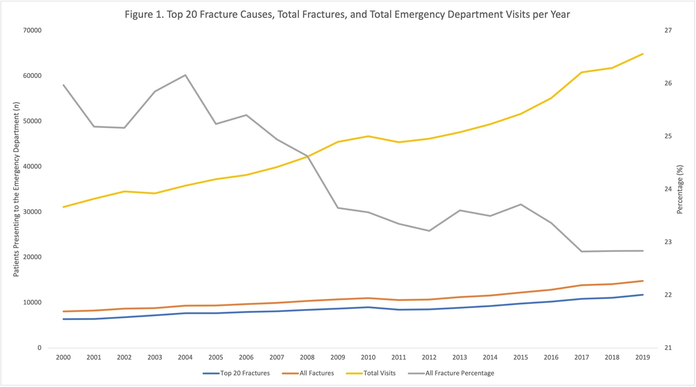

Table 2. Top 20 Causes for Fractures in the Elderly
Category | n (%)
Floors/Flooring Material | 58347 (33.6%)
Stairs/Steps | 29804 (17.2%)
Bed/Bed Frames | 19004 (10.9%)
Chair | 11055 (6.4%)
Rugs/Carpets | 7519 (4.3%)
Bathtub/Shower | 6163 (3.5%)
Walkers | 5050 (2.9%)
Toilets | 4662 (2.7%)
Ladders | 4235 (2.4%)
Footwear | 3783 (2.2%)
Wheelchairs | 3299 (1.9%)
Porches, balconies, open-side floors or floor openings | 3195 (1.8%)
Tables | 3162 (1.8%)
Door Associated | 2873 (1.7%)
Bicycles | 2869 (1.7%)
Wall | 2205 (1.3%)
Sofas and Couches | 1998 (1.2%)
Day Wear/Clothing | 1519 (0.9%)
Exercise | 1512 (0.9%)
Pet Supplies/Pet Associated | 1305 (0.8%)
Total | 173557

Table 3. Patient Demographics
Category | n (%)
Age (SD) | 80.1 (8.7)
Sex
Male | 45804 (26%)
Female | 127753 (74%)
Race
White | 105339 (61%)
Black/African American | 7371 (4%)
Hispanic | 2183 (1%)
Other | 1940 (1%)
Asian | 1157 (1%)
Not specified | 55567 (32%)

Table 4. Patient Injury and Hospital Specific Characteristics
Category | n (%)
Fracture Location
Lower Trunk (Pelvis, Femoral Neck, Lower Spine) | 64132 (37.0%)
Upper Trunk (Rib, Thoracic Spine, Sternum) | 20245 (11.7%)
Humerus | 12479 (7.2%)
Wrist | 10996 (6.3%)
Femur (Non-Femoral Neck) | 9993 (5.8%)
Shoulder (Clavicle/Scapula) | 7895 (4.5%)
Face (Mandible) | 7600 (4.4%)
Ankle | 7574 (4.4%)
Lower Leg (Fibula/Tibia) | 5948 (3.4%)
Lower Arm (Radius/Ulna) | 5605 (3.2%)
Foot | 3918 (2.3%)
Neck (Cervical Spine) | 3900 (2.2%)
Knee (Patella) | 3235 (1.9%)
Elbow | 2685 (1.5%)
Finger | 2423 (1.4%)
Toe | 2395 (1.4%)
Hand | 1571 (0.9%)
Head | 821 (0.5%)
Pubic Region | 142 (0.1%)
Disposition
Treated and Admitted/Hospitalized | 87610 (50.5%)
Treated and Released | 77786 (44.8%)
Treated and Transferred | 5835 (3.4%)
Held for Observation | 2103 (1.2%)
Other | 223 (0.1%)
Location
Home | 113158 (65.2%)
Public | 31162 (18.0%)
Street | 2243 (1.3%)
Sports | 1110 (0.6%)
Other | 175 (0.1%)
Unknown | 25709 (14.8%)

