The Impact of Obesity on Bone and Joint Health

- Obesity is one of the most common diseases that adversely affects bone and joint health. More than two-thirds of adults in the United States are overweight, and one in three adults have obesity.
- Obesity contributes to soft tissue damage and osteoarthritis—a progressive wear and tear disease of the joints.
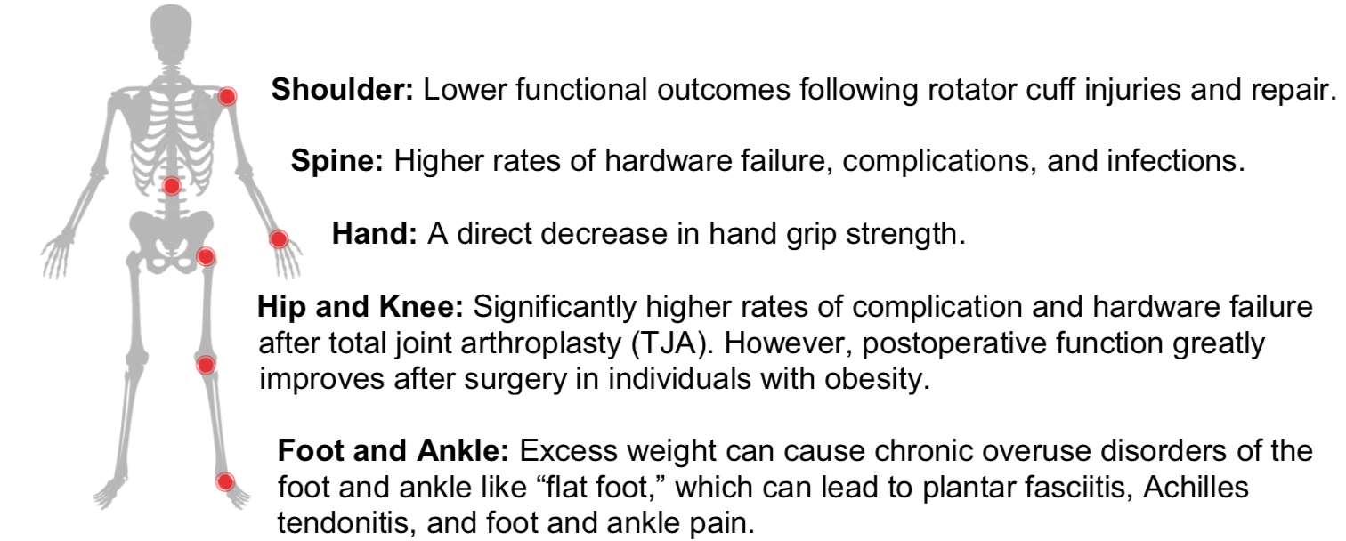
- Each pound of body weight places 4 to 6 pounds of pressure on each knee joint. Individuals with obesity are 20 times more likely to need a knee replacement than those who are not overweight.

- Obesity is also linked to diabetes, heart disease, liver disease, certain cancers, and psychiatric disorders

- Complications around the time of surgery that may result from obesity include poor wound healing, infections, blood clots, blood loss, increased total operative time and length of hospital stay.
*From the 2015 AAOS Position Statement on the Impact of Obesity on Bone and Joint Health; Modified 2021

Weight Reduction Strategies

- Caloric Reduction: A well-balanced, calorie restricted diet is the most prescribed method for weight loss. A calorie reduction of 500 to 1000 kcals from one’s typical daily consumption should be adequate for fat stores to be used and in meeting daily energy requirements. This typically totals 1200 to 1800 kcals of daily caloric intake.

- Nutritional Quality: Weight loss is promoted through diets rich in vegetables, fruits, lean proteins, and whole grains. When looking at a plate, half of the plate should be composed of non-starchy vegetables, and the other half should be split equally to include a lean protein and a whole grain food item.

- Exercise: Consistent exercise is a beneficial addition to a restricted calorie diet in terms of weight loss and overall health. Aquatic exercises, aerobics, and resistance training are all beneficial.

- Lifestyle: Lifestyle modifications along with community support is effective especially when inspiration and accountability are included. Search for local weight loss community support groups in your area.

- Weight Gain Prevention: The following habits have helped promote weight maintenance: eating breakfast daily, weighing in at least weekly, watching television less than 10 hours per week, and exercising an average of 1 hour daily.

- Pharmacotherapeutics: Pharmacotherapeutics (medications) have been shown to help patients lose more weight and keep it off longer. Medication must be taken long term like any other chronic disease to be effective.

- Bariatric Surgery: Bariatric surgery is a safe and effective method for weight loss in patients with obesity who have a BMI greater than 35 with a weight related comorbidity or a BMI greater than 40 who have failed conservative weight loss efforts.

Helpful Nutrition and Weight Loss Links:
- Healthy Eating Plate: https://www.hsph.harvard.edu/nutritionsource/healthy-eating-plate/

- The National Weight Control Registry: http://www.nwcr.ws/

Helpful Smartphone apps:
- MyFitnessPal: https://www.myfitnesspal.com/ Lose It!: https://www.loseit.com/

- RP Diet Coach App: https://www.rpdiet.app/
- *Many smartphone applications exist, and this list is not exhaustive. We have no endorsements with the companies listed above. Users should browse the many options at their own discretion. We make no guarantees. Individual results may vary.

Helpful Nutrition and Weight Loss Links:
- Healthy Eating Plate: https://www.hsph.harvard.edu/nutritionsource/healthy-eating-plate/
- The National Weight Control Registry: http://www.nwcr.ws/

Helpful Smartphone apps:
- MyFitnessPal: https://www.myfitnesspal.com/
- Lose It!: https://www.loseit.com/
- RP Diet Coach App: https://www.rpdiet.app/

*Many smartphone applications exist, and this list is not exhaustive. We have no endorsements with the companies listed above. Users should browse the many options at their own discretion. We make no guarantees. Individual results may vary.

