Supplemental digital content
For manuscript titled: “Transforming Clinical Practice Initiative Boosted Participation in Medicare Alternative Payment Models”

1: Practice selection and similarity between TCPi and matched comparison practices

1. Practice selection
Starting with 18,022 practices (defined by TIN or CCN) enrolled in TCPi through September 2018, after all exclusions, the analytic sample included 6,958 TCPi practices. The exclusions were as follows (Supplemental Digital Content Figure 1.1):
      - Practices for which new enrollment into Medicare APMs is not relevant, including
  - Practices without attributed Medicare beneficiaries, because participation in Medicare APMs is not relevant to such practices. Attribution methods are described on the following page.
  - Practices that were ineligible for participation in Medicare APMs, such as federally qualified health centers and rural health centers
  - Practices that were already participating in a Medicare APM before enrolling in TCPi
  - Practices that served primarily children, because we did not expect TCPi to substantially affect the care and the outcomes for Medicare beneficiaries
- Practices for which TCPi could not meaningfully influence APM participation:
- Practices in which all E&M visits were provided by clinicians not enrolled in TCPi. Since we defined practices at the TIN level, but enrollment in TCPi was at the clinician level, some TCPi practices did not have all of their clinicians participating. Although these practices had attributed beneficiaries, TCPi was less likely to be effective in such practices than in TCPi practices for which E&M visits were provided by TCPi clinicians.
- Practices that started participating in a Medicare APM within 45 days after enrollment. These practices started participating in a Medicare APM so soon after enrolling in TCPi that TCPi did not have a chance to influence these practices’ decision to participate in a Medicare APM.
- Practices for which we could not find credible comparisons:
  - Practices located in Puerto Rico. Because a large proportion of practices in Puerto Rico participated in TCPi, very few good comparisons were available.
  - Practices for which we could not determine practice composition or the location. Because we matched practices locally when possible, lack of a location prevented us from doing so. We removed practices not in MD-PPAS because we could not determine which clinicians work at each practice for the purpose of attribution, and we could not construct key practice characteristics used in matching.

Supplemental Digital Content Figure 1.1. Study exclusion criteria
18,022 practices (TINs or CCNs) enrolled in TCPi
Excluded 2,249 practices for which there were no credible comparisons
Nearly all were in Puerto Rico, where a very large proportion of practices participated in TCPi
Excluded 971 practices for which TCPi could not meaningfully influence APM participation
607 with all E&M visits provided by clinicians not enrolled in TCPi
321 that disenrolled from TCPi quickly (within 45 days)
43 that started participating in a Medicare APM within 45 days of TCPi enrollment

Excluded 7,844 practices for which new enrollment into Medicare APMs is not relevant
6,187 without attributed Medicare beneficiaries or that were not found
in Medicare practice data (MD-PPAS)
1,046 already participating in a Medicare APM before TCPi enrollment
494 FQHCs, RHCs, and other facilities ineligible for Medicare APMs
117 that served primarily children
6,958 TCPi practices remained in analytic sample

Source: Our analyses were based on TCPi model enrollment data; Master Data Management participation data from February 2020; Oncology Care Model and Bundled Payment for Care Improvement Advanced Model participation data from January 2020; and administrative claims data from October 1, 2011, through December 31, 2018.
APM = Alternative Payment Model; CCN = CMS Certification Number; E&M = evaluation and management; FQHC = federally qualified health center; MD-PPAS = Medicare Data on Provider Practice and Specialty; PTN = Practice Transformation Network; RHC = rural health clinic;
TIN = Tax Identification Number; TCPi = Transforming Clinical Practice Initiative.
Attribution of beneficiaries. For each quarter of the baseline and follow-up periods, we retrospectively attributed Medicare FFS beneficiaries to the practice that provided the plurality (largest share) of the beneficiary’s ambulatory E&M visits in the previous 24 months. The main goal of our approach was to attribute beneficiaries to the ambulatory care practices most likely to provide them with ongoing care after the time of attribution. Attributing beneficiaries in each quarter meant that they could be attributed to different practices from one quarter to the next.
We also sought to align our attribution methods with the goals of TCPi and the characteristics of TCPi practices by making it possible to attribute beneficiaries to any ambulatory care practice, regardless of specialty. We included specialists in the attribution because TCPi included a large number of specialty clinicians and because Medicare beneficiaries often receive a significant amount of care, including primary care services, from specialists (Pham et al. 2007). To ensure that the entire spectrum of specialists enrolled in TCPi was represented, we expanded the E&M codes used in the MSSP attribution method to include mental health and optometrist services, reflecting the inclusion of a significant number of mental health clinicians and optometrists in TCPi. Further, the E&M codes below also cover telehealth services (Supplemental Digital Content Table 1.1).
We used the plurality of visits because clinicians with the most contact with beneficiaries are more likely to provide ongoing care. To resolve ties, we attributed beneficiaries to the practice they visited most recently. We counted visits over a 24-month lookback period because it was long enough to reduce the chance that episodic care (such as care for an acute injury) would overshadow continuous care and because it was recent enough to attribute beneficiaries to the practices most likely to continue providing their care.

Supplemental Digital Content Table 1.1. Evaluation and management codes used to attribute Medicare FFS beneficiaries to TCPi practices and matched comparison practices

CPT/HCPCS code | Description
Practices with claims in the carrier file (not FQHCs or RHCs)
99201–99205 | New patient, office, or other outpatient visit
99211–99215 | Established patient, office, or other outpatient visit
99304–99306 | New patient, nursing facility care
99307–99310 | Established patient, nursing facility care
99315–99316 | Established patient, discharge day management service
99318 | Established patient, other nursing facility service
99324–99328 | New patient, domiciliary or rest home visit
99334–99337 | Established patient, domiciliary or rest home visit
99339–99340 | Established patient, physician supervision of patient (patient not present) in home, domiciliary or rest home
99341–99345 | New patient, home visit
99347–99350 | Established patient, home visit
99406–99407 | Counseling risk factor reduction and behavior change intervention, individual counselingª
99490 | Care management services
99487, 99489 | Complex care management servicesª
99491 | Chronic care management services
99483 | Cognitive assessment and care plan services
99484 | General behavioral health integration care management services
99492-99494 | Psychiatric collaborative care management
99495–99496 | Transitional care management services
99497–99498 | Advance care planningª
99499 | Other (unlisted preventive medicine; unlisted evaluation and management service)ª
G0181–G0182 | Care plan oversight services, patient presentª
G0402 | Initial Medicare visit
G0438 | Annual wellness visit, initial
G0439 | Annual wellness visit, subsequent
G0463 | Hospital outpatient clinic visit (ETA hospitals only)ª
90791 | Psychiatric diagnostic evaluation (no medical services) completed by a non-physician
90792 | Psychiatric diagnostic evaluation (with medical services) completed by a physician
90832, 90834, 90837, 90865 | Psychotherapyª
90839 | Psychotherapy for crisisª
90845, 90847, 90846, 90849, 90853, 90880 | Other psychotherapyª
92002, 92004, 92012, 92014 | Ophthalmology exam and evaluationª
90804,90816, 90806, 90818, 90808, 90821 | Retired psychotherapy codes (outpatient and inpatient)ª
FQHC and RHC practices with claims in the outpatient file
0521 | Clinic visit by beneficiary to the FQHC
0522 | Home visit by FQHC/RHC practitioner
0524 | Visit by RHC/FQHC practitioner to a member in a covered Part A stay at a SNF
0525, except if provided in a SNF | Visit by FQHC practitioner to a member in a NF or ICF or other residential facility
0527 | FQHC Visiting Nurse Services to a member's home when in a home health shortage areaª
0900 | Behavioral health treatments and services
G0402 | Initial Preventive Physical Examination or Welcome to Medicare Visit
G0438 | Annual wellness visit, initial
G0439 | Annual wellness visit, subsequent
ª Code not included in attribution methodology for MSSP.

2. Comparison group selection
Identifying potential comparison practices. To improve the likelihood of finding good matches, we started with the potential comparison group of all nonparticipating practices in the country that bill Medicare. We retrospectively attributed Medicare FFS beneficiaries to every potential comparison practice by using the same methods we used for TCPi practices. We then constructed average baseline outcomes—for example, total Medicare Part A and B expenditures, hospitalizations, and stand-alone ED visits (that is, ED visits that did not result in an inpatient admission)—along with baseline beneficiary demographics and chronic condition information to ensure that matched comparison practices had similar attributed patient populations at baseline. We applied the same practice exclusion criteria we used for TCPi practices.
Selecting matched comparisons. We used propensity score methods (Stuart, 2010) to select matched comparison practices similar to TCPi practices on a wide-ranging set of practice-, beneficiary-, and area-level characteristics. We ensured similarity between the two groups, both overall and within predefined subgroups.
To account for unobservable health care market characteristics, we matched practices locally (within a HRR) when possible. HRRs represent regional health care markets for tertiary medical care that generally requires the services of a major referral center for adults enrolled in Medicare (Dartmouth Atlas Project, 2020). When within-HRR matching was not possible, we matched within the state and otherwise, elsewhere.
We matched TCPi and comparison practices based on a given TCPi practice’s quarter of enrollment, to ensure that the characteristics used in matching were drawn from the same baseline period.
Matching variables: exact match subgroups. We matched a comparison practice exactly to a TCPi practice on key characteristics for which we performed subgroup analyses, listed in bullets below. For example, we always matched a primary care practice to another primary care practice. In addition to matching exactly on subgroups, we also ensured that TCPi and matched comparison practices were similar on other characteristics within these subgroups—for example, that TCPi primary care practices were similar to matched comparison primary care practices in terms of practice size and ownership.
- Practice specialty type. Because program impacts might differ based on the practice specialty composition, because of differences in how practices function as well as in the beneficiaries served, we matched within these three subgroups:
  - Primary care practices, in which more than 90 percent of clinicians have a primary care specialty (general practice and family, internal, and geriatric medicine, as used for determining primary care for assigning beneficiaries under MSSP [CMS, 2020]).
  - Specialty care practices, in which less than 10 percent of clinicians have a primary care specialty
  - Mixed primary and specialty care practices, in which 10 to 90 percent of clinicians have a primary care specialty
We ensured that matched comparison practices (and their subgroups) had a similar proportion of the most common specialties as TCPi practices overall.
- Rural practices. Practices in rural areas have a limited supply of health care providers and serve some of the most marginalized populations in health care, we matched rural practices to other rural practices. To do so, we used the U.S. Department of Agriculture’s rural–urban continuum codes indicating nonmetropolitan areas not adjacent to metropolitan areas or with an urban population of fewer than 20,000 (codes 5, 6, 7, 8, and 9) from the Area Health Resource File. Similarly, we matched exactly within practices located in an urban county.
- Small practices (those with fewer than four clinicians). TCPi emphasized recruiting small practices because they are more likely to face significant barriers to practice transformation and APM enrollment given their fewer resources and smaller infrastructure than larger practices (see, for example, Gerteis and Kantz, 2015). Similarly, we matched separately within larger practices (those with four or more clinicians).
In addition to exact matching within subgroups, we also matched exactly on whether a practice had fewer than 40 attributed Medicare beneficiaries per quarter during baseline, because such practices might provide fewer E&M visits, thus providing different types of care than practices with many beneficiaries.
Other key matching variables. To ensure that matched comparison practices served similar types of beneficiaries, we matched on many aggregated beneficiary characteristics including:
- Average outcomes in each baseline quarter (or year) for nine claims-based beneficiary outcomes, aggregated to the practice level, to establish similarity in baseline trends for TCPi and matched comparison practices. These outcomes included Medicare Part A and B expenditures, emergency department (ED) visits, inpatient admissions, admissions for heart failure, admissions for asthma or chronic obstructive pulmonary disease, 30-day unplanned readmissions, receipt of comprehensive diabetes care, appropriate imaging for low back pain, and potential opioid overuse. In Supplemental Digital Content Figure 1.2, we show the standardized differences by quarter for the three key beneficiary outcomes: Medicare expenditures, inpatient admissions, and ED visits.
- Average number of chronic conditions and average Hierarchical Condition Category score, to ensure that practices were serving beneficiaries with a similar disease burden
- Average age, gender, dual status, and original reason for Medicare entitlement
Key practice characteristics that could influence readiness for transformation and APMs on which we matched included
- Participation in other transformation initiatives such as patient centered medical homes and practice size (as measured by the number of clinicians who serve Medicare beneficiaries).
- Practice location characteristics such as county poverty rate and characteristics of the healthcare market in which practices operate, such as hospital bed availability and primary care and specialist availability.
We matched on several other variables (Supplemental Digital Content Tables 1.2. and 1.3).
One-to-one optimal matching algorithm. We matched each TCPi practice to a single matched comparison practice because one-to-one matching produces a better matched comparison group than does matching to multiple comparisons (Smith and Todd, 2005). Further, we matched each comparison practice to only one TCPi practice because we had a sufficient number of good potential comparison practices. To select comparison practices, we used GroupMatch, a technique that addresses rolling enrollment by choosing the best potential comparison practice to match each intervention practice and optimizing the balance simultaneously across all enrollment cohorts (Pimentel et al., 2020). GroupMatch is an extension of optimal matching (Rosenbaum, 1989) which, compared to traditional matching techniques, tends to produce comparison groups that more closely resemble the intervention group on observed covariates.

3. Similarity of TCPi practices and matched comparison group practices
When determining whether matched comparison practices were sufficiently similar to TCPi practices, we relied on several diagnostics, including balance tables and density plots.
Supplemental Digital Content Tables 1.2 and 1.3 show that TCPi practices were similar to comparison practices on all measured practice, area, and aggregated beneficiary characteristics. Supplemental Digital Content Table 1.3 shows average beneficiary claims-based outcomes one quarter before a practice enrolled in TCPi. We also found similarity between the trends in beneficiary claims-based outcomes over time for TCPi and comparison practices (Supplemental Digital Content Figure 1.2).
In addition, the distributions of the estimated propensity scores and key matching variables overlapped greatly for TCPi and matched comparison practices. Supplemental Digital Content Figure 1.3 shows the distribution of estimated propensity scores for TCPi and matched comparison practices, illustrating that it was very similar for the two groups. The estimated propensity score was low on average because we used all practices in the country as potential comparisons. We truncated the x-axis because of a very long tail. Further, using GroupMatch meant that we ran the matching regression using the sample of TCPi practices and all nonparticipating practices in the country, duplicated so that each nonparticipating practice serves as a potential comparison for each enrollment cohort of TCPi practices. This resulted in low estimated propensity scores. However, this is not a concern because estimated propensity scores were able to differentiate between “good” and “bad” comparisons, enabling us to obtain exceptional balance on all characteristics and their distributions. See Section 2 of Supplemental Digital Content 1 for more detail about comparison group construction.
Supplemental Digital Content Figure 1.4 shows the distribution of practice sizes for the two groups, illustrating that they were similar on this important characteristic. The densities of other key matching variables mirrored these two figures and are available upon request.
Supplemental Digital Content Table 1.2. Baseline practice characteristics for TCPi and comparison practices

Characteristic | Mean for TCPi practices  (n = 6,958) | Mean for comparison  practices  (n = 6,958) | Difference between TCPi and comparison practices | Absolute standardized difference (standard deviations)
Exact-match characteristicsª
Practice specialty type in year before enrollment^{b,c} (%)
Primary care | 25.3 | 25.3 | 0.0 | 0.00
Specialty care | 62.0 | 62.0 | 0.0 | 0.00
Mixed primary/specialty care | 12.7 | 12.7 | 0.0 | 0.00
Small practice: Three or fewer clinicians billing Medicare in year before enrollment (%) | 69.1 | 69.1 | 0.0 | 0.00
Located in a rural county (%, 2013) | 13.2 | 13.2 | 0.0 | 0.00
Fewer than 40 attributed beneficiaries per quarter during two-year baseline (%) | 44.3 | 44.3 | 0.0 | 0.00
Practice size and ownership
Average number of attributed beneficiaries per quarter during two-year baseline | 364.4 | 320.9 | 43.5 | 0.02
Number of clinicians billing Medicare^{d} | 14.5 | 13.3 | 1.2 | 0.01
Solo practice (%) | 45.5 | 49.8 | -4.3 | 0.09
2–4 clinicians (%) | 28.5 | 25.4 | 3.2 | 0.07
5–24 clinicians (%) | 18.5 | 18.0 | 0.5 | 0.01
25–49 clinicians (%) | 3.4 | 3.4 | 0.0 | 0.00
50 or more clinicians (%) | 4.1 | 3.4 | 0.6 | 0.03
Ownership type^{e,f} (%, 2017)
Hospital-owned | 27.5 | 23.8 | 3.7 | 0.09
Physician-owned | 72.5 | 76.2 | -3.7 | 0.09
Practice specialty and clinician type
Average proportion of clinicians at practice within broad disciplinary categories^{g} (%)
Non-physician | 35.4 | 37.6 | -2.2 | 0.05
Medical specialty | 12.0 | 10.2 | 1.8 | 0.06
Surgical specialty | 11.0 | 11.2 | -0.1 | 0.01
Hospital-based specialty | 3.3 | 3.9 | -0.7 | 0.04
Average proportion of clinicians at practice with select specialties (%)
Primary care^{c} | 30.4 | 30.2 | 0.2 | 0.01
Optometry | 27.8 | 28.3 | -0.5 | 0.01
Obstetrics and gynecology | 4.0 | 2.9 | 1.2 | 0.06
Licensed clinical social work or clinical psychology | 3.7 | 4.2 | -0.5 | 0.03
Ophthalmology | 2.6 | 2.9 | -0.3 | 0.02
Podiatry | 2.1 | 2.7 | -0.6 | 0.04
General surgery | 2.2 | 1.8 | 0.4 | 0.03
Orthopedic surgery | 2.0 | 2.2 | -0.2 | 0.01
Cardiology | 2.0 | 1.7 | 0.3 | 0.03
Gastroenterology | 1.8 | 1.3 | 0.6 | 0.04
Psychiatry | 1.7 | 1.9 | -0.2 | 0.02
Neurology | 1.3 | 1.1 | 0.2 | 0.02
Dermatology | 1.2 | 1.8 | -0.6 | 0.06
Pulmonary disease | 1.1 | 0.8 | 0.3 | 0.03
Nephrology | 1.1 | 0.6 | 0.5 | 0.05
Urology | 1.0 | 1.0 | 0.0 | 0.00
Average proportion of all clinicians who were advanced practice nurses or physician assistants (%) | 10.3 | 9.5 | 0.7 | 0.03
Participation in other programs and Medicaid acceptance
Proportion of clinicians participating in medical home programs in year before TCPi enrollment^{h} (%)
All | 3.2 | 2.5 | 0.7 | 0.04
Some but not all | 4.0 | 3.1 | 0.9 | 0.05
None | 92.7 | 94.4 | -1.6 | 0.06
At least one clinician received meaningful use payment for EHRs before TCPi enrollment (%) | 59.5 | 53.4 | 6.1 | 0.12
At least one clinician participated in PQRS before TCPi enrollment (%) | 99.6 | 99.6 | 0.0 | 0.00
Accepts Medicaid^{e,f} (%, 2017) | 68.9 | 64.8 | 4.2 | 0.10
County characteristics
Proportion of county below poverty line (%, 2015) | 14.9 | 14.9 | 0.0 | 0.00
Medicare Advantage penetration (%, year before TCPi enrollment) | 30.1 | 29.7 | 0.5 | 0.03
Health professional shortage area (%, year before TCPi enrollment)
Primary care, whole county | 3.8 | 3.3 | 0.6 | 0.03
Primary care, partial county | 87.5 | 88.0 | -0.5 | 0.02
Mental health, whole county | 26.7 | 26.5 | 0.2 | 0.01
Mental health, partial county | 65.1 | 65.8 | -0.6 | 0.01
Number of hospital beds per 10,000 residents (2015) | 31.6 | 31.2 | 0.4 | 0.02
Number of primary care physicians per 10,000 residents (2015) | 7.8 | 7.9 | -0.1 | 0.02
Number of specialists per 10,000 residents (2015) | 15.6 | 15.9 | -0.2 | 0.03
Population in county age 25 and older with less than a high school diploma (%, 2015) | 13.1 | 13.1 | 0.0 | 0.01
Population age 25 and older with at least a four-year college degree (%, 2015) | 30.0 | 30.4 | -0.4 | 0.04
Population in county age 5 and older that do not speak English as primary language (%, 2010) | 4.7 | 4.6 | 0.1 | 0.01
Source: Analyses were based on enrollment data from PTNs and SAN 2.0s, MD-PPAS, and the NPPES. We obtained meaningful use and PQRS participation data from CMS. Source of Medicaid acceptance and ownership was SK&A for practices identified by a TIN (https://www.skainfo.com/databases/physician-data). County-level market characteristics were from the AHRF. Medical home participation was from NCQA PCMH Recognition Program data (https://www.ncqa.org/programs/health-care-providers-practices/patient-centered-medical-home-pcmh/), TJC, AAAHC, and state-specific certification programs (covering Arkansas, Iowa, Michigan, Minnesota, Missouri, Montana, Oklahoma, Oregon, South Carolina, and West Virginia). Physician specialty information came from MD-PPAS.
Note: Characteristics were measured as of the year before a practice enrolled, unless otherwise noted.
a We required that each TCPi practice be matched to a comparison practice that shared each exact-match characteristic. For example, a TCPi practice with a primary care specialty type was always matched to another primary care practice.
b Primary care practices had more than 90 percent of primary care clinicians; specialty care practices had fewer than 10 percent. Mixed primary/specialty practices had either (1) between 10 percent and 90 percent primary care clinicians or (2) were solely comprised of clinicians whose specialty was unknown.
c We used the CMS definition of primary care, which includes general practice, family medicine, internal medicine, and geriatric medicine specialties. Centers for Medicare & Medicaid Services. “Two-Step Attribution for Measures Included in the Value Modifier.” August 2015. Available at https://www.cms.gov/Medicare/Medicare-Fee-for-Service-Payment/PhysicianFeedbackProgram/Downloads/Attribution-Fact-Sheet.pdf. Accessed April 15, 2020.
d Clinicians in each TIN were those who billed the plurality of their Medicare Part B charges to that TIN in the year before the practice’s enrollment.
e In SK&A data, these characteristics were defined for each practice location. Because practice locations might share a TIN, we assigned to each TIN the proportion of practice locations within a TIN that had the characteristic, weighted by the number of clinicians at each location.
f Data for this characteristic were available for only about a third of all practices. Over three-quarters of primary care practices had these data compared to less than two-thirds of mixed primary/specialty care practices, and less than 10 percent of specialty care practices.
g These broad disciplinary categories were defined by MD-PPAS based on combinations of CMS specialty codes.
h Most practices recognized as medical homes gained this status through NCQA’s PCMH Recognition Program.
AAAHC = Accreditation Association for Ambulatory Health Care; AHRF = Area Health Resource File; CMS = Centers for Medicare & Medicaid Services; MD-PPAS = Medicare Data on Provider Practice and Specialty; NCQA = National Committee for Quality Assurance; NPPES = National Plan and Provider Enumeration System; PCMH = patient-centered medical home; PQRS = Physician Quality Reporting System; PTN = Practice Transformation Network; SAN = Support and Alignment Network; TIN = Tax Identification Number; TJC = The Joint Commission.

Supplemental Digital Content Table 1.3. Baseline beneficiary outcomes and characteristics for TCPi and comparison practices

Characteristic | Mean for TCPi practices  (n = 53,817 practice-quarter observations) | Mean for comparison  practices  (n = 53,766  practice-quarter observations) | Difference between TCPi and comparison practices | Absolute standardized difference (standard deviations)
Beneficiary outcomes during the quarter before enrolling in TCPi
Medicare Part A and B expenditures ($/beneficiary) | 2,803 | 2,746 | 57 | 0.05
Outpatient ED visits (#/1,000 beneficiaries) | 133.4 | 133.8 | -0.5 | 0.01
All-cause inpatient admissions (#/1,000 beneficiaries) | 76.1 | 75.5 | 0.6 | 0.02
Beneficiary characteristics
Age | 71.7 | 71.7 | -0.1 | 0.01
Female (%) | 56.5 | 56.8 | -0.3 | 0.04
Race/ethnicity (%)
White | 83.6 | 84.0 | -0.3 | 0.02
Black | 10.5 | 9.7 | 0.7 | 0.05
Asian | 2.2 | 2.3 | -0.1 | 0.01
Hispanic ethnicity | 1.7 | 1.5 | 0.2 | 0.04
North American Native or other | 2.0 | 2.5 | -0.5 | 0.16
Dual eligibility status (%)
Not dually eligible | 80.0 | 80.1 | -0.1 | 0.01
Fully eligible | 15.1 | 15.0 | 0.0 | 0.00
Partially eligible | 4.9 | 4.8 | 0.1 | 0.02
Original reason for entitlement is disability and/or ESRD (%) | 25.1 | 25.1 | 0.0 | 0.00
Number of chronic conditionsª | 4.4 | 4.5 | 0.0 | 0.02
Select chronic conditions (%)
Hypertension | 61.2 | 61.7 | -0.5 | 0.04
Hyperlipidemia | 50.1 | 50.3 | -0.2 | 0.01
Rheumatoid arthritis or osteoarthritis | 35.4 | 36.4 | -1.0 | 0.09
Diabetes | 31.4 | 31.5 | -0.2 | 0.02
Ischemic heart disease | 30.6 | 30.7 | -0.1 | 0.01
Anemia | 22.5 | 22.8 | -0.3 | 0.03
Chronic kidney disease | 21.1 | 20.7 | 0.4 | 0.04
Cataract | 20.6 | 20.7 | -0.1 | 0.01
Depression | 18.4 | 18.1 | 0.3 | 0.03
Anxiety disorders | 16.4 | 16.3 | 0.1 | 0.01
Acquired hypothyroidism | 15.9 | 16.3 | -0.4 | 0.08
Congestive heart failure | 15.2 | 14.9 | 0.2 | 0.03
Obesity | 14.6 | 14.7 | -0.1 | 0.01
COPD | 11.7 | 11.8 | -0.1 | 0.02
Alzheimer’s disease and related disorders or senile dementia | 11.4 | 11.2 | 0.2 | 0.02
Glaucoma | 10.5 | 10.5 | 0.0 | 0.01
Any cancer^{b} | 9.4 | 9.2 | 0.2 | 0.04
Source: Analyses were based on enrollment data from PTNs and SAN 2.0s, MD-PPAS, and the NPPES. We attributed beneficiaries and calculated outcomes by using data from Medicare FFS Part A and Part B claims. We took beneficiary characteristics from the MBSF.
Note: This exhibit was based on data with one record per practice per quarter that were weighted by (1) the proportion of the quarter for which the beneficiary was observable summed across all beneficiaries attributed to the practice in that quarter, and (2) a practice-level weight for each TCPi and comparison practice set indicating the proportion of beneficiaries at TCPi practice seen by TCPi-enrolled clinicians during the two-year baseline period.
Sample sizes represent the total number of practice-quarter observations during baseline in each group. For baseline outcomes, we measured among the 6,926 TCPi and 6,877 comparison practices that had at least one beneficiary attributed during the quarter before enrolling in TCPi.
a In addition to the select chronic conditions listed in the exhibit, we also counted the following conditions: tobacco use disorder, atrial fibrillation, benign prostatic hyperplasia, osteoporosis, asthma, attention deficit hyperactivity disorder and other conduct disorders, acute myocardial infarction, bipolar disorder, hip or pelvic fracture, personality disorders, post-traumatic stress disorder, schizophrenia and other psychotic disorders, stroke or transient ischemic attack, and ESRD. We also counted each type of cancer (among breast, colorectal, endometrial, lung, and prostate cancers) separately.
b Any cancer was defined as having at least one of breast, colorectal, endometrial, lung, or prostate cancer.
COPD = chronic obstructive pulmonary disease; ED = emergency department; ESRD = end-stage renal disease; FFS = fee-for-service; MBSF = Master Beneficiary Summary File; MD-PPAS = Medicare Data on Provider Practice and Specialty; NPPES = National Plan and Provider Enumeration System; PTN = Practice Transformation Network; SAN = Support and Alignment Network.

Supplemental Digital Content Figure 1.2. Similarity of baseline aggregate beneficiary spending and utilization between TCPi and matched comparison practices
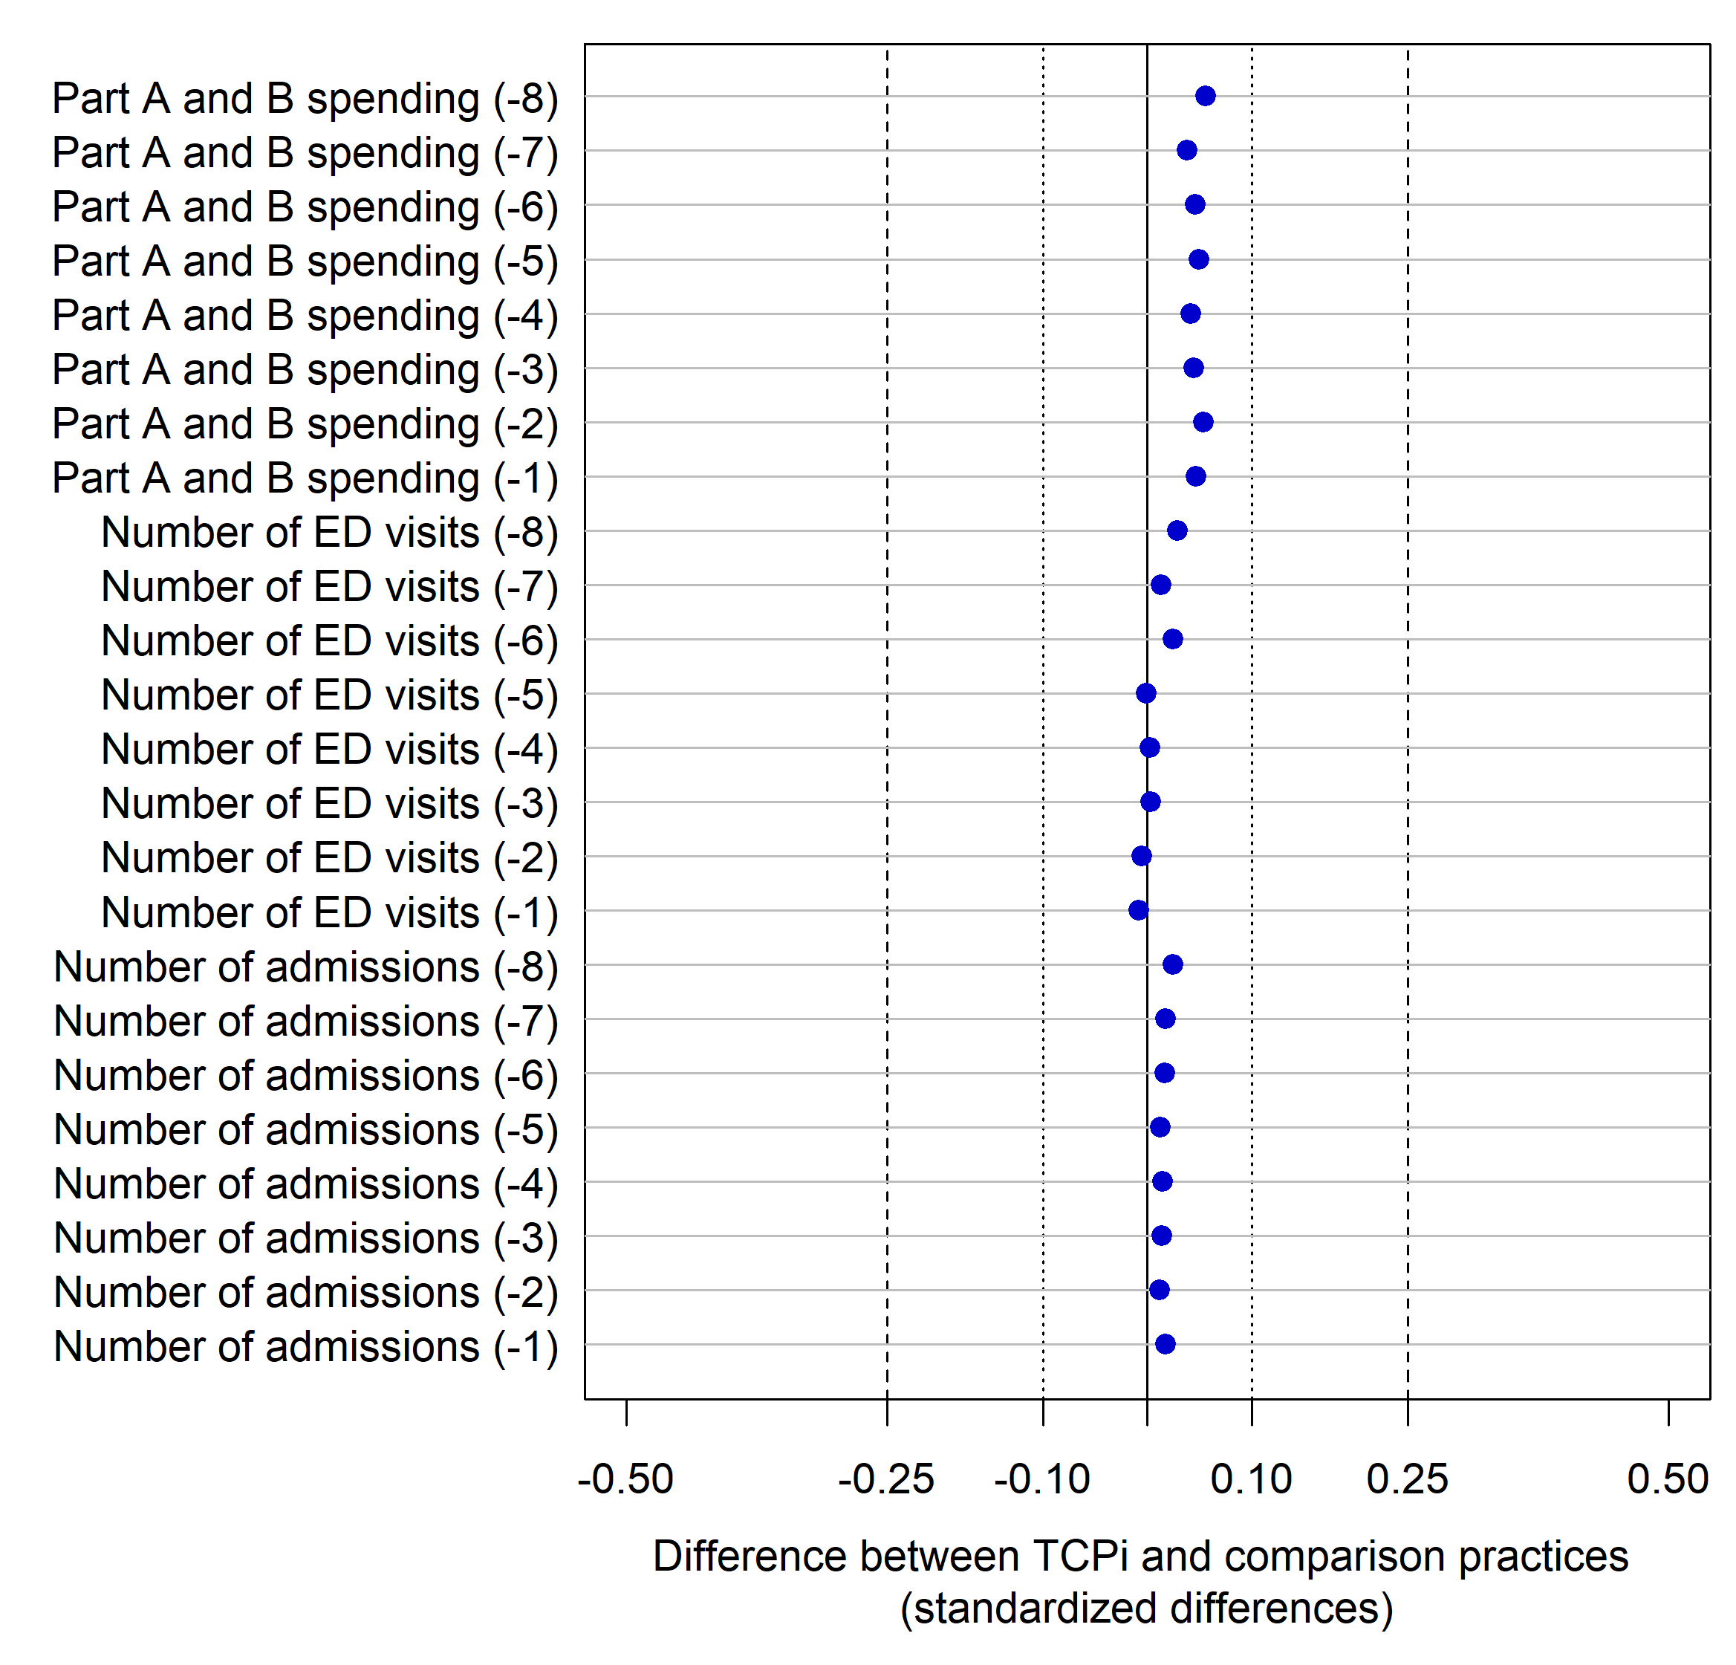
Source: Analyses were based on enrollment data from PTNs and SAN 2.0s, MD-PPAS, and the NPPES. We attributed beneficiaries and calculated outcomes by using data from Medicare FFS Part A and Part B claims.
Note: This figure was based on data with one record per practice per quarter, ranging from the eighth quarter prior to TCPi enrollment (-8) through the first quarter prior (-1), weighted by (1) the proportion of the quarter for which the beneficiary was observable summed across all beneficiaries attributed to the practice in that quarter, and (2) a practice-level weight for each TCPi and comparison practice set indicating the proportion of beneficiaries at TCPi practice seen by TCPi-enrolled clinicians during the two-year baseline period.
Positive differences indicate that the outcome was of a higher value for TCPi practices on average than comparisons; similarly, negative values indicate lower average values for TCPi practices than comparisons.
ED = emergency department; FFS = fee-for-service; MD-PPAS = Medicare Data on Provider Practice and Specialty; NPPES = National Plan and Provider Enumeration System; PTN = Practice Transformation Network; SAN = Support and Alignment Network.

Supplemental Digital Content Figure 1.3. Density plot for the estimated propensity score for TCPi and comparison practices

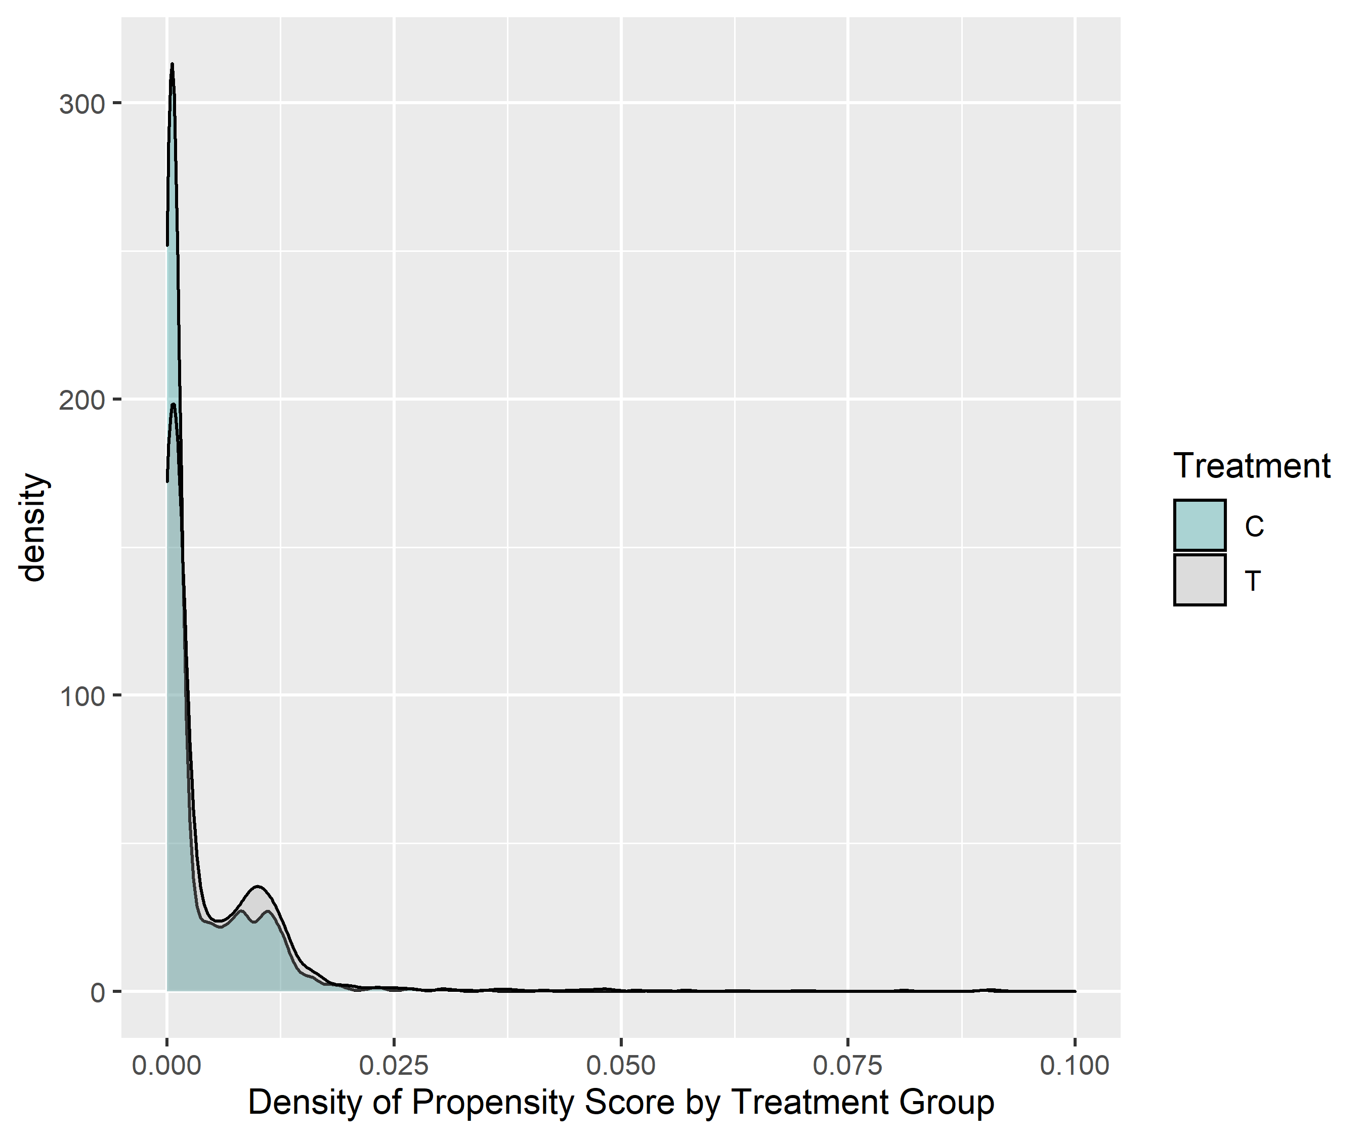
Source: Analyses were based on enrollment data from PTNs and SAN 2.0s, MD-PPAS, and the NPPES. We attributed beneficiaries by using data from Medicare FFS Part A and Part B claims.

Supplemental Digital Content Figure 1.4. Density plot for practice size for TCPi and comparison practices

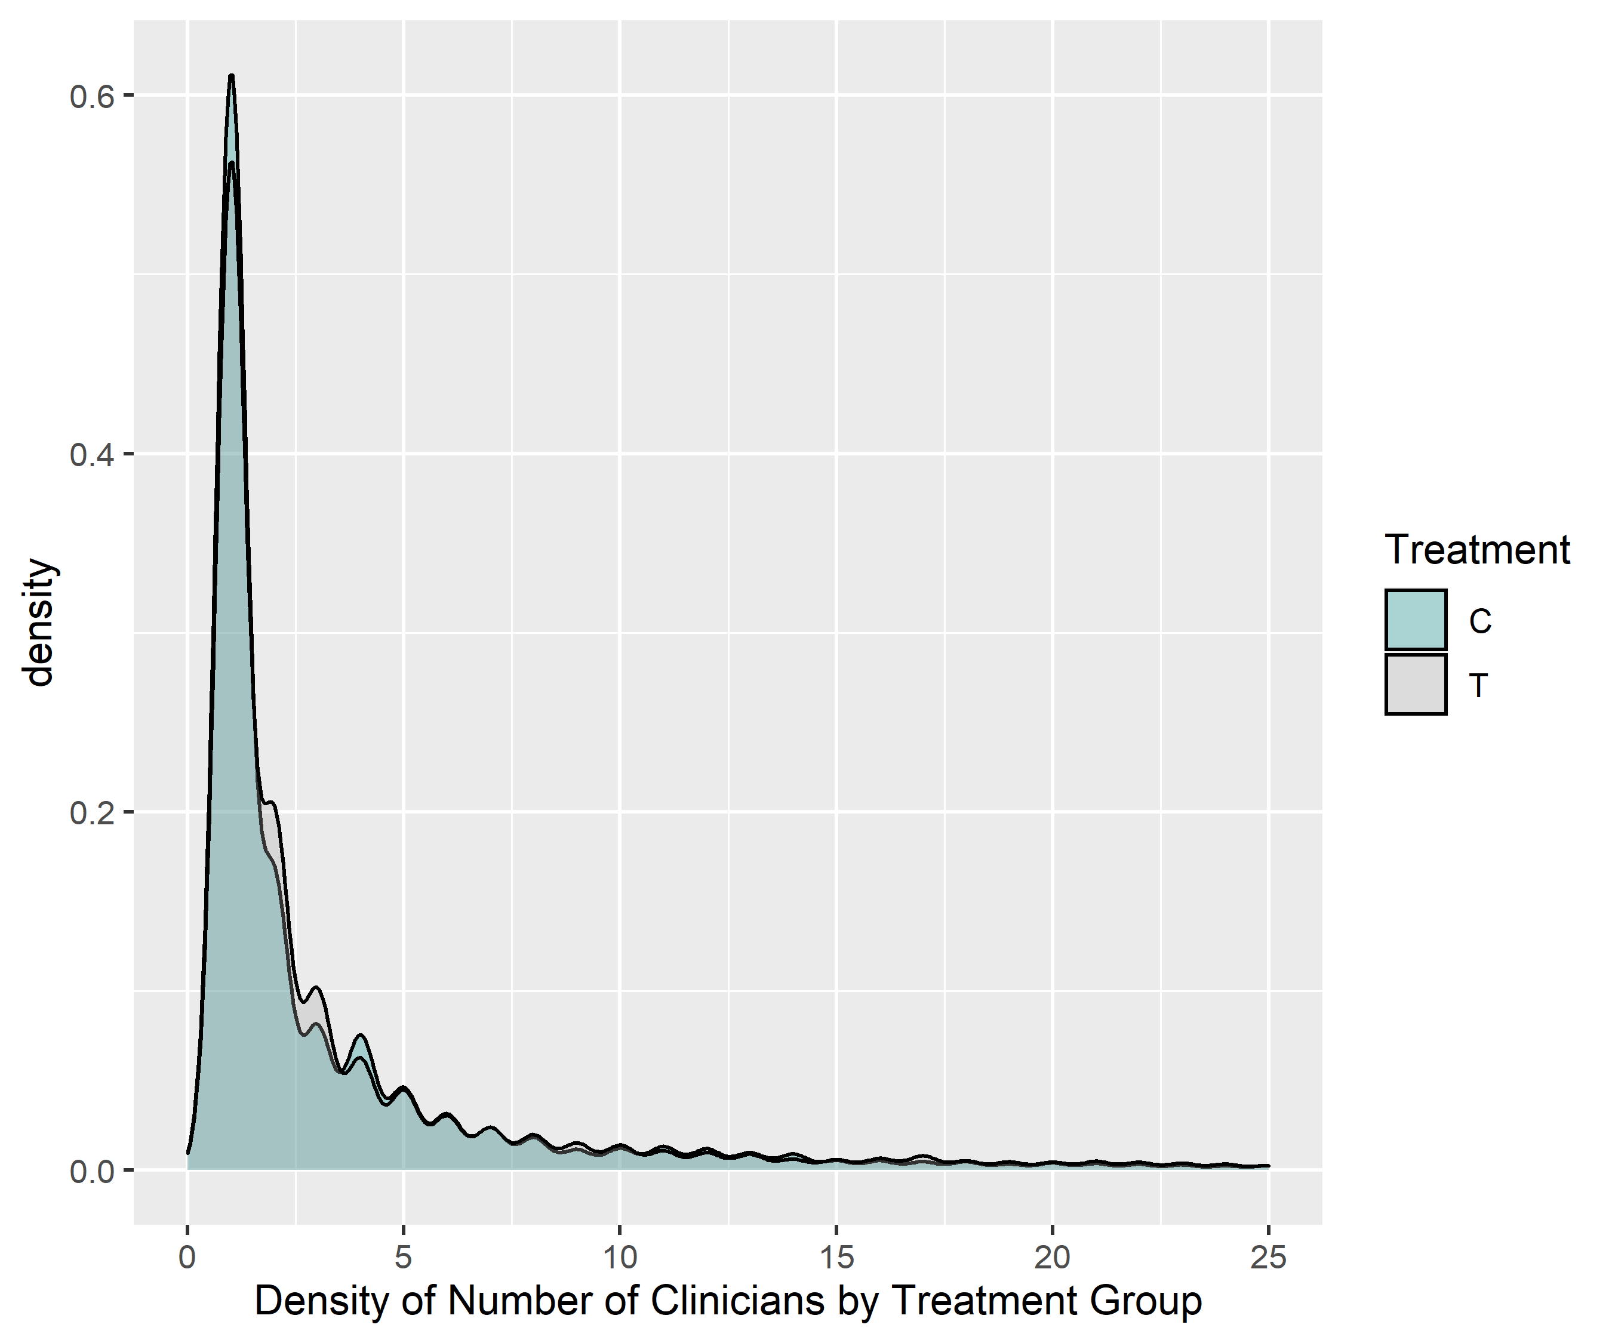
Source: Analyses were based on enrollment data from PTNs and SAN 2.0s, MD-PPAS, and the NPPES. We attributed beneficiaries by using data from Medicare FFS Part A and Part B claims.

2: Estimation approach

1. Overview
We estimated effects as the difference between the Transforming Clinical Practice Initiative (TCPi) and comparison groups in Medicare Alternative Payment Model (APM) participation after practices joined TCPi. This approach is analogous to a difference-in-difference analysis where the preintervention outcome is identical at baseline – in our analysis, because we are assessing new APM enrollment, no TCPi or comparison practices participated in APMs at baseline.
Comparing APM enrollment over time. To compare the two groups on the same timeline, we started following each comparison practice at the same time we started following its matched TCPi practice – 90 days after its enrollment into TCPi. In other words, for each matched set consisting of one TCPi practice and one comparison practice, we assessed whether either enrolled into an APM 90 days or longer after the TCPi practice enrolled in TCPi. This approach was appropriate because we selected the comparison group using case matching, that is, we selected a particular comparison practice for each TCPi practice.

2. Model specification
To estimate the effect of TCPi, we analyzed the treatment-comparison difference in new Medicare APM participation between 90 days after enrolling in TCPi and January 2020. We estimated the following linear regression model using fit (lm) in R:
In this model, j indexes the practice, and is the outcome of interest.
- The covariate is a vector of beneficiary characteristics for practice j and is a vector of characteristics of practice j and area characteristics of practice j. All covariates are listed in Supplemental Digital Content Table 2.1 below.
- is a binary indicator of intervention status; the indicator takes the value of 1 if practice j participated in TCPi or 0 if it is a comparison practice.
- is the idiosyncratic error term. It represents unexplained variability in the outcome for practice j.
- Regressions include additional terms to capture TCPi’s effect in subgroups. Subgroup indicators are interacted with the indicator.
Weighting. We did not weight regressions. Because the goal of the program was to help as many practices as possible transition into APMs (rather than maximize the number of beneficiaries affected), each practice contributed equally to the estimation of impacts of TCPi on APM transition.

2. Regression coefficients
Supplemental Digital Content Table 2.1 provides the estimated regression coefficients from the above model, for the overall and Advanced APM participation outcomes presented in Figure 2. For each regression, the exhibits also include goodness-of-fit statistics, including R-squared and F-tests.
Supplemental Digital Content Table 2.1. Estimated regression coefficients for the effect of TCPi on participation in a Medicare APM and in an Advanced APM

Covariate | Participation in a Medicare APM  (n = 6,958  TCPi practices)  Coefficient  (SE) | Participation in an Advanced APM  (n = 6,958  TCPi practices)  Coefficient  (SE)
Enrolled in TCPi | 0.194***  (0.016) | 0.080***  (0.013)
Practice specialty type in year before enrollment
Primary care | (reference) | (reference)
Specialty care | 0.090***  (0.035) | 0.033  (0.027)
Mixed primary/specialty care | 0.050*  (0.026) | 0.013  (0.020)
Located in a rural county | -0.024*  (0.013) | 0.017  (0.010)
Small practice: Three or fewer clinicians billing Medicare in year before enrollment | -0.024  (0.015) | -0.034***  (0.012)
TCPi enrollment cohort
October 2015–September 2016 | (reference) | (reference)
October 2016–September 2017 | -0.068***  (0.010) | -0.051***  (0.008)
October 2017–September 2018 | -0.087***  (0.018) | -0.050***  (0.014)
Fewer than 40 beneficiaries attributed per quarter during two-year baseline | -0.015  (0.010) | -0.018**  (0.008)
Enrolled in TCPi * Practice specialty type in year before enrollment
Primary care | (reference) | (reference)
Specialty care | -0.164***  (0.014) | -0.111***  (0.011)
Mixed primary/specialty care | -0.088***  (0.021) | -0.076***  (0.016)
Enrolled in TCPi * Located in a rural county | 0.012  (0.017) | -0.035***  (0.013)
Enrolled in TCPi * Small practice | -0.015  (0.014) | 0.061***  (0.011)
Enrolled in TCPi * TCPi enrollment cohort
October 2015–September 2016 | (reference) | (reference)
October 2016–September 2017 | 0.044***  (0.013) | 0.019*  (0.010)
October 2017–September 2018 | 0.035  (0.025) | 0.003  (0.019)
Enrolled in TCPi * Fewer than 40 beneficiaries attributed per quarter during two-year baseline | 0.011  (0.013) | -0.013  (0.010)
Number of clinicians billing Medicare
Solo practice | -0.003  (0.007) | 0.008  (0.006)
2–4 clinicians | (reference) | (reference)
5–24 clinicians | 0.033**  (0.014) | 0.014  (0.011)
25–49 clinicians | 0.122***  (0.020) | 0.085***  (0.016)
50 or more clinicians | 0.113***  (0.022) | 0.135***  (0.017)
Hospital-owned (2017) | 0.160***  (0.013) | 0.036***  (0.011)
Accepts Medicaid (2017) | -0.013  (0.011) | -0.022**  (0.009)
Missing data on hospital ownership and Medicaid acceptance | -0.065***  (0.013) | -0.057***  (0.010)
Proportion of clinicians at practice with select specialties (%)
Primary care | (reference) | (reference)
Surgical specialty | -0.082**  (0.035) | -0.023  (0.028)
Hospital-based specialty | -0.163***  (0.038) | -0.064**  (0.030)
Cardiology | -0.131***  (0.043) | -0.048  (0.034)
Dermatology | -0.151***  (0.041) | -0.075**  (0.032)
Gastroenterology | -0.099**  (0.041) | -0.001  (0.032)
Licensed clinical social work or clinical psychology | -0.167***  (0.041) | -0.022  (0.032)
Obstetrics and gynecology | -0.122***  (0.039) | -0.059*  (0.030)
Ophthalmology | -0.070***  (0.024) | -0.048**  (0.019)
Optometry | -0.178***  (0.036) | -0.074***  (0.028)
Podiatry | -0.153***  (0.039) | -0.061**  (0.030)
Other non-primary care specialties | -0.090***  (0.032) | -0.029  (0.025)
Proportion of clinicians participating in medical home programs in year before TCPi enrollment
All | 0.035**  (0.016) | 0.014  (0.012)
Some but not all | 0.119***  (0.020) | 0.111***  (0.016)
None | (reference) | (reference)
At least one clinician received meaningful use payment for EHRs before TCPi enrollment | 0.033***  (0.006) | 0.020***  (0.005)
Proportion of county below poverty line (%, 2015) | 0.258***  (0.089) | -0.012  (0.069)
Medicare Advantage penetration (%, year before TCPi enrollment) | -0.062***  (0.023) | 0.032*  (0.018)
Health professional shortage area (%, year before TCPi enrollment)
Primary care, whole county | -0.059***  (0.021) | -0.026  (0.016)
Primary care, partial county | -0.013  (0.013) | 0.003  (0.01)
Mental health, whole county | 0.006  (0.014) | -0.011  (0.011)
Mental health, partial county | 0.024*  (0.014) | 0.011  (0.011)
Number of hospital beds per 10,000 residents (2015) | -0.0002  (0.0001) | -0.0004***  (0.0001)
Number of primary care physicians per 10,000 residents (2015) | 0.005**  (0.002) | -0.0004  (0.002)
Number of specialists per 10,000 residents (2015) | -0.0002  (0.001) | 0.001**  (0.001)
Population in county age 25 and older with less than a high school diploma (%, 2015) | -0.203  (0.139) | -0.275**  (0.108)
Population in county age 25 and older with at least a four-year college degree (%, 2015) | -0.175***  (0.060) | -0.180***  (0.047)
Population in county age 5 and older that do not speak English as primary language (%, 2010) | 0.089  (0.146) | 0.411***  (0.113)
Average age of beneficiaries attributed during baseline | -0.00002  (0.001) | 0.002***  (0.001)
Proportion of beneficiaries attributed during baseline that are female (%) | 0.006  (0.024) | 0.028  (0.019)
Proportion of beneficiaries attributed during baseline that are of a given race/ethnicity (%)
White | (reference) | (reference)
Black | -0.004  (0.021) | -0.010  (0.017)
Asian | 0.117***  (0.033) | 0.045*  (0.026)
Hispanic | 0.047  (0.046) | 0.049  (0.036)
North American Native or other | -0.048  (0.040) | 0.021  (0.031)
Proportion of beneficiaries attributed during baseline with a given dual eligibility status (%)
Not dually eligible | (reference) | (reference)
Fully eligible | -0.064***  (0.023) | -0.0001  (0.018)
Partially eligible | -0.045  (0.052) | -0.056  (0.041)
Proportion of beneficiaries attributed during baseline with a given original reason for entitlement (%)
Aged | (reference) | (reference)
Disability | -0.034  (0.035) | 0.038  (0.028)
ESRD or ESRD and disability | 0.121  (0.086) | 0.034  (0.067)
Proportion of beneficiaries attributed during baseline with a given number of chronic conditions (%)
None | (reference) | (reference)
1–4 | 0.016  (0.025) | 0.023  (0.019)
5 or more | -0.009  (0.040) | 0.006  (0.032)
Proportion of beneficiaries attributed during baseline with select chronic conditions (%)
Acquired hypothyroidism | -0.033  (0.038) | -0.060**  (0.029)
Alzheimer’s disease and related disorders or senile dementia | 0.022  (0.032) | 0.006  (0.025)
Anemia | -0.081***  (0.028) | -0.027  (0.021)
Anxiety disorders | 0.005  (0.034) | -0.021  (0.026)
Asthma | -0.023  (0.047) | 0.007  (0.036)
Atrial fibrillation | 0.075  (0.065) | 0.065  (0.051)
Benign prostatic hyperplasia | -0.040  (0.055) | -0.003  (0.043)
Cancerª | 0.062  (0.039) | -0.008  (0.030)
Cataract | 0.011  (0.027) | 0.008  (0.021)
Chronic kidney disease | 0.010  (0.030) | -0.014  (0.024)
Chronic obstructive pulmonary disease | 0.048  (0.039) | -0.010  (0.031)
Congestive heart failure | -0.034  (0.040) | -0.011  (0.031)
Depression | -0.022  (0.034) | -0.040  (0.026)
Diabetes | 0.013  (0.027) | 0.004  (0.021)
Glaucoma | -0.033  (0.029) | 0.0001  (0.023)
Hyperlipidemia | 0.051*  (0.027) | 0.039*  (0.021)
Hypertension | 0.044  (0.030) | 0.003  (0.024)
Ischemic heart disease | 0.029  (0.030) | -0.005  (0.023)
Obesity | 0.128***  (0.030) | 0.060**  (0.023)
Osteoporosis | -0.063  (0.054) | -0.078*  (0.042)
Rheumatoid arthritis or osteoarthritis | 0.016  (0.020) | 0.018  (0.016)
Tobacco use disorder | 0.013  (0.035) | 0.008  (0.028)
Proportion of beneficiaries attributed during baseline who were missing information on chronic conditions (%) | 0.013  (0.028) | 0.051**  (0.022)
Constant | 0.167*  (0.092) | -0.049  (0.072)
R² | 0.221 | 0.140
F-statistic | 47.219*** | 27.054***
Degrees of freedom (residual) | 13,832 | 13,832
Source: Analyses were based on TCPi model enrollment data; February 2020 MDM and January 2020 OCM and BPCI-A APM participation data; and administrative claims data from October 1, 2011, through December 31, 2018.
Note: The number of TCPi practices in each regression is presented in parentheses. The regressions for participation in a Medicare APM and in and Advanced APM also included those practices’ matched comparisons. For the regression on whether MSSP practices ever achieved savings, only the subset of 605 TCPi practices and 374 comparison practices that started participating in MSSP by 2018 were included in the regression.
a Cancer was defined as having at least one of breast, colorectal, endometrial, lung, or prostate cancer.
* = p < 0.10, two-tailed test; ** = p < 0.05, two-tailed test; *** = p < 0.01, two-tailed test.
APM = alternative payment model; BPCI-A = Bundled Payments for Care Improvement Advanced Model; EHR = electronic health record; ESRD = end-stage renal disease; MDM = Master Data Management; MSSP = Medicare Shared Savings Program; OCM = Oncology Care Model.

REFERENCES
Centers for Medicare & Medicaid Services. “Medicare Shared Savings Program — Shared Savings and Losses and Assignment Methodology: Specifications.” August 2020. Available at https://www.cms.gov/files/document/shared-savings-losses-assignment-spec-v8.pdf. Accessed October 13, 2021.
Dartmouth Atlas Project. “Research Methods.” 2020. Available at https://www.dartmouthatlas.org/research-methods/. Accessed October 13, 2021.
Gerteis, Jessie, and Beth Kantz. “Findings from the AHRQ Transforming Primary Care Grant Initiative: A Synthesis Report.” Rockville, MD: Agency for Healthcare Research and Quality, July 2015.
Pham, Hoangmai H., Deborah Schrag, Ann S. O’Malley, Beny Wu, and Peter B. Bach. “Care Patterns in Medicare and Their Implications for Pay for Performance.” New England Journal of Medicine, vol. 356, no. 11, 2007, pp. 1130 1139.
Pimentel, S. D., Forrow Vollmer, L., Gellar, J., & Li, J. (2020). Optimal matching approaches in health policy evaluations under rolling enrollment. Journal of the Royal Statistical Society, Series A, 183(4), 1411–1435.
Rosenbaum. P. R. (1989). Optimal matching for observational studies. Journal of the American Statistical Association, 84(408), 1024–1032.
Smith, Jeffrey A., and Petra E. Todd. “Does Matching Overcome LaLonde's Critique of Nonexperimental Estimators?” Journal of Econometrics, vol. 125, no. 1-2, 2005, pp. 305-353.
Stuart, E. A. (2010). Matching methods for causal inference: A review and a look forward. Statistical Science, 25(1), 1–21. doi:10.1214/09-STS313

