ICMJE DISCLOSURE FORM
Date: | 4/8/2022
Your Name: | Robert A. Adler, MD
Manuscript Title: | Acute Lower Extremity Fracture Management in Chronic Spinal Cord Injury: 2022 Delphi Consensus Recommendations
Manuscript Number (if known): | JBJS-D-21-00152
In the interest of transparency, we ask you to disclose all relationships/activities/interests listed below that are related to the content of your manuscript. “Related” means any relation with for-profit or not-for-profit third parties whose interests may be affected by the content of the manuscript. Disclosure represents a commitment to transparency and does not necessarily indicate a bias. If you are in doubt about whether to list a relationship/activity/interest, it is preferable that you do so.

The author’s relationships/activities/interests should be defined broadly. For example, if your manuscript pertains to the epidemiology of hypertension, you should declare all relationships with manufacturers of antihypertensive medication, even if that medication is not mentioned in the manuscript.

In item #1 below, report all support for the work reported in this manuscript without time limit. For all other items, the time frame for disclosure is the past 36 months.

 |  |  | Name all entities with whom you have this relationship or indicate none (add rows as needed) | Specifications/Comments (e.g., if payments were made to you or to your institution)
Time frame: Since the initial planning of the work
1 | All support for the present manuscript (e.g., funding, provision of study materials, medical writing, article processing charges, etc.)  No time limit for this item. |  | ☒ None  Click the tab key to add additional rows.
Time frame: past 36 months
2 |  | Grants or contracts from any entity (if not indicated in item #1 above). | ☐ None  Radius Health To institution  Department of Veterans Affairs To institution
3 |  | Royalties or licenses | ☒ None
4 |  | Consulting fees | ☒ None
5 |  | Payment or honoraria for lectures, presentations, speakers bureaus, manuscript writing or educational events | ☐ None  University of Texas, Houston Lecture honorarium  Bone Health and Osteoporosis Foundation Lecture honorarium
6 |  | Payment for expert testimony | ☒ None
7 |  | Support for attending meetings and/or travel | ☐ None  Controversies in Vitamin D Meeting Travel support
8 |  | Patents planned, issued or pending | ☒ None
9 |  | Participation on a Data Safety Monitoring Board or Advisory Board | ☒ None
10 |  | Leadership or fiduciary role in other board, society, committee or advocacy group, paid or unpaid | ☐ None  Chair, Ethics Committee, ASBMR No compensation
11 |  | Stock or stock options | ☒ None
12 |  | Receipt of equipment, materials, drugs, medical writing, gifts or other services | ☒ None
13 |  | Other financial or non-financial interests | ☐ None  Associate Editor, Osteoporosis International Honorarium
Please place an “X” next to the following statement to indicate your agreement:
☒ |  | I certify that I have answered every question and have not altered the wording of any of the questions on this form.

ICMJE DISCLOSURE FORM
Date: | 4/11/2022
Your Name: | Jaimo Ahn
Manuscript Title: | Acute Lower Extremity Fracture Management in Chronic Spinal Cord Injury: 2022 Delphi Consensus Recommendations
Manuscript Number (if known): | JBJS-D-21-00152
In the interest of transparency, we ask you to disclose all relationships/activities/interests listed below that are related to the content of your manuscript. “Related” means any relation with for-profit or not-for-profit third parties whose interests may be affected by the content of the manuscript. Disclosure represents a commitment to transparency and does not necessarily indicate a bias. If you are in doubt about whether to list a relationship/activity/interest, it is preferable that you do so.

The author’s relationships/activities/interests should be defined broadly. For example, if your manuscript pertains to the epidemiology of hypertension, you should declare all relationships with manufacturers of antihypertensive medication, even if that medication is not mentioned in the manuscript.

In item #1 below, report all support for the work reported in this manuscript without time limit. For all other items, the time frame for disclosure is the past 36 months.

 |  |  | Name all entities with whom you have this relationship or indicate none (add rows as needed) | Specifications/Comments (e.g., if payments were made to you or to your institution)
Time frame: Since the initial planning of the work
1 | All support for the present manuscript (e.g., funding, provision of study materials, medical writing, article processing charges, etc.)  No time limit for this item. |  | ☒ None  No direct funding  Click the tab key to add additional rows.
Time frame: past 36 months
2 |  | Grants or contracts from any entity (if not indicated in item #1 above). | ☐ None  Canadian Institutes of Health Research – HIP ATTACK 2
3 |  | Royalties or licenses | ☒ None  None relevant
4 |  | Consulting fees | ☐ None  Radius Health Consulting fees to me – biologic development  Synthes USA Consulting fees to me – implant related
5 |  | Payment or honoraria for lectures, presentations, speakers bureaus, manuscript writing or educational events | ☐ None  AO North America Teaching fees to me
6 |  | Payment for expert testimony | ☐ None  Rx Pro Services Consulting fees for injury cases to me
7 |  | Support for attending meetings and/or travel | ☐ None  Foundation for Orthopaedic Trauma Travel payments for teaching (to me)
8 |  | Patents planned, issued or pending | ☒ None
9 |  | Participation on a Data Safety Monitoring Board or Advisory Board | ☒ None
10 |  | Leadership or fiduciary role in other board, society, committee or advocacy group, paid or unpaid | ☐ None  Clinical Orthopaedics and Related Research Board of Trustees  American Physician Scientist Association Board of Directors
11 |  | Stock or stock options | ☒ None
12 |  | Receipt of equipment, materials, drugs, medical writing, gifts or other services | ☒ None
13 |  | Other financial or non-financial interests | ☒ None
Please place an “X” next to the following statement to indicate your agreement:
☒ |  | I certify that I have answered every question and have not altered the wording of any of the questions on this form.

ICMJE DISCLOSURE FORM
Date: | 4/12/2022
Your Name: | Laura Carbone
Manuscript Title: | Acute Lower Extremity Fracture Management in Chronic Spinal Cord Injury: 2022 Delphi Consensus Recommendations
Manuscript Number (if known): | JBJS-D-21-00152
In the interest of transparency, we ask you to disclose all relationships/activities/interests listed below that are related to the content of your manuscript. “Related” means any relation with for-profit or not-for-profit third parties whose interests may be affected by the content of the manuscript. Disclosure represents a commitment to transparency and does not necessarily indicate a bias. If you are in doubt about whether to list a relationship/activity/interest, it is preferable that you do so.

The author’s relationships/activities/interests should be defined broadly. For example, if your manuscript pertains to the epidemiology of hypertension, you should declare all relationships with manufacturers of antihypertensive medication, even if that medication is not mentioned in the manuscript.

In item #1 below, report all support for the work reported in this manuscript without time limit. For all other items, the time frame for disclosure is the past 36 months.

 |  |  | Name all entities with whom you have this relationship or indicate none (add rows as needed) | Specifications/Comments (e.g., if payments were made to you or to your institution)
Time frame: Since the initial planning of the work
1 | All support for the present manuscript (e.g., funding, provision of study materials, medical writing, article processing charges, etc.)  No time limit for this item. |  | ☐ None  VA HSRD Grant VA Grant; no monies received  Click the tab key to add additional rows.
Time frame: past 36 months
2 |  | Grants or contracts from any entity (if not indicated in item #1 above). | ☐ None  See above
3 |  | Royalties or licenses | ☒ None
4 |  | Consulting fees | ☒ None
5 |  | Payment or honoraria for lectures, presentations, speakers bureaus, manuscript writing or educational events | ☒ None
6 |  | Payment for expert testimony | ☒ None
7 |  | Support for attending meetings and/or travel | ☒ None
8 |  | Patents planned, issued or pending | ☒ None
9 |  | Participation on a Data Safety Monitoring Board or Advisory Board | ☒ None
10 |  | Leadership or fiduciary role in other board, society, committee or advocacy group, paid or unpaid | ☒ None
11 |  | Stock or stock options | ☒ None
12 |  | Receipt of equipment, materials, drugs, medical writing, gifts or other services | ☒ None
13 |  | Other financial or non-financial interests | ☒ None
Please place an “X” next to the following statement to indicate your agreement:
☒ |  | I certify that I have answered every question and have not altered the wording of any of the questions on this form.

ICMJE DISCLOSURE FORM
Date: | 4/22/2022
Your Name: | Tomas Cervinka
Manuscript Title: | Acute Lower Extremity Fracture Management in Chronic Spinal Cord Injury: 2022 Delphi Consensus Recommendations
Manuscript Number (if known): | JBJS-D-21-00152
In the interest of transparency, we ask you to disclose all relationships/activities/interests listed below that are related to the content of your manuscript. “Related” means any relation with for-profit or not-for-profit third parties whose interests may be affected by the content of the manuscript. Disclosure represents a commitment to transparency and does not necessarily indicate a bias. If you are in doubt about whether to list a relationship/activity/interest, it is preferable that you do so.

The author’s relationships/activities/interests should be defined broadly. For example, if your manuscript pertains to the epidemiology of hypertension, you should declare all relationships with manufacturers of antihypertensive medication, even if that medication is not mentioned in the manuscript.

In item #1 below, report all support for the work reported in this manuscript without time limit. For all other items, the time frame for disclosure is the past 36 months.

 |  |  | Name all entities with whom you have this relationship or indicate none (add rows as needed) | Specifications/Comments (e.g., if payments were made to you or to your institution)
Time frame: Since the initial planning of the work
1 | All support for the present manuscript (e.g., funding, provision of study materials, medical writing, article processing charges, etc.)  No time limit for this item. |  | ☒ None  Click the tab key to add additional rows.
Time frame: past 36 months
2 |  | Grants or contracts from any entity (if not indicated in item #1 above). | ☐ None  Rehabilitation Foundation Peurunka, Laukaa, Finland Personal research grant
3 |  | Royalties or licenses | ☒ None
4 |  | Consulting fees | ☒ None
5 |  | Payment or honoraria for lectures, presentations, speakers bureaus, manuscript writing or educational events | ☒ None
6 |  | Payment for expert testimony | ☒ None
7 |  | Support for attending meetings and/or travel | ☐ None  Paralyzed Veterans of America, Washington, DC Personal grant covering travel expenses
8 |  | Patents planned, issued or pending | ☒ None
9 |  | Participation on a Data Safety Monitoring Board or Advisory Board | ☒ None
10 |  | Leadership or fiduciary role in other board, society, committee or advocacy group, paid or unpaid | ☐ None  Paralyzed Veterans of America, consultant to the Guideline Development Panel (Bone health) unpaid
11 |  | Stock or stock options | ☒ None
12 |  | Receipt of equipment, materials, drugs, medical writing, gifts or other services | ☒ None
13 |  | Other financial or non-financial interests | ☒ None
Please place an “X” next to the following statement to indicate your agreement:
☒ |  | I certify that I have answered every question and have not altered the wording of any of the questions on this form.

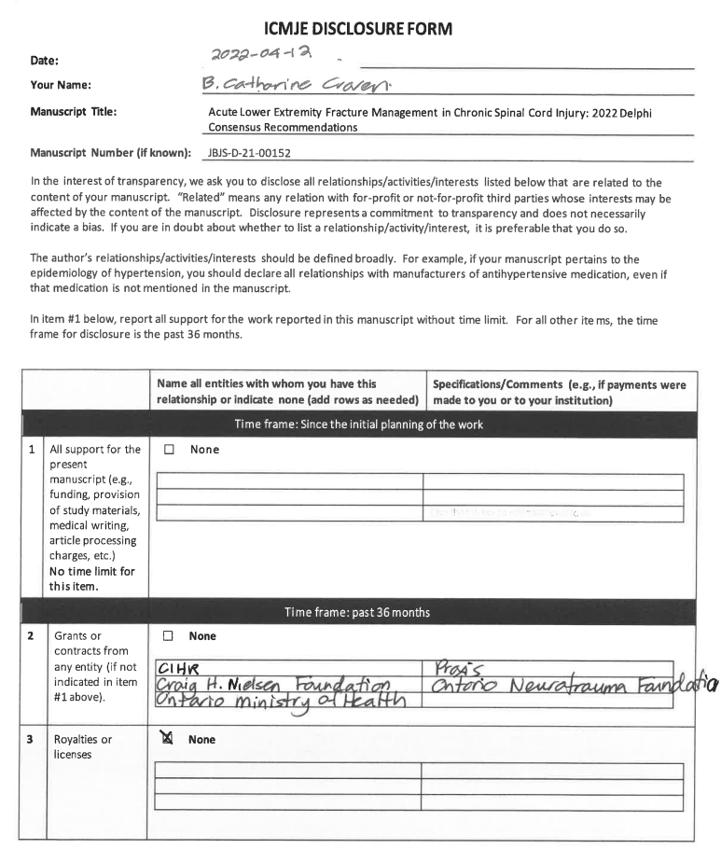

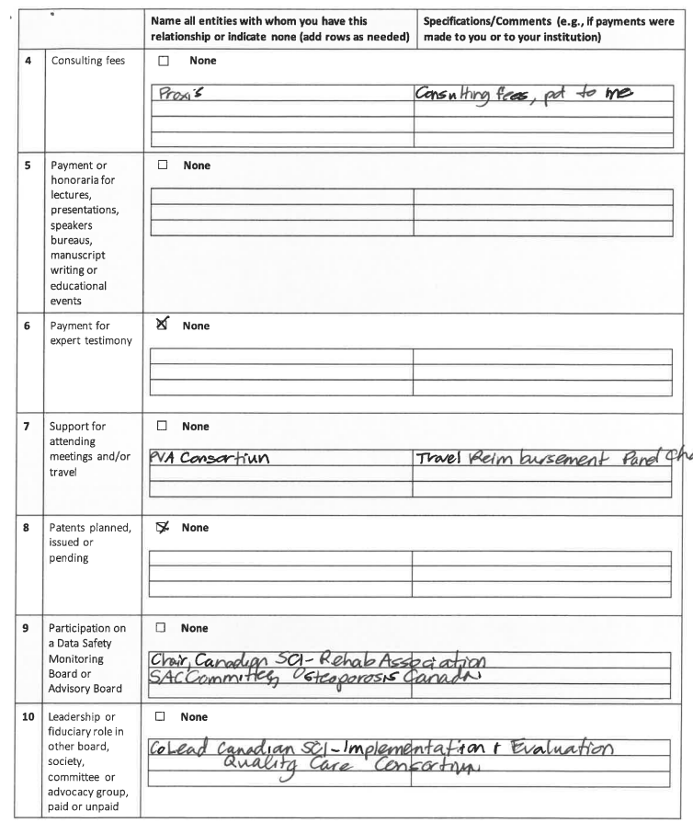

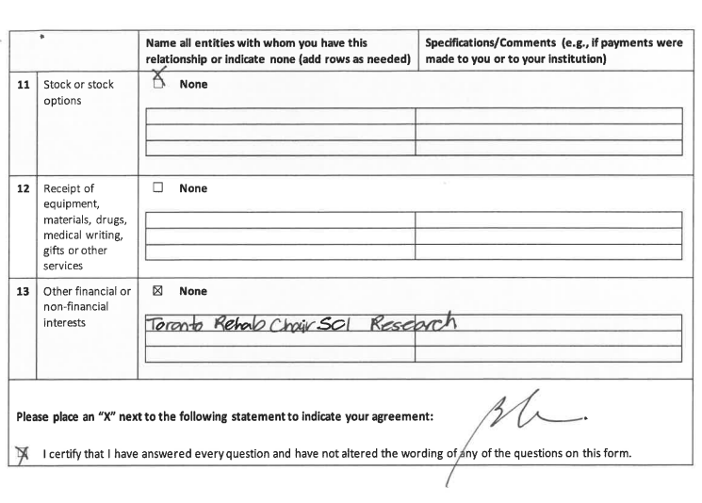

ICMJE DISCLOSURE FORM
Date: | 5/11/2022
Your Name: | Joseph Hsu
Manuscript Title: | Acute Lower Extremity Fracture Management in Chronic Spinal Cord Injury: 2022 Delphi Consensus Recommendations
Manuscript Number (if known): | JBJS-D-21-00152
In the interest of transparency, we ask you to disclose all relationships/activities/interests listed below that are related to the content of your manuscript. “Related” means any relation with for-profit or not-for-profit third parties whose interests may be affected by the content of the manuscript. Disclosure represents a commitment to transparency and does not necessarily indicate a bias. If you are in doubt about whether to list a relationship/activity/interest, it is preferable that you do so.

The author’s relationships/activities/interests should be defined broadly. For example, if your manuscript pertains to the epidemiology of hypertension, you should declare all relationships with manufacturers of antihypertensive medication, even if that medication is not mentioned in the manuscript.

In item #1 below, report all support for the work reported in this manuscript without time limit. For all other items, the time frame for disclosure is the past 36 months.

 |  |  | Name all entities with whom you have this relationship or indicate none (add rows as needed) | Specifications/Comments (e.g., if payments were made to you or to your institution)
Time frame: Since the initial planning of the work
1 | All support for the present manuscript (e.g., funding, provision of study materials, medical writing, article processing charges, etc.)  No time limit for this item. |  | ☒ None  Click the tab key to add additional rows.
Time frame: past 36 months
2 |  | Grants or contracts from any entity (if not indicated in item #1 above). | ☒ None
3 |  | Royalties or licenses | ☒ None
4 |  | Consulting fees | ☐ None  Stryker Paid to me  Smith Nephew Paid to me
5 |  | Payment or honoraria for lectures, presentations, speakers bureaus, manuscript writing or educational events | ☐ None  Depuy Synthes Paid to me  Smith Nephew Paid to me  Stryker Paid t ome
6 |  | Payment for expert testimony | ☒ None
7 |  | Support for attending meetings and/or travel | ☒ None
8 |  | Patents planned, issued or pending | ☒ None
9 |  | Participation on a Data Safety Monitoring Board or Advisory Board | ☒ None
10 |  | Leadership or fiduciary role in other board, society, committee or advocacy group, paid or unpaid | ☒ None
11 |  | Stock or stock options | ☒ None
12 |  | Receipt of equipment, materials, drugs, medical writing, gifts or other services | ☒ None
13 |  | Other financial or non-financial interests | ☒ None
Please place an “X” next to the following statement to indicate your agreement:
☒ |  | I certify that I have answered every question and have not altered the wording of any of the questions on this form.

ICMJE DISCLOSURE FORM
Date: | 4/13/2022
Your Name: | Donna Huang
Manuscript Title: | Acute Lower Extremity Fracture Management in Chronic Spinal Cord Injury: 2022 Delphi Consensus Recommendations
Manuscript Number (if known): | JBJS-D-21-00152
In the interest of transparency, we ask you to disclose all relationships/activities/interests listed below that are related to the content of your manuscript. “Related” means any relation with for-profit or not-for-profit third parties whose interests may be affected by the content of the manuscript. Disclosure represents a commitment to transparency and does not necessarily indicate a bias. If you are in doubt about whether to list a relationship/activity/interest, it is preferable that you do so.

The author’s relationships/activities/interests should be defined broadly. For example, if your manuscript pertains to the epidemiology of hypertension, you should declare all relationships with manufacturers of antihypertensive medication, even if that medication is not mentioned in the manuscript.

In item #1 below, report all support for the work reported in this manuscript without time limit. For all other items, the time frame for disclosure is the past 36 months.

 |  |  | Name all entities with whom you have this relationship or indicate none (add rows as needed) | Specifications/Comments (e.g., if payments were made to you or to your institution)
Time frame: Since the initial planning of the work
1 | All support for the present manuscript (e.g., funding, provision of study materials, medical writing, article processing charges, etc.)  No time limit for this item. |  | ☒ None  Click the tab key to add additional rows.
Time frame: past 36 months
2 |  | Grants or contracts from any entity (if not indicated in item #1 above). | ☒ None
3 |  | Royalties or licenses | ☒ None
4 |  | Consulting fees | ☒ None
5 |  | Payment or honoraria for lectures, presentations, speakers bureaus, manuscript writing or educational events | ☒ None
6 |  | Payment for expert testimony | ☒ None
7 |  | Support for attending meetings and/or travel | ☒ None
8 |  | Patents planned, issued or pending | ☒ None
9 |  | Participation on a Data Safety Monitoring Board or Advisory Board | ☒ None
10 |  | Leadership or fiduciary role in other board, society, committee or advocacy group, paid or unpaid | ☒ None
11 |  | Stock or stock options | ☒ None
12 |  | Receipt of equipment, materials, drugs, medical writing, gifts or other services | ☒ None
13 |  | Other financial or non-financial interests | ☒ None
Please place an “X” next to the following statement to indicate your agreement:
☒ |  | I certify that I have answered every question and have not altered the wording of any of the questions on this form.

ICMJE DISCLOSURE FORM
Date: | 4/8/2022
Your Name: | Madhav A. Karunakar
Manuscript Title: | Acute Lower Extremity Fracture Management in Chronic Spinal Cord Injury: 2022 Delphi Consensus Recommendations
Manuscript Number (if known): | JBJS-D-21-00152
In the interest of transparency, we ask you to disclose all relationships/activities/interests listed below that are related to the content of your manuscript. “Related” means any relation with for-profit or not-for-profit third parties whose interests may be affected by the content of the manuscript. Disclosure represents a commitment to transparency and does not necessarily indicate a bias. If you are in doubt about whether to list a relationship/activity/interest, it is preferable that you do so.

The author’s relationships/activities/interests should be defined broadly. For example, if your manuscript pertains to the epidemiology of hypertension, you should declare all relationships with manufacturers of antihypertensive medication, even if that medication is not mentioned in the manuscript.

In item #1 below, report all support for the work reported in this manuscript without time limit. For all other items, the time frame for disclosure is the past 36 months.

 |  |  | Name all entities with whom you have this relationship or indicate none (add rows as needed) | Specifications/Comments (e.g., if payments were made to you or to your institution)
Time frame: Since the initial planning of the work
1 | All support for the present manuscript (e.g., funding, provision of study materials, medical writing, article processing charges, etc.)  No time limit for this item. |  | ☒ None  Click the tab key to add additional rows.
Time frame: past 36 months
2 |  | Grants or contracts from any entity (if not indicated in item #1 above). | ☐ None  Department of Defense- Major Extremity Trauma and Rehabilitation Consortium
3 |  | Royalties or licenses | ☒ None
4 |  | Consulting fees | ☒ None
5 |  | Payment or honoraria for lectures, presentations, speakers bureaus, manuscript writing or educational events | ☐ None  AO North America Pelvic Course
6 |  | Payment for expert testimony | ☒ None
7 |  | Support for attending meetings and/or travel | ☒ None
8 |  | Patents planned, issued or pending | ☒ None
9 |  | Participation on a Data Safety Monitoring Board or Advisory Board | ☒ None
10 |  | Leadership or fiduciary role in other board, society, committee or advocacy group, paid or unpaid | ☐ None  Chair, Orthopaedic Trauma Fellowship Committee
11 |  | Stock or stock options | ☒ None
12 |  | Receipt of equipment, materials, drugs, medical writing, gifts or other services | ☒ None
13 |  | Other financial or non-financial interests | ☒ None
Please place an “X” next to the following statement to indicate your agreement:
☒ |  | I certify that I have answered every question and have not altered the wording of any of the questions on this form.

ICMJE DISCLOSURE FORM
Date: | 4/8/2022
Your Name: | B. Jenny Kiratli
Manuscript Title: | Acute Lower Extremity Fracture Management in Chronic Spinal Cord Injury: 2022 Delphi Consensus Recommendations
Manuscript Number (if known): | JBJS-D-21-00152
In the interest of transparency, we ask you to disclose all relationships/activities/interests listed below that are related to the content of your manuscript. “Related” means any relation with for-profit or not-for-profit third parties whose interests may be affected by the content of the manuscript. Disclosure represents a commitment to transparency and does not necessarily indicate a bias. If you are in doubt about whether to list a relationship/activity/interest, it is preferable that you do so.

The author’s relationships/activities/interests should be defined broadly. For example, if your manuscript pertains to the epidemiology of hypertension, you should declare all relationships with manufacturers of antihypertensive medication, even if that medication is not mentioned in the manuscript.

In item #1 below, report all support for the work reported in this manuscript without time limit. For all other items, the time frame for disclosure is the past 36 months.

 |  |  | Name all entities with whom you have this relationship or indicate none (add rows as needed) | Specifications/Comments (e.g., if payments were made to you or to your institution)
Time frame: Since the initial planning of the work
1 | All support for the present manuscript (e.g., funding, provision of study materials, medical writing, article processing charges, etc.)  No time limit for this item. |  | ☒ None  Click the tab key to add additional rows.
Time frame: past 36 months
2 |  | Grants or contracts from any entity (if not indicated in item #1 above). | ☐ None  VA Rehabilitation R&D Service – “Assessing Bone Health after SCI: Establishing Evidence for a Clinical Protocol”
3 |  | Royalties or licenses | ☒ None
4 |  | Consulting fees | ☒ None
5 |  | Payment or honoraria for lectures, presentations, speakers bureaus, manuscript writing or educational events | ☒ None
6 |  | Payment for expert testimony | ☒ None
7 |  | Support for attending meetings and/or travel | ☐ None  VA Rehabilitation R&D Service
8 |  | Patents planned, issued or pending | ☒ None
9 |  | Participation on a Data Safety Monitoring Board or Advisory Board | ☒ None
10 |  | Leadership or fiduciary role in other board, society, committee or advocacy group, paid or unpaid | ☐ None  President, American Paraplegia Society Section Board of Directors; Governance Board, Academy of SCI Professionals
11 |  | Stock or stock options | ☒ None
12 |  | Receipt of equipment, materials, drugs, medical writing, gifts or other services | ☒ None
13 |  | Other financial or non-financial interests | ☒ None
Please place an “X” next to the following statement to indicate your agreement:
☒ |  | I certify that I have answered every question and have not altered the wording of any of the questions on this form.

ICMJE DISCLOSURE FORM
Date: | 04/10/22
Your Name: | Peter Carl Krause
Manuscript Title: | Acute Lower Extremity Fracture Management in Chronic Spinal Cord Injury: 2022 Delphi Consensus Recommendations
Manuscript Number (if known): | JBJS-D-21-00152
In the interest of transparency, we ask you to disclose all relationships/activities/interests listed below that are related to the content of your manuscript. “Related” means any relation with for-profit or not-for-profit third parties whose interests may be affected by the content of the manuscript. Disclosure represents a commitment to transparency and does not necessarily indicate a bias. If you are in doubt about whether to list a relationship/activity/interest, it is preferable that you do so.

The author’s relationships/activities/interests should be defined broadly. For example, if your manuscript pertains to the epidemiology of hypertension, you should declare all relationships with manufacturers of antihypertensive medication, even if that medication is not mentioned in the manuscript.

In item #1 below, report all support for the work reported in this manuscript without time limit. For all other items, the time frame for disclosure is the past 36 months.

 |  |  | Name all entities with whom you have this relationship or indicate none (add rows as needed) | Specifications/Comments (e.g., if payments were made to you or to your institution)
Time frame: Since the initial planning of the work
1 | All support for the present manuscript (e.g., funding, provision of study materials, medical writing, article processing charges, etc.)  No time limit for this item. |  | x None  Click the tab key to add additional rows.
Time frame: past 36 months
2 |  | Grants or contracts from any entity (if not indicated in item #1 above). | ☐ None  LIFT2 Grant From LSU for developing orthopedic technology 3/15/22
3 |  | Royalties or licenses | x None
4 |  | Consulting fees | x None
5 |  | Payment or honoraria for lectures, presentations, speakers bureaus, manuscript writing or educational events | x None
6 |  | Payment for expert testimony | ☐ None  Expert testimony for Faircloth, Melton, Sobel,& Bash, LLC regarding a medical case ending 5/2020
7 |  | Support for attending meetings and/or travel | x None
8 |  | Patents planned, issued or pending | x None
9 |  | Participation on a Data Safety Monitoring Board or Advisory Board | x None
10 |  | Leadership or fiduciary role in other board, society, committee or advocacy group, paid or unpaid | ☐ None  OTA EBQVS Committee member
11 |  | Stock or stock options | ☐ None  None pertinent to this study
12 |  | Receipt of equipment, materials, drugs, medical writing, gifts or other services | x None
13 |  | Other financial or non-financial interests | ☒ None
Please place an “X” next to the following statement to indicate your agreement:
x |  | I certify that I have answered every question and have not altered the wording of any of the questions on this form.

ICMJE DISCLOSURE FORM
Date: | 4/22/2022
Your Name: | Gudrun Mirick Mueller
Manuscript Title: | Acute Lower Extremity Fracture Management in Chronic Spinal Cord Injury: 2022 Delphi Consensus Recommendations
Manuscript Number (if known): | JBJS-D-21-00152
In the interest of transparency, we ask you to disclose all relationships/activities/interests listed below that are related to the content of your manuscript. “Related” means any relation with for-profit or not-for-profit third parties whose interests may be affected by the content of the manuscript. Disclosure represents a commitment to transparency and does not necessarily indicate a bias. If you are in doubt about whether to list a relationship/activity/interest, it is preferable that you do so.

The author’s relationships/activities/interests should be defined broadly. For example, if your manuscript pertains to the epidemiology of hypertension, you should declare all relationships with manufacturers of antihypertensive medication, even if that medication is not mentioned in the manuscript.

In item #1 below, report all support for the work reported in this manuscript without time limit. For all other items, the time frame for disclosure is the past 36 months.

 |  |  | Name all entities with whom you have this relationship or indicate none (add rows as needed) | Specifications/Comments (e.g., if payments were made to you or to your institution)
Time frame: Since the initial planning of the work
1 | All support for the present manuscript (e.g., funding, provision of study materials, medical writing, article processing charges, etc.)  No time limit for this item. |  | ☒ None  Click the tab key to add additional rows.
Time frame: past 36 months
2 |  | Grants or contracts from any entity (if not indicated in item #1 above). | ☒ None
3 |  | Royalties or licenses | ☒ None
4 |  | Consulting fees | ☒ None
5 |  | Payment or honoraria for lectures, presentations, speakers bureaus, manuscript writing or educational events | ☐ None  AO North America Course instructor
6 |  | Payment for expert testimony | ☒ None
7 |  | Support for attending meetings and/or travel | ☒ None
8 |  | Patents planned, issued or pending | ☒ None
9 |  | Participation on a Data Safety Monitoring Board or Advisory Board | ☒ None
10 |  | Leadership or fiduciary role in other board, society, committee or advocacy group, paid or unpaid | ☐ None  Minnesota Orthopaedic Society Past President
11 |  | Stock or stock options | ☒ None
12 |  | Receipt of equipment, materials, drugs, medical writing, gifts or other services | ☒ None
13 |  | Other financial or non-financial interests | ☐ None
Please place an “X” next to the following statement to indicate your agreement:
☒ |  | I certify that I have answered every question and have not altered the wording of any of the questions on this form.

ICMJE DISCLOSURE FORM
Date: | 4/12/2022
Your Name: | Leslie Morse
Manuscript Title: | Acute Lower Extremity Fracture Management in Chronic Spinal Cord Injury: 2022 Delphi Consensus Recommendations
Manuscript Number (if known): | JBJS-D-21-00152
In the interest of transparency, we ask you to disclose all relationships/activities/interests listed below that are related to the content of your manuscript. “Related” means any relation with for-profit or not-for-profit third parties whose interests may be affected by the content of the manuscript. Disclosure represents a commitment to transparency and does not necessarily indicate a bias. If you are in doubt about whether to list a relationship/activity/interest, it is preferable that you do so.

The author’s relationships/activities/interests should be defined broadly. For example, if your manuscript pertains to the epidemiology of hypertension, you should declare all relationships with manufacturers of antihypertensive medication, even if that medication is not mentioned in the manuscript.

In item #1 below, report all support for the work reported in this manuscript without time limit. For all other items, the time frame for disclosure is the past 36 months.

 |  |  | Name all entities with whom you have this relationship or indicate none (add rows as needed) | Specifications/Comments (e.g., if payments were made to you or to your institution)
Time frame: Since the initial planning of the work
1 | All support for the present manuscript (e.g., funding, provision of study materials, medical writing, article processing charges, etc.)  No time limit for this item. |  | ☒ None  Click the tab key to add additional rows.
Time frame: past 36 months
2 |  | Grants or contracts from any entity (if not indicated in item #1 above). | ☐ None  Neilsen Foundation NIH  NIDILRR PVA
3 |  | Royalties or licenses | ☒ None
4 |  | Consulting fees | ☒ None
5 |  | Payment or honoraria for lectures, presentations, speakers bureaus, manuscript writing or educational events | ☒ None
6 |  | Payment for expert testimony | ☒ None
7 |  | Support for attending meetings and/or travel | ☒ None
8 |  | Patents planned, issued or pending | ☒ None
9 |  | Participation on a Data Safety Monitoring Board or Advisory Board | ☒ None
10 |  | Leadership or fiduciary role in other board, society, committee or advocacy group, paid or unpaid | ☒ None
11 |  | Stock or stock options | ☒ None
12 |  | Receipt of equipment, materials, drugs, medical writing, gifts or other services | ☒ None
13 |  | Other financial or non-financial interests | ☒ None
Please place an “X” next to the following statement to indicate your agreement:
☒ |  | I certify that I have answered every question and have not altered the wording of any of the questions on this form.

ICMJE DISCLOSURE FORM
Date: | 4/13/2022
Your Name: | Arvind D. Nana, MD, MBA
Manuscript Title: | Acute Lower Extremity Fracture Management in Chronic Spinal Cord Injury: 2022 Delphi Consensus Recommendations
Manuscript Number (if known): | JBJS-D-21-00152
In the interest of transparency, we ask you to disclose all relationships/activities/interests listed below that are related to the content of your manuscript. “Related” means any relation with for-profit or not-for-profit third parties whose interests may be affected by the content of the manuscript. Disclosure represents a commitment to transparency and does not necessarily indicate a bias. If you are in doubt about whether to list a relationship/activity/interest, it is preferable that you do so.

The author’s relationships/activities/interests should be defined broadly. For example, if your manuscript pertains to the epidemiology of hypertension, you should declare all relationships with manufacturers of antihypertensive medication, even if that medication is not mentioned in the manuscript.

In item #1 below, report all support for the work reported in this manuscript without time limit. For all other items, the time frame for disclosure is the past 36 months.

 |  |  | Name all entities with whom you have this relationship or indicate none (add rows as needed) | Specifications/Comments (e.g., if payments were made to you or to your institution)
Time frame: Since the initial planning of the work
1 | All support for the present manuscript (e.g., funding, provision of study materials, medical writing, article processing charges, etc.)  No time limit for this item. |  | ☒ None  Click the tab key to add additional rows.
Time frame: past 36 months
2 |  | Grants or contracts from any entity (if not indicated in item #1 above). | ☒ None
3 |  | Royalties or licenses | ☐ None
4 |  | Consulting fees | ☐ None
5 |  | Payment or honoraria for lectures, presentations, speakers bureaus, manuscript writing or educational events | ☒ None
6 |  | Payment for expert testimony | ☒ None
7 |  | Support for attending meetings and/or travel | ☐ None  Axogen Reimburse of travel expenses
8 |  | Patents planned, issued or pending | ☐ None  Bone Foam Product in development
9 |  | Participation on a Data Safety Monitoring Board or Advisory Board | ☒ None
10 |  | Leadership or fiduciary role in other board, society, committee or advocacy group, paid or unpaid | ☒ None  AAOS Liaison to the American Geriatric Society
11 |  | Stock or stock options | ☒ None
12 |  | Receipt of equipment, materials, drugs, medical writing, gifts or other services | ☒ None
13 |  | Other financial or non-financial interests | ☒ None
Please place an “X” next to the following statement to indicate your agreement:
☒ |  | I certify that I have answered every question and have not altered the wording of any of the questions on this form.

ICMJE DISCLOSURE FORM
Date: | 4/12/2022
Your Name: | Jessica C Rivera, MD, PhD
Manuscript Title: | Acute Lower Extremity Fracture Management in Chronic Spinal Cord Injury: 2022 Delphi Consensus Recommendations
Manuscript Number (if known): | JBJS-D-21-00152
In the interest of transparency, we ask you to disclose all relationships/activities/interests listed below that are related to the content of your manuscript. “Related” means any relation with for-profit or not-for-profit third parties whose interests may be affected by the content of the manuscript. Disclosure represents a commitment to transparency and does not necessarily indicate a bias. If you are in doubt about whether to list a relationship/activity/interest, it is preferable that you do so.

The author’s relationships/activities/interests should be defined broadly. For example, if your manuscript pertains to the epidemiology of hypertension, you should declare all relationships with manufacturers of antihypertensive medication, even if that medication is not mentioned in the manuscript.

In item #1 below, report all support for the work reported in this manuscript without time limit. For all other items, the time frame for disclosure is the past 36 months.

 |  |  | Name all entities with whom you have this relationship or indicate none (add rows as needed) | Specifications/Comments (e.g., if payments were made to you or to your institution)
Time frame: Since the initial planning of the work
1 | All support for the present manuscript (e.g., funding, provision of study materials, medical writing, article processing charges, etc.)  No time limit for this item. |  | ☒ None  Click the tab key to add additional rows.
Time frame: past 36 months
2 |  | Grants or contracts from any entity (if not indicated in item #1 above). | ☒ None
3 |  | Royalties or licenses | ☒ None
4 |  | Consulting fees | ☒ None
5 |  | Payment or honoraria for lectures, presentations, speakers bureaus, manuscript writing or educational events | ☐ None  Nuvasive Specialized Orthopaedics Paid speaker (past)
6 |  | Payment for expert testimony | ☒ None
7 |  | Support for attending meetings and/or travel | ☒ None
8 |  | Patents planned, issued or pending | ☒ None
9 |  | Participation on a Data Safety Monitoring Board or Advisory Board | ☒ None
10 |  | Leadership or fiduciary role in other board, society, committee or advocacy group, paid or unpaid | ☐ None  Limb Lengthening and Reconstruction Society, Board member unpaid  Orthopaedic Research Society, committee member Unpaid  American Academy of Orthopaedic Surgeons, committee member Unpaid
11 |  | Stock or stock options | ☒ None
12 |  | Receipt of equipment, materials, drugs, medical writing, gifts or other services | ☒ None
13 |  | Other financial or non-financial interests | ☒ None
Please place an “X” next to the following statement to indicate your agreement:
☒ |  | I certify that I have answered every question and have not altered the wording of any of the questions on this form.

ICMJE DISCLOSURE FORM
Date: | 4/9/2022
Your Name: | Clay A Spitler
Manuscript Title: | Acute Lower Extremity Fracture Management in Chronic Spinal Cord Injury: 2022 Delphi Consensus Recommendations
Manuscript Number (if known): | JBJS-D-21-00152
In the interest of transparency, we ask you to disclose all relationships/activities/interests listed below that are related to the content of your manuscript. “Related” means any relation with for-profit or not-for-profit third parties whose interests may be affected by the content of the manuscript. Disclosure represents a commitment to transparency and does not necessarily indicate a bias. If you are in doubt about whether to list a relationship/activity/interest, it is preferable that you do so.

The author’s relationships/activities/interests should be defined broadly. For example, if your manuscript pertains to the epidemiology of hypertension, you should declare all relationships with manufacturers of antihypertensive medication, even if that medication is not mentioned in the manuscript.

In item #1 below, report all support for the work reported in this manuscript without time limit. For all other items, the time frame for disclosure is the past 36 months.

 |  |  | Name all entities with whom you have this relationship or indicate none (add rows as needed) | Specifications/Comments (e.g., if payments were made to you or to your institution)
Time frame: Since the initial planning of the work
1 | All support for the present manuscript (e.g., funding, provision of study materials, medical writing, article processing charges, etc.)  No time limit for this item. |  | ☐ None  Click the tab key to add additional rows.
Time frame: past 36 months
2 |  | Grants or contracts from any entity (if not indicated in item #1 above). | ☐ None  Department of Defense – Effect of Early weightbearing on ankle fractures  Department of Defense – Early Mechanical Stabilization of unstable pelvic fractures  Stryker Corporation  Depuy Synthes
3 |  | Royalties or licenses | ☒ None
4 |  | Consulting fees | ☐ None  Depuy Synthes self  Invibio self
5 |  | Payment or honoraria for lectures, presentations, speakers bureaus, manuscript writing or educational events | ☐ None  Depuy Synthes self  AO North America
6 |  | Payment for expert testimony | ☐ None
7 |  | Support for attending meetings and/or travel | ☒ None
8 |  | Patents planned, issued or pending | ☒ None
9 |  | Participation on a Data Safety Monitoring Board or Advisory Board | ☒ None
10 |  | Leadership or fiduciary role in other board, society, committee or advocacy group, paid or unpaid | ☐ None  AO fellowship committee  OTA EBVQS committee  Alabama orthopaedic society board member  AAOS trauma ICL committee
11 |  | Stock or stock options | ☐ None  ROM 3
12 |  | Receipt of equipment, materials, drugs, medical writing, gifts or other services | ☒ None
13 |  | Other financial or non-financial interests | ☒ None
Please place an “X” next to the following statement to indicate your agreement:
☒ |  | I certify that I have answered every question and have not altered the wording of any of the questions on this form.

ICMJE DISCLOSURE FORM
Date: | 4/8/2022
Your Name: | Frances M. Weaver
Manuscript Title: | Acute Lower Extremity Fracture Management in Chronic Spinal Cord Injury: 2022 Delphi Consensus Recommendations
Manuscript Number (if known): | JBJS-D-21-00152
In the interest of transparency, we ask you to disclose all relationships/activities/interests listed below that are related to the content of your manuscript. “Related” means any relation with for-profit or not-for-profit third parties whose interests may be affected by the content of the manuscript. Disclosure represents a commitment to transparency and does not necessarily indicate a bias. If you are in doubt about whether to list a relationship/activity/interest, it is preferable that you do so.

The author’s relationships/activities/interests should be defined broadly. For example, if your manuscript pertains to the epidemiology of hypertension, you should declare all relationships with manufacturers of antihypertensive medication, even if that medication is not mentioned in the manuscript.

In item #1 below, report all support for the work reported in this manuscript without time limit. For all other items, the time frame for disclosure is the past 36 months.

 |  |  | Name all entities with whom you have this relationship or indicate none (add rows as needed) | Specifications/Comments (e.g., if payments were made to you or to your institution)
Time frame: Since the initial planning of the work
1 | All support for the present manuscript (e.g., funding, provision of study materials, medical writing, article processing charges, etc.)  No time limit for this item. |  | ☐ None  Department of Veterans Affairs, Health Services Research & Development Research funding for grant: Characterizing Best Practice in Management of Lower Extremity Fractures in Veterans with SCI/D  Click the tab key to add additional rows.
Time frame: past 36 months
2 |  | Grants or contracts from any entity (if not indicated in item #1 above). | ☒ None
3 |  | Royalties or licenses | ☒ None
4 |  | Consulting fees | ☒ None
5 |  | Payment or honoraria for lectures, presentations, speakers bureaus, manuscript writing or educational events | ☒ None
6 |  | Payment for expert testimony | ☒ None
7 |  | Support for attending meetings and/or travel | ☒ None
8 |  | Patents planned, issued or pending | ☒ None
9 |  | Participation on a Data Safety Monitoring Board or Advisory Board | ☒ None
10 |  | Leadership or fiduciary role in other board, society, committee or advocacy group, paid or unpaid | ☒ None  Editorial Board: Journal of Spinal Cord Injury & Disorder  Editorial board: Evaluation and the Health Professions
11 |  | Stock or stock options | ☒ None
12 |  | Receipt of equipment, materials, drugs, medical writing, gifts or other services | ☒ None
13 |  | Other financial or non-financial interests | ☒ None
Please place an “X” next to the following statement to indicate your agreement:
☒ |  | I certify that I have answered every question and have not altered the wording of any of the questions on this form.

ICMJE DISCLOSURE FORM
Date: | 4/25/2022
Your Name: | Elaine M Rogers, PT, ATP
Manuscript Title: | Acute Lower Extremity Fracture Management in Chronic Spinal Cord Injury: 2022 Delphi Consensus Recommendations
Manuscript Number (if known): | JBJS-D-21-00152
In the interest of transparency, we ask you to disclose all relationships/activities/interests listed below that are related to the content of your manuscript. “Related” means any relation with for-profit or not-for-profit third parties whose interests may be affected by the content of the manuscript. Disclosure represents a commitment to transparency and does not necessarily indicate a bias. If you are in doubt about whether to list a relationship/activity/interest, it is preferable that you do so.

The author’s relationships/activities/interests should be defined broadly. For example, if your manuscript pertains to the epidemiology of hypertension, you should declare all relationships with manufacturers of antihypertensive medication, even if that medication is not mentioned in the manuscript.

In item #1 below, report all support for the work reported in this manuscript without time limit. For all other items, the time frame for disclosure is the past 36 months.

 |  |  | Name all entities with whom you have this relationship or indicate none (add rows as needed) | Specifications/Comments (e.g., if payments were made to you or to your institution)
Time frame: Since the initial planning of the work
1 | All support for the present manuscript (e.g., funding, provision of study materials, medical writing, article processing charges, etc.)  No time limit for this item. |  | ☐ None  VA Puget Sound Health Care System- Seattle VA Primary emplotyer, salary only, use medical library and time to participate in meetings.  Click the tab key to add additional rows.
Time frame: past 36 months
2 |  | Grants or contracts from any entity (if not indicated in item #1 above). | ☒ None
3 |  | Royalties or licenses | ☒ None
4 |  | Consulting fees | ☒ None
5 |  | Payment or honoraria for lectures, presentations, speakers bureaus, manuscript writing or educational events | ☒ None
6 |  | Payment for expert testimony | ☒ None
7 |  | Support for attending meetings and/or travel | ☒ None
8 |  | Patents planned, issued or pending | ☒ None
9 |  | Participation on a Data Safety Monitoring Board or Advisory Board | ☒ None
10 |  | Leadership or fiduciary role in other board, society, committee or advocacy group, paid or unpaid | ☐ None  Academy of Spinal Cord Injury Professionals Conference planning committee member- airfare/hotel to attend planning meeting and conference.
11 |  | Stock or stock options | ☒ None
12 |  | Receipt of equipment, materials, drugs, medical writing, gifts or other services | ☒ None
13 |  | Other financial or non-financial interests | ☒ None
Please place an “X” next to the following statement to indicate your agreement:
☒ |  | I certify that I have answered every question and have not altered the wording of any of the questions on this form.

ICMJE DISCLOSURE FORM
Date: | 5/9/2022
Your Name: | William Geerts
Manuscript Title: | Acute Lower Extremity Fracture Management in Chronic Spinal Cord Injury: 2022 Delphi Consensus Recommendations
Manuscript Number (if known): | JBJS-D-21-00152
In the interest of transparency, we ask you to disclose all relationships/activities/interests listed below that are related to the content of your manuscript. “Related” means any relation with for-profit or not-for-profit third parties whose interests may be affected by the content of the manuscript. Disclosure represents a commitment to transparency and does not necessarily indicate a bias. If you are in doubt about whether to list a relationship/activity/interest, it is preferable that you do so.

The author’s relationships/activities/interests should be defined broadly. For example, if your manuscript pertains to the epidemiology of hypertension, you should declare all relationships with manufacturers of antihypertensive medication, even if that medication is not mentioned in the manuscript.

In item #1 below, report all support for the work reported in this manuscript without time limit. For all other items, the time frame for disclosure is the past 36 months.

 |  |  | Name all entities with whom you have this relationship or indicate none (add rows as needed) | Specifications/Comments (e.g., if payments were made to you or to your institution)
Time frame: Since the initial planning of the work
1 | All support for the present manuscript (e.g., funding, provision of study materials, medical writing, article processing charges, etc.)  No time limit for this item. |  | ☒ None  Click the tab key to add additional rows.
Time frame: past 36 months
2 |  | Grants or contracts from any entity (if not indicated in item #1 above). | ☒ None
3 |  | Royalties or licenses | ☒ None
4 |  | Consulting fees | ☒ None
5 |  | Payment or honoraria for lectures, presentations, speakers bureaus, manuscript writing or educational events | ☐ None  Pfizer Honorarium for single presentation
6 |  | Payment for expert testimony | ☒ None
7 |  | Support for attending meetings and/or travel | ☒ None
8 |  | Patents planned, issued or pending | ☒ None
9 |  | Participation on a Data Safety Monitoring Board or Advisory Board | ☒ None
10 |  | Leadership or fiduciary role in other board, society, committee or advocacy group, paid or unpaid | ☒ None
11 |  | Stock or stock options | ☒ None
12 |  | Receipt of equipment, materials, drugs, medical writing, gifts or other services | ☒ None
13 |  | Other financial or non-financial interests | ☐ None  Sanofi Program support
Please place an “X” next to the following statement to indicate your agreement:
☒ |  | I certify that I have answered every question and have not altered the wording of any of the questions on this form.

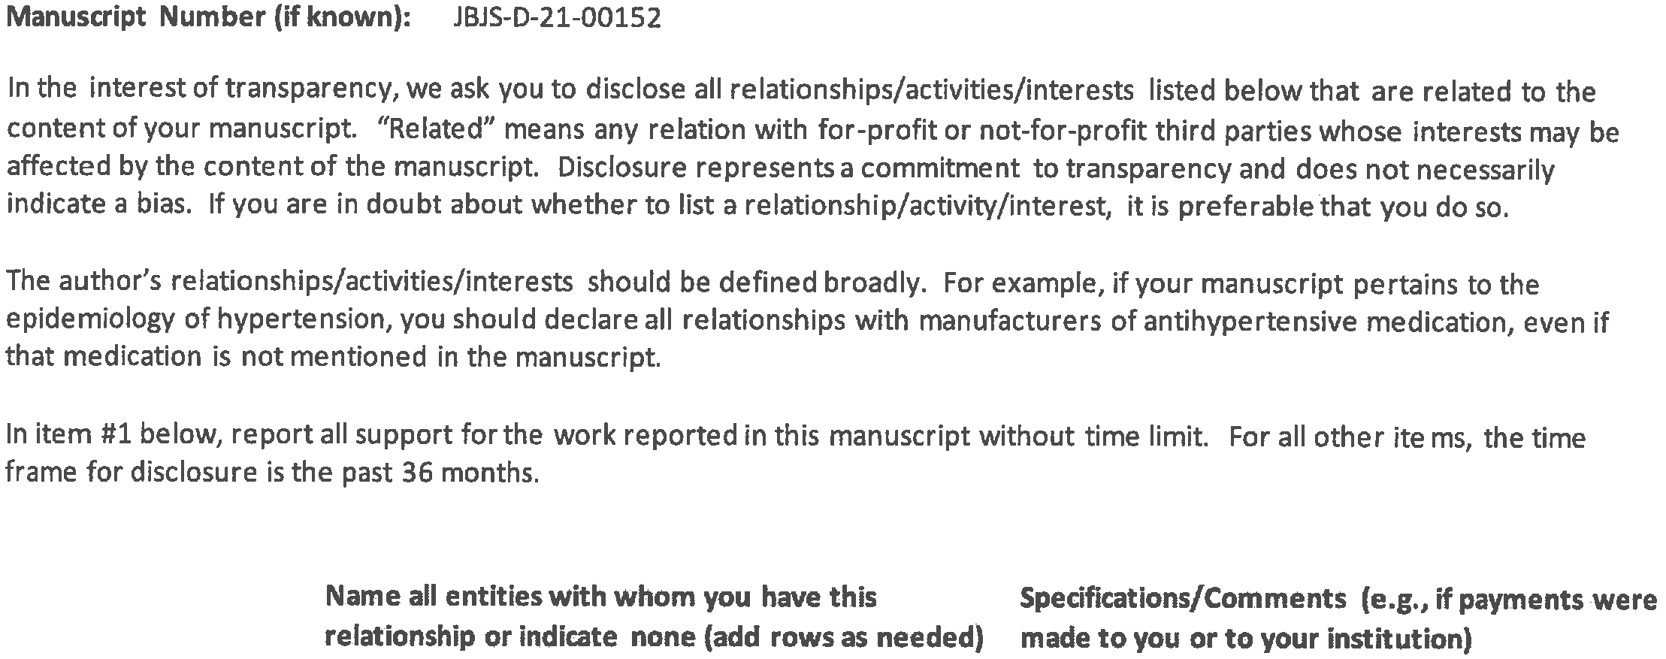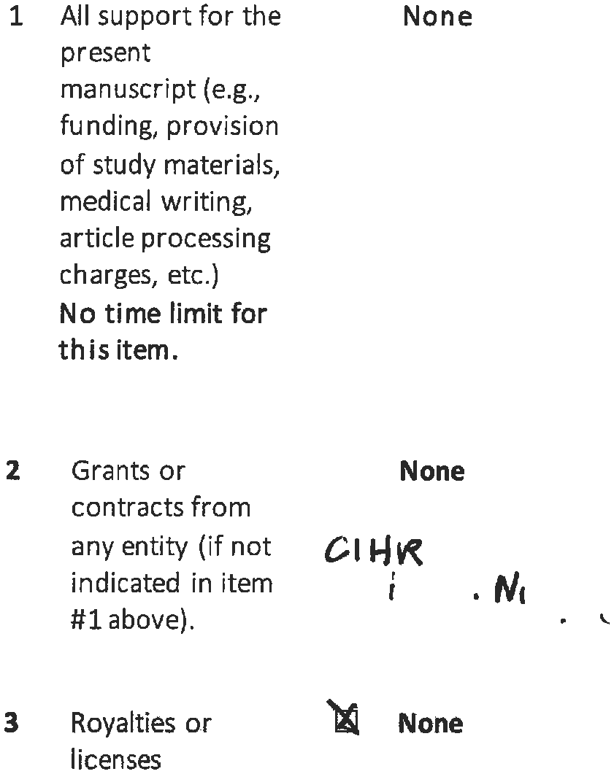
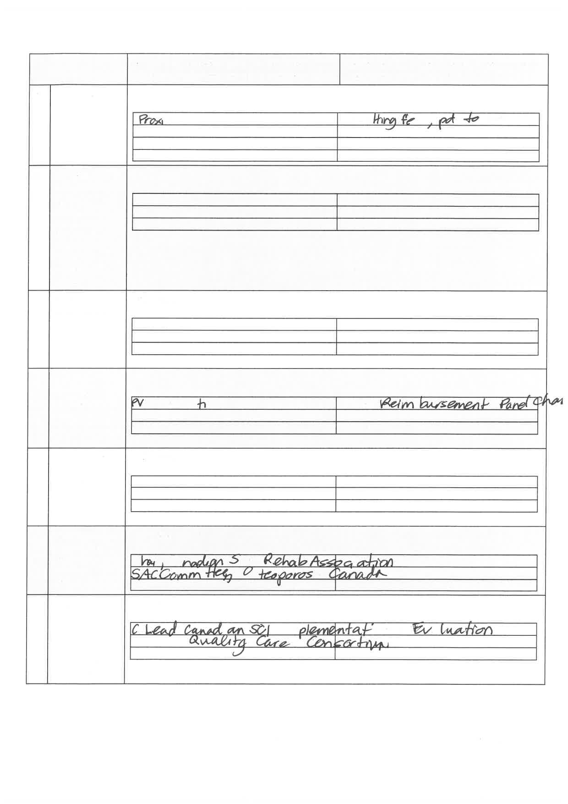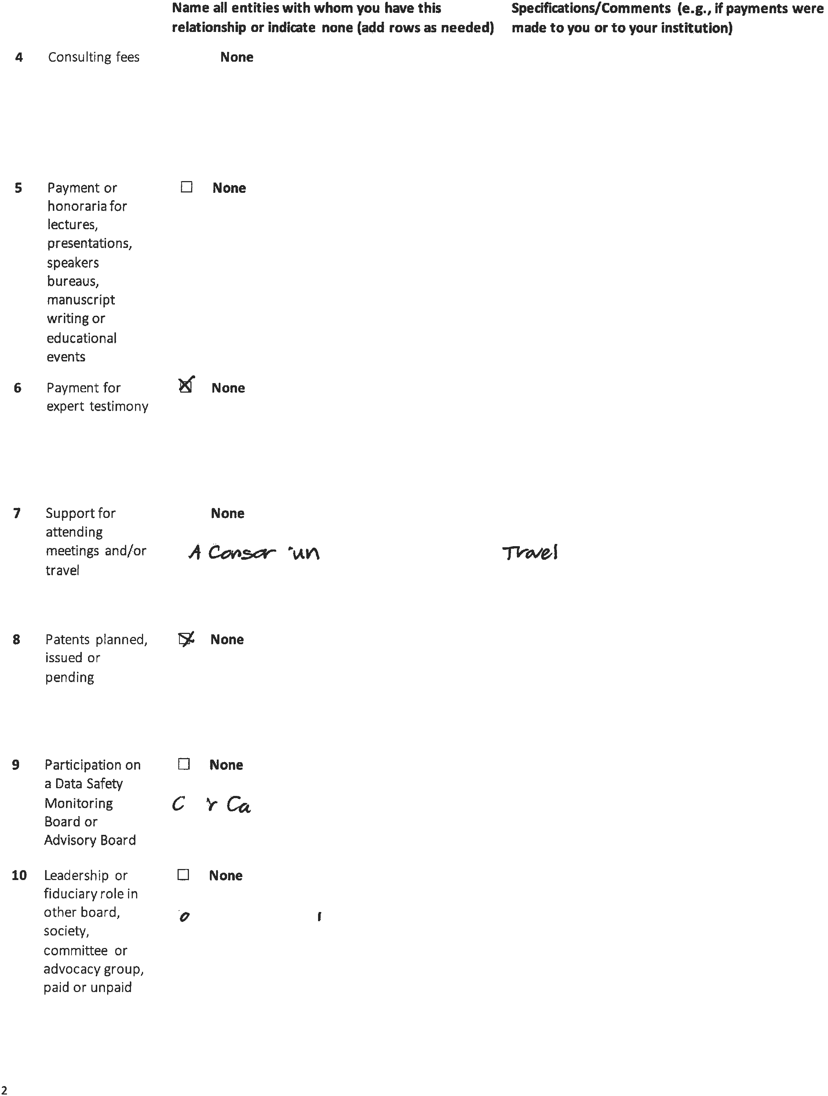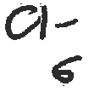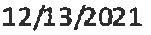
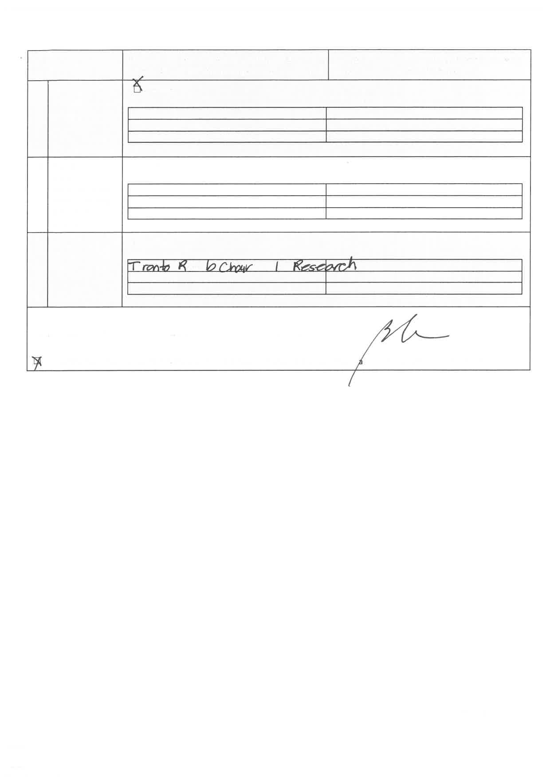

ICMJE DISCLOSURE FORM
Date: | 4/4/2022
Your Name: | William Obremskey
Manuscript Title: | Acute Lower Extremity Fracture Management in Chronic Spinal Cord Injury: 2022 Delphi Consensus Recommendations
Manuscript Number (if known): | JBJS-D-21-00152
In the interest of transparency, we ask you to disclose all relationships/activities/interests listed below that are related to the content of your manuscript. “Related” means any relation with for-profit or not-for-profit third parties whose interests may be affected by the content of the manuscript. Disclosure represents a commitment to transparency and does not necessarily indicate a bias. If you are in doubt about whether to list a relationship/activity/interest, it is preferable that you do so.

The author’s relationships/activities/interests should be defined broadly. For example, if your manuscript pertains to the epidemiology of hypertension, you should declare all relationships with manufacturers of antihypertensive medication, even if that medication is not mentioned in the manuscript.

In item #1 below, report all support for the work reported in this manuscript without time limit. For all other items, the time frame for disclosure is the past 36 months.

 |  |  | Name all entities with whom you have this relationship or indicate none (add rows as needed) | Specifications/Comments (e.g., if payments were made to you or to your institution)
Time frame: Since the initial planning of the work
1 | All support for the present manuscript (e.g., funding, provision of study materials, medical writing, article processing charges, etc.)  No time limit for this item. |  | ☒ None  Click the tab key to add additional rows.
Time frame: past 36 months
2 |  | Grants or contracts from any entity (if not indicated in item #1 above). | ☐ None  Department of Defense – Early weigh tbearing on ankle fractures  Department of Defense – PO vs IV antibiotics for iinfeted nonunions
3 |  | Royalties or licenses | ☒ None
4 |  | Consulting fees | ☒ None
5 |  | Payment or honoraria for lectures, presentations, speakers bureaus, manuscript writing or educational events | ☒ None
6 |  | Payment for expert testimony | ☐ None  Several law firms
7 |  | Support for attending meetings and/or travel | ☐ None  AO Inteernational
8 |  | Patents planned, issued or pending | ☒ None
9 |  | Participation on a Data Safety Monitoring Board or Advisory Board | ☒ None
10 |  | Leadership or fiduciary role in other board, society, committee or advocacy group, paid or unpaid | ☐ None  Southeastern Fracture Consortium Baord
11 |  | Stock or stock options | ☐ None
12 |  | Receipt of equipment, materials, drugs, medical writing, gifts or other services | ☐ None
13 |  | Other financial or non-financial interests | ☒ None
Please place an “X” next to the following statement to indicate your agreement:
☒ |  | I certify that I have answered every question and have not altered the wording of any of the questions on this form.

