Appendix 1. The Master Adaptive Learner Framework
Master Adaptive Learner
Beginning in the top right, the four phases of the Master Adaptive Learner cycle includes Identifying a gap and Planning out the learning; Engaging in effective science-based learning; Assessing and monitoring the success of the learning. The Adjusting phase explicitly describes the imperative for the learner to change their organization in consequence of their learning.

Examples of how the Master Adaptive Learner framework can inform EHR design to promote a Learning Organization:
- Planning: EHR alerting or reminder systems can help the clinician identify gaps in their knowledge; bookmarking functions allow management of learning needs
- Learning: Close integration with the organization’s Learning Management System makes just-in-time education feasible; learning analytic data can then be linked with clinical data; longitudinal data allows tracking of learning efficiency
- Assessing: Dashboards with clinical metrics can be another point of “gap identification”; structured reflections on the success of learning can be effective.
- Adjusting: The learner advocates for changes in work (i.e. EHR) processes based on their learning (e.g. new order entry set). Learning leads to innovation.

Appendix 2: The Plan-Do-Study-Act Cycle

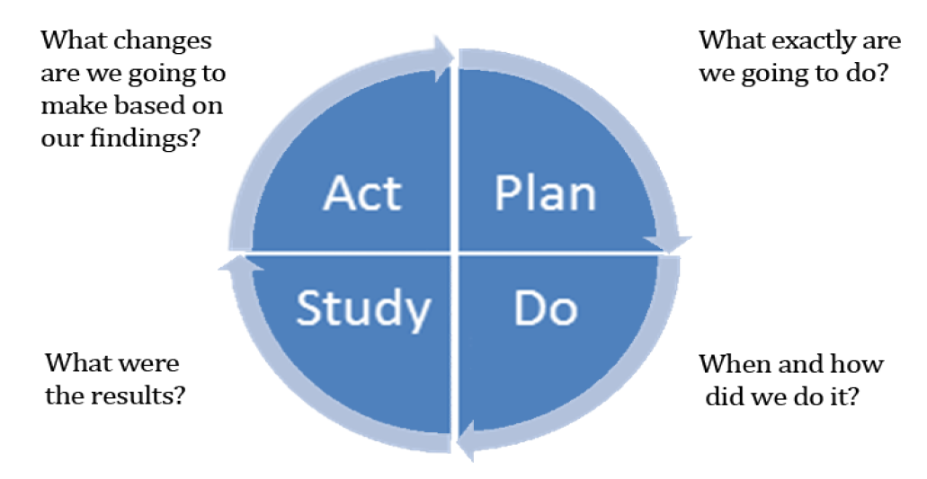

Plan-Do-Study-Act
Beginning in the top right, the four phases of the Plan-Do-Study-Act cycle includes: Plan, Identifying a gap and Planning out the quality improvement project; Do, Engaging in effective data collection; Study, Assessing and monitoring the success of the project; Act, the imperative for the learner to change their workflow or behavior in consequence of their learning.

The resemblance of the Master Adaptive Learner framework to the PDSA cycle is intentional. Whereas the unit of activity for the PDSA cycle is typically a Quality Improvement project, for the MAL cycle the goal is personal improvement leading to organizational change.

Examples of how the PDSA framework can inform EHR development in a Learning Organization:
- Plan: EHR alerting, reminder systems as well as Clinical Data Repositories can help the organization identify gaps in care and establish goals. Error reporting systems provide stimuli for critical incident methods
- Do: Carry out the QI project data collection within the EHR over a defined period of time.
- Study: Analysis of data; reflections collected from stakeholders.
- Act: The project team advocates for changes in work (e.g. EHR) processes based on their learning. Promotes innovation. Plans new cycle.

Appendix 3: Senge’s Five Disciplines of a Learning Organization

Senge’s Five Disciplines of the Learning Organization
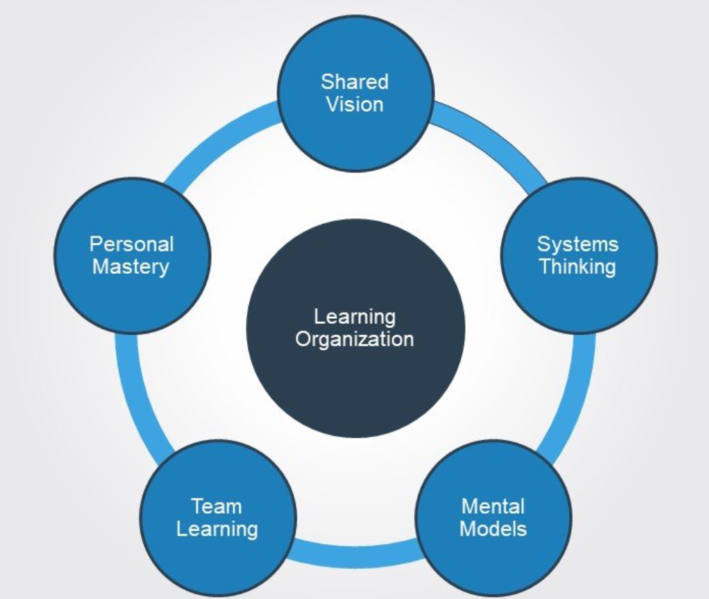
Senge Learning Organization
Unlike the MAL and PDSA cycles, the Senge Five Disciplines are not a lock-step cycle but rather different dimensions of a learning organization.

Examples of how the Senge framework can inform EHR (and overall Information system) development in a Learning Organization:
- Systems Thinking: the EHR is more than the component parts; learning is emergent from the interactions of the system’s components, as facilitated by and reflected in the EHR.
- Shared Vision: Co-created at all levels of the organization. Creates engagement with improvement processes; the shared vision changes with organizational learning. EHR evolves towards the shared vison. Or impedes it.
- Mental Models: Assumptions and generalizations that underpin peoples’ actions in an organization and with the EHR. An underappreciated area of study is to characterize individuals’ conceptualizations of the EHR and how it relates to the organization.
- Team Learning: Teams generate results that individuals cannot. If properly designed, EHRs can leverage those interactions.
- Personal Mastery: …of a clinical role involves knowing what is important and having an accurate view of the current reality; each can be communicated through the EHR.

