ONLINE SUPPLEMENT

Supplementary Table 2. Sensitivity analysis of treatment success in patients with Zenker’s diverticula. Sensitivity analysis was restricted to a) moderate/high quality studies, b) prospective studies, c) study location (East versus West). A further sensitivity analysis was performed restricted only to studies with standard Z-POEM. Numbers in parentheses indicate 95% confidence intervals.

Variable | Subgroup | No. of Cohorts | No. of patients | Summary Estimate (95% CI) | Within-group heterogeneity (I²)
Sample Adequacy
Study quality | High quality | 6 | 149 | 92.9% (89%-96.9%) | 0%
Study design | Prospective studies | 1 | 20 | 92.3% (84.4%-100%) | Not applicable
Location | East | 3 | 39 | 91.3% (83.6%-100%) | 23.3%
 | West | 7 | 257 | 90.8% (87.3%-94.4%) | 0%
Technique | Z-POEM | 6 | 221 | 89.8% (85.9%-93.8%) | 0%
Abbreviation: CI, Confidence Interval.

Supplementary Table 3. Meta-regression analysis of clinical success rate conducted separately according to diverticulum location

All studies (p heterogeneity= 0.62)
Studies evaluating POEM in Zenker’s diverticulum (p heterogeneity=0.43)
Timing of response assessment |  | -0.94 (-0.88 to 1.11) | 0.12 | 0% | 0.55
Diverticular size |  | -0.97 (-0.88 to 1.14) | 0.14 | 0% | 0.63
Prior treatment |  | -0.95 (-0.89 to 1.21) | 0.17 | 0% | 0.48
Studies evaluating POEM in epiphrenic diverticulum (p heterogeneity=0.85)
Timing of response assessment | -0.88 (-0.81 to 1.19) |  | 0.24 | 0% | 0.58
Diverticular size | -0.95 (-0.86 to 1.18) |  | 0.21 | 0% | 0.53
Prior treatment | -0.94 (-0.88 to 1.12) |  | 0.17 | 0% | 0.26
CI, Confidence Interval; POEM, Per-Oral Endoscopic Myotomy; SE, Standard Error
R² represents the amount of heterogeneity accounted for the variable

Supplementary Table 4. Adverse events reported in the included studies

Study, Year | Adverse events
Al Ghamdi, 2020 | Mild/moderate in 6 pts (6.6%)
Aslan 2019 | Subcutaneous emphysema in 5 pts (55.5%)
Basile 2020 | Mild fever (1 patient: 14.2%)
Demeter 2020 | Mucosal leak (1 patient: 14.2%)
Desai 2019 | Not specified in 14% of patients
Kinoshita 2020 | Pneumoperitoneum in 1 pt (7.1%)
Klingler 2020 | Perforation in 1 pt (5.2%)  Abscess in 1 pt (5.2%)
Yang 2020 | 5 pts (6.7%) : 1 bleeding and 4 perforations
Repici 2020 | 4 asymptomatic subcutaneous emphysema (20%)
Sanaei 2020 | Inadvertent mucosotomy in 2 pts (6.25%)  Mucosal leak in 2 pts (6.25%)

Supplementary Figure 1. Temporal kinetics of a) Dakkak and Bennett score in patients with Zenker’s diverticula, and b) Eckardt score in patients with epiphrenic diverficula after POEM

a)

b)

Supplementary Figure 2. Meta-regression plot of a) prior treatments and b) diverticular size on treatment success in patients with Zenker’s diverticula

a)

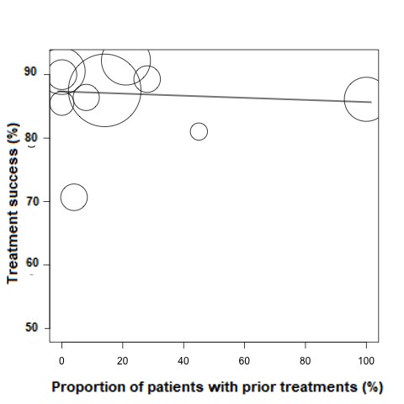

b)

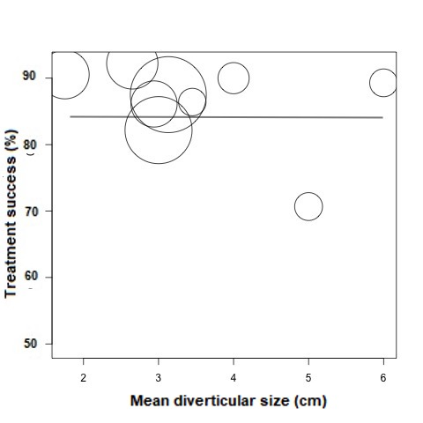

Supplementary Figure 3. Funnel plot concerning the risk of publication bias for treatment success analysis in a) patients with Zenker’s diverticula and b) epiphrenic diverticula

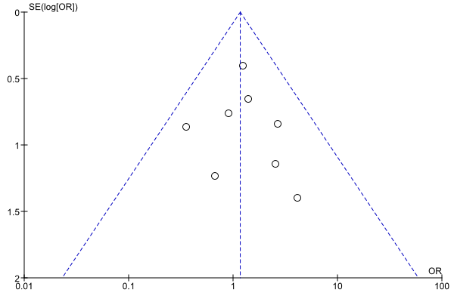

b)
