**SUPPLEMENTAL DIGITAL CONTENT**

**Supplementary Table 1. Studies 1, 2, and 3: Assessment Scales For A) Skin Irritation, B) Skin Discomfort, C) Patch Adhesion, and D) Adhesive Residue**

|  |  |  |
| --- | --- | --- |
| **Skin Irritation** | | |
| **Dermal Response Scale1** | | |
| Definition | Score | |
| No evidence of irritation | 0 | |
| Minimal erythema, barely perceptible | 1 | |
| Definite erythema, readily visible; or minimal edema or minimal papular response | 2 | |
| Erythema and papules | 3 | |
| Definite edema | 4 | |
| Erythema, edema, and papules | 5 | |
| Vesicular eruption | 6 | |
| Strong reaction spreading beyond test (ie, application) site | 7 | |
| **Other Effects Observation Scale** | | |
| Definition | | Score (Numerical Equivalent) |
| No other effects | | N (0) |
| Slightly glazed appearance | | A (0) |
| Marked glazed appearance | | B (1) |
| Glazing with peeling and cracking | | C (2) |
| Glazing with fissures | | F (3) |
| Film of dried serous exudates covering all or part of the patch site | | G (3) |
| Small petechial erosions and/or scabs | | H (3) |

**B.**

|  |  |
| --- | --- |
| **Skin Discomfort** | |
| **Experience of Discomfort Scale** | |
| Definition | Score |
| No discomfort | 0 |
| Mild discomfort | 1 |
| Moderate but tolerable discomfort | 2 |
| Severe, intolerable discomfort | 3 |
| Not applicable, patch detached (completely off the skin) | 4 |

**C.**

|  |  |
| --- | --- |
| **Patch Adhesion** | |
| Definition | Score |
| ≥90% adhered (essentially no lift off the skin) | 0 |
| ≥75% to <90% adhered (some edges only lifting off the skin) | 1 |
| ≥50% to <75% adhered (less than half the patch lifting off the skin) | 2 |
| >0% to <50% adhered but not detached (more than half the patch lifting off of the skin without falling off) | 3 |
| 0% adhered – patch detached (patch completely off the skin) | 4 |

**D.**

|  |  |
| --- | --- |
| **Adhesive Residue** | |
| **Adhesive Residue Scale** | |
| Definition | Score |
| None | 0 |
| Light | 1 |
| Medium | 2 |
| Heavy | 3 |

**Supplementary Table 2. Studies 1, 2, and 3: Subject Demographics**

|  |  |  |  |  |  |
| --- | --- | --- | --- | --- | --- |
|  | **Study 1** | **Study 2** | | | **Study 3** |
|  | Overall  (N=18) | Caucasian  (n=20) | Japanese  (n=20) | Overall  (N=40) | Overall  (N=24) |
| **Age** (years), mean (SD) | 29.3 (6.3) | 29 (6) | 29 (4) | 29 (5) | 38.5 (13.5) |
| **Weight** (kg), mean (SD) | 71.2 (11.2) | 63.9 (9.2) | 56.9 (6.8) | 60.4 (8.8) | 88.6 (16.6) |
| **BMI** (kg/m2)  mean (SD) | 24.8 (2.7) | 22.2 (1.9) | 20.9 (1.4) | 21.5 (1.8) | 28.1 (4.9) |
| **Sex**, n (%) | | | | | |
| Male | 9 (50.0) | 10 (50.0) | 10 (50.0) | 20 (50.0) | 22 (91.7) |
| Female | 9 (50.0) | 10 (50.0) | 10 (50.0) | 20 (50.0) | 2 (8.3) |
| **Race**, n (%) | | | | | |
| White | 14 (77.8) | 20 (100.0) | 0 | 20 (50.0) | 18 (75.0) |
| Black | 3 (16.7) | 0 | 0 | 0 | 3 (12.5) |
| Asian | 0 | 0 | 20 (100.0) | 20 (50.0) | 1 (4.2) |
| Mixed | 1 (5.6) | 0 | 0 | 0 | 2 (8.3) |

BMI, body mass index; PK, pharmacokinetic; SD, standard deviation.

**Supplementary Table 3. Residual Asenapine Maleate-Related Parameters for HP-3070 Patches After Removal 24 Hours After Application**

|  |  |  |  |  |  |
| --- | --- | --- | --- | --- | --- |
| **HP-3070 Treatment** | **n** | **Residual amounta, mg**  **Mean (CV)** | **Residual drug**  **% (CV)** | **Apparent dose, mg**  **Mean (CV)** | **Drug released**  **% (CV)** |
| **Study 1** | | | | | |
| HP-3070 1.9 mg/24h  No heat application | 17 | 1.7 (13.6) | 38.1 (13.7) | 2.7 (8.4) | 61.9 (8.4) |
| HP-3070 1.9 mg/24h  8-hour heating pad application | 16 | 1.3 (18.1) | 30.8 (18.0) | 3.0 (8.0) | 69.2 (8.0) |
| **Study 2** | | | | | |
| HP-3070 3.8 mg/24h Abdomen | 40 | 4.1 (18.7) | 46.7 (18.7) | 4.7 (16.4) | 53.3 (16.4) |
| HP-3070 3.8 mg/24h Hip area | 40 | 3.7 (19.9) | 42.5 (19.9) | 5.0 (14.7) | 57.5 (14.7) |
| HP-3070 3.8 mg/24h Upper arm | 40 | 3.5 (23.4) | 40.0 (23.4) | 5.3 (15.6) | 60.0 (15.6) |
| HP-3070 3.8 mg/24h Upper back | 40 | 3.6 (18.2) | 40.5 (18.2) | 5.2 (12.4) | 59.5 (12.4) |
| HP-3070 3.8 mg/24h Upper chest | 40 | 4.0 (16.7) | 45.7 (16.7) | 4.8 (14.0) | 54.3 (14.0) |
| HP-3070 3.8 mg/24h Caucasian subjects | 20 | 3.5 (21.7) | 40.2 (21.7) | 5.2 (14.6) | 59.8 (14.6) |
| HP-3070 3.8 mg/24h Japanese subjects | 20 | 4.0 (16.8) | 45.9 (16.8) | 4.7 (14.2) | 54.1 (14.3) |
| **Study 3** | | | | | |
| HP-3070 1.9 mg/24h | 22 | 1.9 (27.6) | 43.4 (27.6) | 2.5 (21.2) | 56.6 (21.2) |
| HP-3070 3.8 mg/24h | 21 | 3.7 (21.2) | 42.7 (21.2) | 5.0 (15.8) | 57.3 (15.8) |
| HP-3070 5.7 mg/24h | 20 | 5.1 (26.3) | 39.1 (26.3) | 8.0 (16.9) | 60.9 (16.9) |
| HP-3070 7.6 mg/24h | 20 | 6.7 (18.0) | 38.9 (18.0) | 10.6 (11.5) | 61.1 (11.5) |

CV, coefficient of variation.

**Supplementary Table 4. Studies 1, 2, and 3: Summary of Dermal Assessment Scores**

|  |  |  |  |  |  |  |  |  |  |  |  |
| --- | --- | --- | --- | --- | --- | --- | --- | --- | --- | --- | --- |
| **Dermal assessment** | **Study 1** | | **Study 2** | | | | | **Study 3** | | | |
| **HP-3070**  **1.9 mg/24h** | | **HP-3070**  **3.8 mg/24h** | | | | | **HP-3070** | | | |
| With 8 hours heat  (n=16) | Without heat  (n=17) | Upper back  (n=40) | Abdomen  (n=40) | Upper chest  (n=40) | Hip  (n=40) | Upper arm  (n=40) | 1.9 mg/24ha  (n=24) | 3.8 mg/24h  (n=22) | 5.7 mg/24h  (n=21) | 7.6 mg/24h  (n=20) |
| Combined worst skin irritation score ≥3a, n (% of subjects) | 0 | 0 | 1 (2.5)b | 0b | 0b | 0b | 0b | 0 | 0 | 2 (9.5) | 1 (5) |
| Moderate but tolerable discomfort (Score ≥2), n (% of subjects) | 0 | 0 | 0 | 0 | 0 | 0 | 0 | 0 | 0 | 1 (4.8)c | 2 (10.0) |
| Patch ≥90% adhered at any time during the study (Score=0), n/number of evaluationsd (% of evaluations) [number of patches evaluated] | 14/16  (87.5)  [16] | 17/17  (100)  [17] | 158/160  (98.8) [40] | 155/160  (96.9) [39] | 151/160  (94.4)  [40] | 156/160(97.5) [40] | 155/160  (96.9) [40] | 653/681  (95.9) [165] | 583/638 (91.4)  [154] | 519/594 (87.4)  [144] | 463/580 (79.8)  [140] |
| Adhesive residue light or greater (Score ≥1), n/number of patches evaluated (% of evaluated patches) | 0/16  (0) | 1/17  (5.9) | 1/40 (2.5) | 1/40  (2.5) | 0/40  (0) | 3/40 (7.5) | 0/40  (0) | 12/163 (7.4) | 7/154 (4.5) | 6/144 (4.2) | 8/140  (5.7) |

aCombined skin irritation score = sum of Dermal Response and Other Effects score.

bDermal Response score ≥3 or Other Effects score ≥3.

cDiscomfort score of 4 (not applicable, patch completely detached).

dStudy 1 evaluation: 24 hours post-dose; Study 2 evaluations: 2, 4, 12, 24 hours post-dose; Study 3 evaluations: 2, 4, 12, 24 hours post-dose.

**Supplementary Table 5. Studies 1, 2, and 3: Summary of TEAEs Related to Study Treatment Occurring in ≥7% of Subjects in Any HP-3070 Treatment Group by SOC**

|  |  |  |  |  |  |  |  |  |  |  |  |  |  |
| --- | --- | --- | --- | --- | --- | --- | --- | --- | --- | --- | --- | --- | --- |
| **Preferred term, n (%)** | **Study 1** | | | | **Study 2** | | | | | **Study 3** | | | |
| **HP-3070**  **1.9 mg/24h** | | | **Sublingual Asenapine** | **HP-3070 3.8 mg/24h** | | | | | **HP-3070** | | | |
| With 8 hours heat  (n=16) | Without heat  (n=17) | 5 mg BID  (n=17) | | Upper back  (n=40) | Abdomen  (n=40) | Upper chest  (n=40) | Hip  (n=40) | Upper arm  (n=40) | 1.9 mg/24ha  (n=24) | 3.8 mg/24h  (n=22) | 5.7 mg/24h  (n=21) | 7.6 mg/24h  (n=20) |
| Somnolence | 0 | 0 | 9 (52.9) | | 7 (17.5) | 2 (5.0) | 6 (15.0) | 6 (15.0) | 4 (10.0) | 3 (12.5) | 1 (4.5) | 0 | 2 (10.0) |
| Application site erythema | 8 (50.0) | 14 (82.4) | 0 | | 0 | 1 (2.5)a | 0 | 0 | 0 | 0 | 1 (4.5)b | 1 (4.8)c | 0 |
| Dizziness | 2 (12.5) | 1 (5.9) | 6 (35.3) | | 1 (2.5) | 1 (2.5) | 1 (2.5) | 0 | 1 (2.5) | 1 (4.2) | 1 (4.5) | 0 | 1 (5.0) |
| Headache | 2 (12.5) | 1 (5.9) | 1 (5.9) | | 0 | 0 | 3 (7.5) | 0 | 1 (2.5) | 1 (4.2) | 2 (9.1) | 0 | 0 |
| Insomnia | 0 | 0 | 0 | | 0 | 1 (2.5) | 3 (7.5) | 3 (7.5) | 3 (7.5) | 0 | 1 (4.5) | 0 | 0 |
| Fatigue | 0 | 1 (5.9) | 0 | | 1 (2.5) | 1 (2.5) | 0 | 2 (5.0) | 3 (7.5) | 0 | 0 | 1 (4.8) | 0 |

aPreferred term: Application site irritation.

bPreferred term: Application site discoloration.

cPreferred term: Application site reaction.

BID, twice daily.

**Supplementary Figure 1. HP-3070 Patch Application**



**Supplementary Figure 2. Study 3: Dose Proportionality of Steady-State Asenapine A) AUC0-24 and B) Cmax Following Multiple Dosing of HP-3070 and Comparison to Sublingual Asenapine 5 and 10 mg BID in Patients With Schizophrenia**

**A.**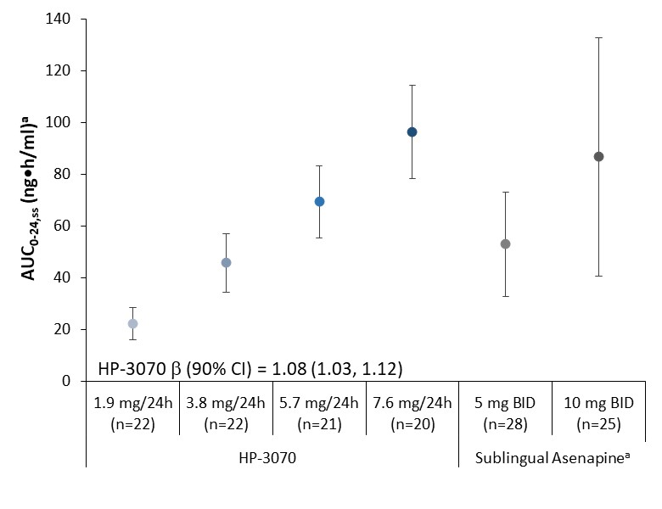

Data shown as mean±SD.

aMean AUC0-24 for sublingual asenapine was calculated as double the reported mean AUC0-12 and is presented for comparison purposes.2

AUC0-12, area under the curve from 0 to 12 hours; AUC0-24,ss, area under the plasma concentration-time curve from time 0 to 24 hours at steady-state; BID, twice daily; SD, standard deviation.

**B. 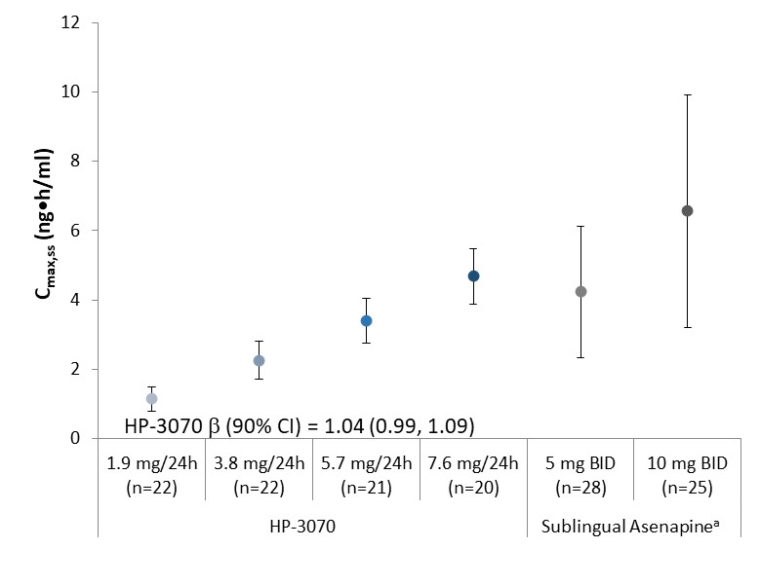**Data shown as mean±SD.

aReported mean Cmax for sublingual asenapine is presented for comparison purposes.2

BID, twice daily;Cmax,ss, maximum observed plasma concentration at steady state; SD, standard deviation.

**SUPPLEMENTARY DOCUMENT 1**

*Plasma Asenapine Concentrations From Blood Samples*

Aliquots of plasma were obtained after centrifugation of blood samples, and asenapine concentrations were determined using validated liquid chromatography with electrospray ionization/positive ion tandem mass spectrometry detection methods (LC-MS/MS).

*Study 1*

The internal standard was asenapine-13C,d3. Analytes were isolated through liquid-phase extraction. The final extract was analyzed via HPLC with MS/MS detection using positive ion electrospray ionization (monitored ion [*m/z* (mass-to-charge ratios)] 286.1→229.1 for asenapine and 290.2→229.0 for internal standard). Calibration curves covered the asenapine concentration range of 0.0500 to 50.0 ng/mL and required a 300-L human plasma aliquot. Inter-day accuracy (% difference from theoretical concentration) ranged from -8.47% to 2.23%, and precision (%CV) ranged from 1.19% to 9.25%. Intra-day accuracy ranged from -5.17% to 0.314%, and intra-day precision ranged from 2.36% to 6.86%.

*Study 2 and Study 3*

The internal standard was 13C6-asenapine. Analytes were isolated through liquid-liquid extraction.

Liquid chromatography was performed using an Acquity UPLC BEH C18 column (2.1 mm x 50 mm, Waters, Inc.) with a mobile phase of formic acid in water and acetonitrile. Detection was performed via MS/MS using positive ion electrospray ionization (monitored ion [*m/z*] 286.0→229.1 for asenapine and 292.2→235.1 for internal standard). Calibration curves covered the asenapine concentration range of 0.0100 to 10.0 ng/mL and required 200 L aliquots of plasma. Inter-day accuracy (% difference from theoretical concentration) ranged from -2.6% to 3.8%, and precision (%CV) ranged from 2.7% to 10.0%. Intra-day accuracy and precision ranged from -6.2 to 7.9% and 0.9 to 13.1%, respectively.

*Residual Asenapine Maleate in HP-3070 Patches and Apparent Dose*

Analysis of residual asenapine maleate in the transdermal patches following patch removal was performed using a validated HPLC method with ultraviolet detection. A patch, with the release liner removed, was extracted through liquid-phase extraction. The resulting solution was centrifuged and then combined with internal standard solution. Liquid chromatography was performed using a stainless steel TSKgel ODS-80Ts column (5 μm, 4.6 mm x 15 cm, Tosoh Corporation) and a mobile phase mixture of methanol and diluted phosphoric acid containing anionic surfactant. Detection was performed using an ultraviolet spectrophotometer (measured wavelength: 230 nm). Analytical range was 10 to 120% of asenapine maleate, and linearity was well-established (R=1.000). Recovery ranged from 98.8 to 99.8%, and precision (%CV) was 0.38%. Apparent dose, % residual drug, and % drug released were calculated using the initial and residual drug content in the patch.

**References**

1. Berger RS, Bowman JP. A reappraisal of the 21-day cumulative irritation test in man. *Cutan Ocul Toxicol*. 1982;1:109-115.
2. Chapel S, Hutmacher MM, Haig G, et al. Exposure-response analysis in patients with schizophrenia to assess the effect of asenapine on QTc prolongation. *J Clin Pharmacol*. 2009;49:1297-1308.