Contents of On-Line Supplement

Figure S1. Study Design and Disposition of Patients
Figure S2. Least-Square Mean Change (±SE) from Baseline for MADRS Total Score During the Follow-up Phase (MMRM; Observed Cases)
Figure S3. Remission Rate During the Double-Blind Treatment Phase
Figure S4. Response Rate During the Double-Blind Treatment Phase
Figure S5. Least-Squares Mean (95% CI) Treatment Difference on CGI SS r and Other Suicidality Indices During the Double-Blind Treatment Phaseª
Table S1. Summary of Most Frequently Reported Adverse Events During the Follow-up Phase
Table S2. Treatment-Emergent Serious Adverse Events During the Double-Blind Treatment Phase
Table S3. Serious Adverse Events During the Follow-up Phase

Figure S1. Study Design and Disposition of Patients
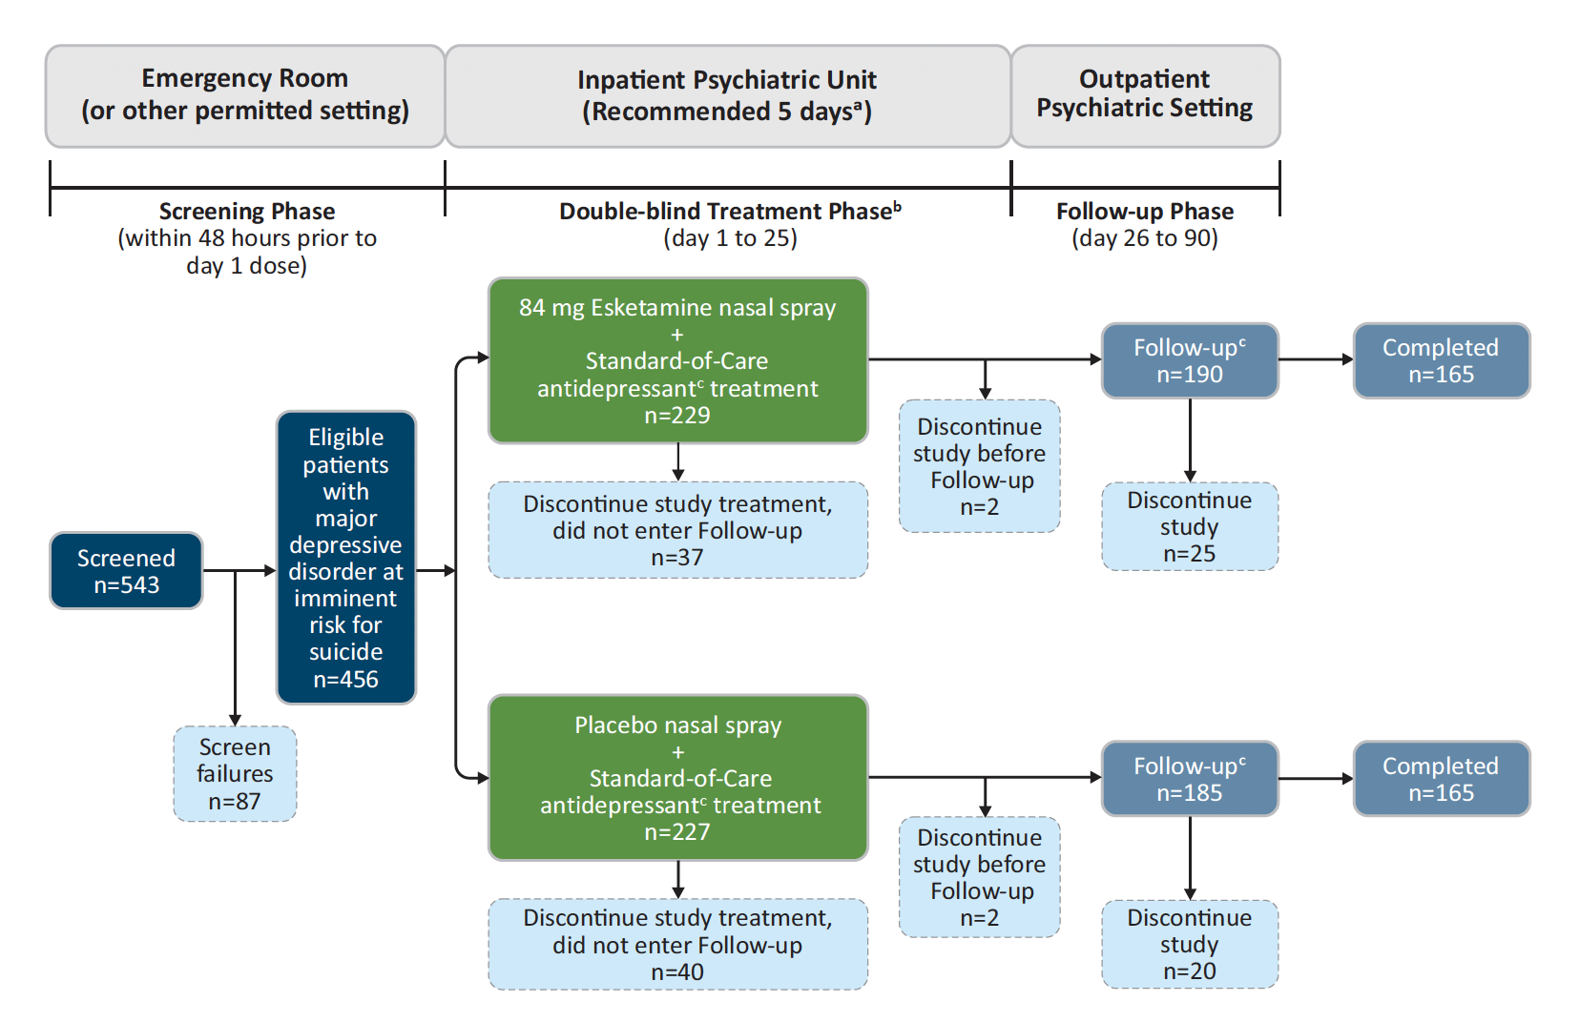
ª14 days in certain countries within the European Union
^{b}Patients who completed the double-blind phase and either entered the follow-up phase or had adverse events evaluated after the double-blind treatment phase.
^{c}Standard antidepressant was initiated or optimized on day 1.
Note: Five patients were not included in the efficacy analysis dataset due to discontinuing prior to receiving study drug or not providing postbaseline efficacy data.

Figure S2. Least-Squares Mean Change (±SE) from Baseline for MADRS Total Score During the Follow-up Phase (MMRM; Observed Cases)

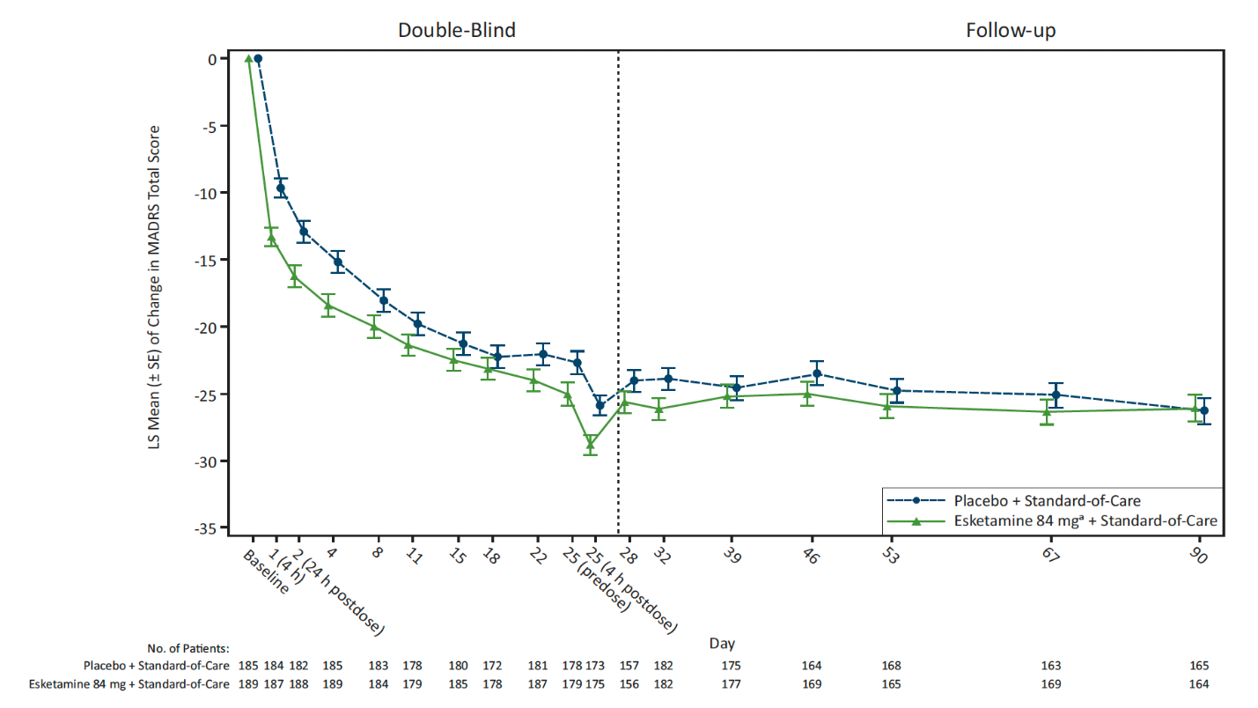

LS = least squares; MADRS = Montgomery-Åsberg Depression Rating Scale; MMRM = mixed-effects model using repeated measures; SE = standard error
- Includes patients who had their dose reduced due to tolerability issues.
Notes: Negative change in score indicates improvement.
During the follow-up phase, these were patients formerly treated with placebo and patients formerly treated with esketamine.

Figure S3. Remission Rate During the Double-Blind Treatment Phase
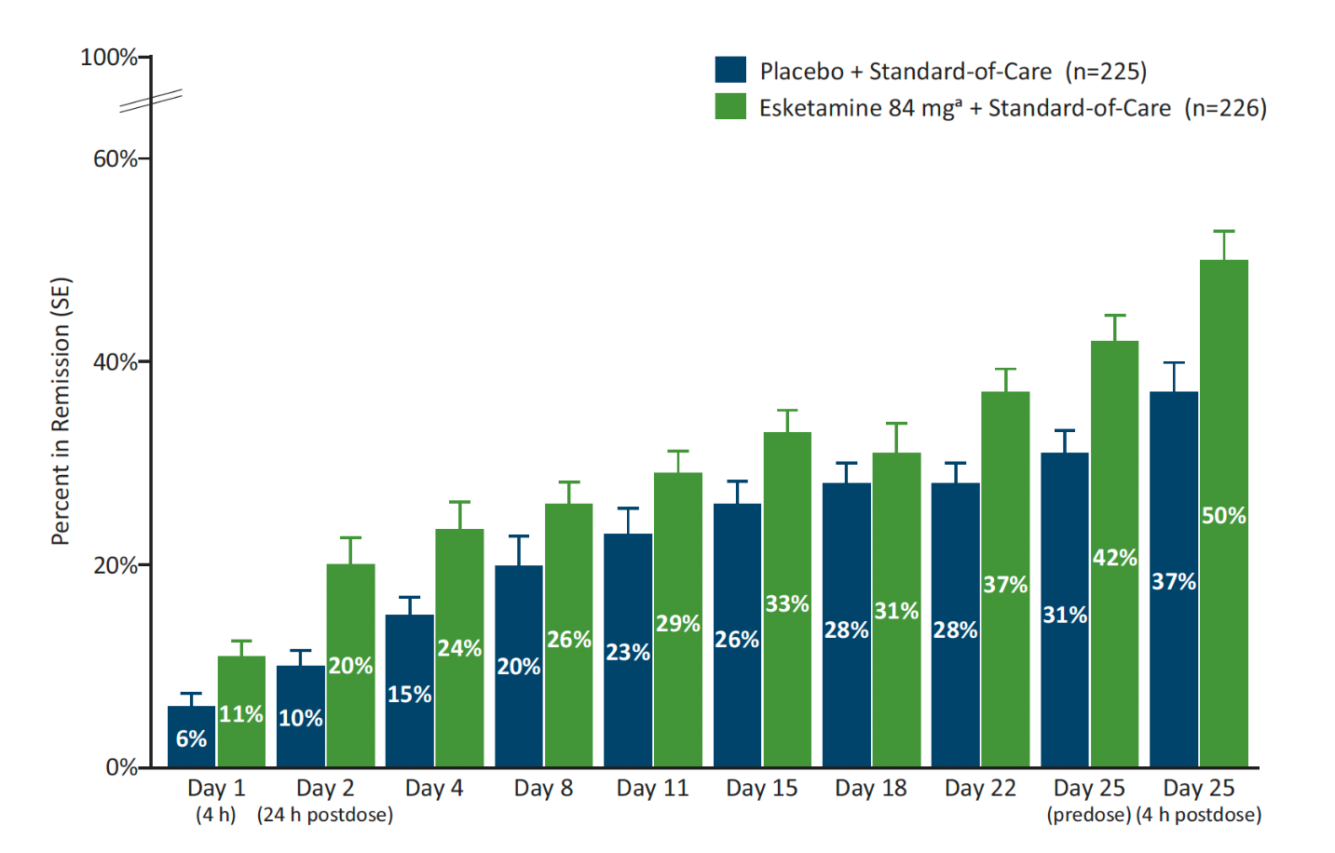
MADRS = Montgomery-Åsberg Depression Rating Scale; SE = standard error
- Includes patients who had their dose reduced due to tolerability issues.
Notes: Remission defined as MADRS total score ≤12. Patients who did not meet such criterion or discontinued prior to the time point for any reason were not be considered to be in remission. Negative change in score indicates improvement.

Figure S4. Response Rate During the Double-Blind Treatment Phase
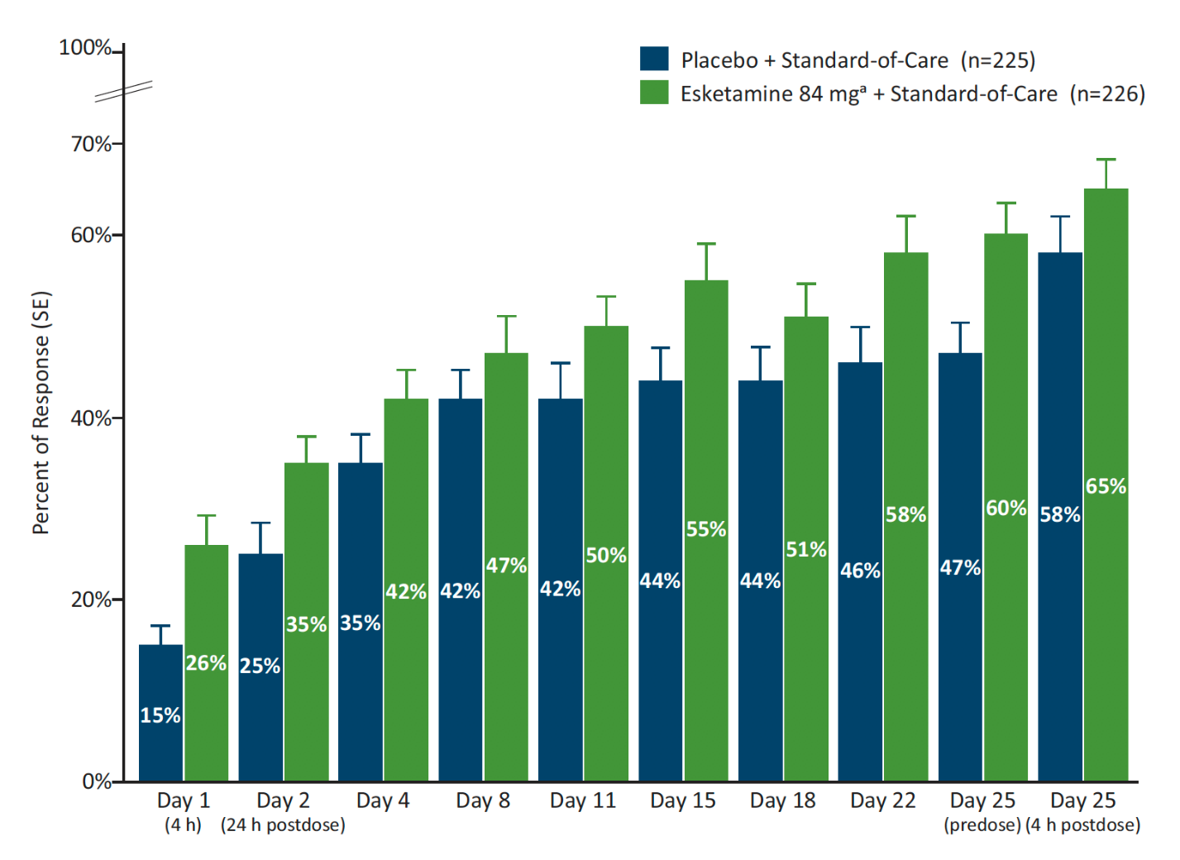
MADRS = Montgomery-Åsberg Depression Rating Scale; SE = standard error
ªIncludes patients who had their dose reduced due to tolerability issues.
Notes: Response defined as ≥50% reduction in MADRS total score. Patients who did not meet such criterion or discontinued prior to the time point for any reason were not considered a responder.

Figure S5. Least-Squares Mean (95% CI) Treatment Difference on CGI-SS-r and Other Suicidality Indices During the Double-Blind Treatment Phaseª
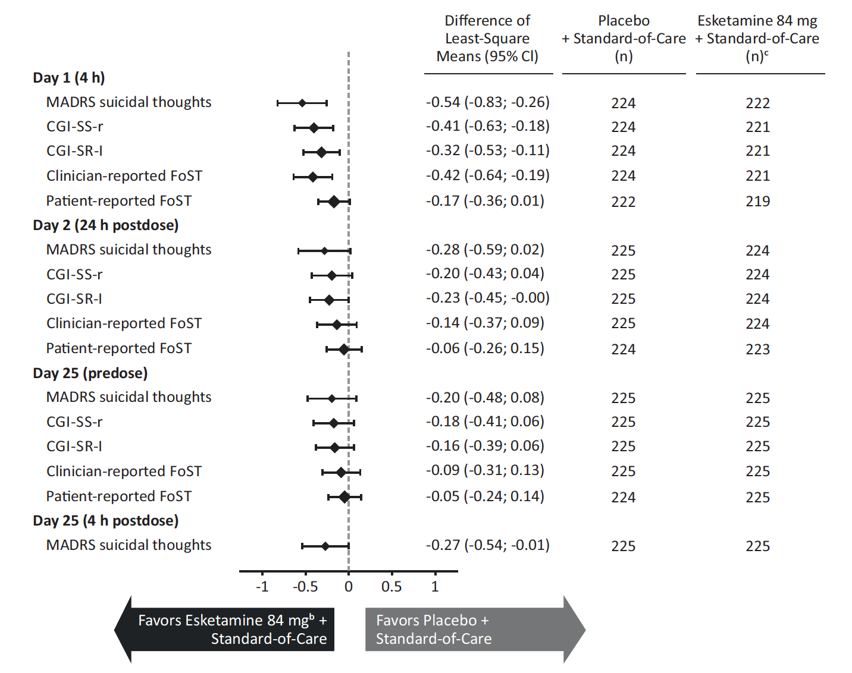

ANCOVA = analysis of covariance, CGI-SR-I = Clinical Global Impression–Imminent Suicide Risk, CGI-SS-r = Clinical Global Impression of Severity of Suicidality Revised version, FoST = Frequency of Suicidal Thinking, LOCF = last observation carried forward, LS = least-squares, MADRS = Montgomery-Åsberg Depression Rating Scale
ªChange in suicidal indices score was analyzed using ANCOVA with LOCF.
^{b}Includes patients who had their dose reduced due to tolerability issues.
^{c}At baseline, 1 patient had missing MADRS data and another patient had missing CGI-SS-r, CGI-SR-I, and clinician-rated FoST data, two other patients had missing patient-reported FoST data.
Note: The SIBAT contains 8 modules, including the clinician-reported CGI-SS-r, rated on a 0–6 scale (0=normal, not at all suicidal to 6=among the most extremely suicidal patients), CGI-SR-I, rated on a 0–6 scale (0=no imminent suicidal risk to 6=extreme imminent suicidal risk), clinician-reported FoST, rated on a 0–5 scale (0=never to 5=all of the time), and patient-reported FoST, rated on a 0–4 scale (0=no suicidal thoughts to 4=suicidal thoughts all the time).

Table S1. Summary of Most Frequently Reportedª Adverse Events During the Follow-up Phase
 | Number (%) of Patients
Adverse Event | Placebo + Standard-of-Care  N = 185 | Esketamine 84 mg^{b} + Standard-of-Care  N = 190
Depression | 6 (3.2) | 13 (6.8)
Headache | 17 (9.2) | 13 (6.8)
Insomnia | 11 (5.9) | 12 (6.3)
Anxiety | 18 (9.7) | 11 (5.8)
Suicidal ideation | 12 (6.5) | 10 (5.3)
ª Most frequently reported is defined as ≥5% of patients in either treatment group during the follow-up phase. Events are presented in descending order in the esketamine group and in alphabetical order for events with same incidence.
^{b} Includes patients who had their dose reduced due to tolerability issues.

Table S2. Treatment-Emergent Serious Adverse Events During the Double-Blind Treatment Phase
 | Number (%) of Patients
Adverse Eventª | Placebo + Standard-of-Care  N = 225 | Esketamine 84 mg^{b} + Standard-of-Care  N = 227
Suicide attempt | 4 (1.8) | 4 (1.8)
Depression suicidal | 1 (0.4) | 2 (0.9)
Depersonalisation/derealisation disorder | 0 | 1 (0.4)
Depression | 2 (0.9) | 1 (0.4)
Diabetic ketoacidosis | 0 | 1 (0.4)
Suicidal ideation | 4 (1.8) | 1 (0.4)
Aggression | 1 (0.4) | 0
Arrhythmia | 1 (0.4) | 0
Hypertransaminasemia | 1 (0.4) | 0
Pericardial effusion | 1 (0.4) | 0
Pneumothorax | 1 (0.4) | 0
ª Events are presented in descending order in the esketamine group and in alphabetic order for events with same incidence.
^{b} Includes patients who had their dose reduced due to tolerability issues.
Note: A serious adverse event is any untoward medical occurrence that, at any dose: resulted in death; was life-threatening; required inpatient hospitalization or prolongation of existing hospitalization; resulted in persistent or significant disability/incapacity; was a congenital anomaly/birth defect; was a suspected transmission of any infectious agent via a medicinal product; or was medically important.

Table S3. Serious Adverse Events During the Follow-up Phase
 | Number (%) of Patients
Adverse Event | Placebo + Standard-of-Care  N = 185 | Esketamine 84 mg^{b} + Standard-of-Care  N = 190
Suicide attempt | 3 (1.6) | 7 (3.7)
Depression suicidal | 5 (2.7) | 5 (2.6)
Suicidal ideation | 6 (3.2) | 5 (2.6)
Depression | 1 (0.5) | 2 (1.1)
Major depression | 0 | 2 (1.1)
Acute stress disorder | 0 | 1 (0.5)
Completed suicide | 0 | 1 (0.5)
Hemothorax | 0 | 1 (0.5)
Encephalopathy | 1 (0.5) | 0
Erysipelas | 1 (0.5) | 0
Homicidal ideation | 1 (0.5) | 0
Overdose | 1 (0.5) | 0
Papillary thyroid cancer | 1 (0.5) | 0
Pyelonephritis | 1 (0.5) | 0
Rhabdomyolysis | 1 (0.5) | 0
Staphylococcal bacteremia | 1 (0.5) | 0
ª Events are presented in descending order in the esketamine group and in alphabetic order for events with same incidence.
^{b} Includes patients who had their dose reduced due to tolerability issues.
Note: A serious adverse event is any untoward medical occurrence that, at any dose: resulted in death; was life-threatening; required inpatient hospitalization or prolongation of existing hospitalization; resulted in persistent or significant disability/incapacity; was a congenital anomaly/birth defect; was a suspected transmission of any infectious agent via a medicinal product; or was medically important.

