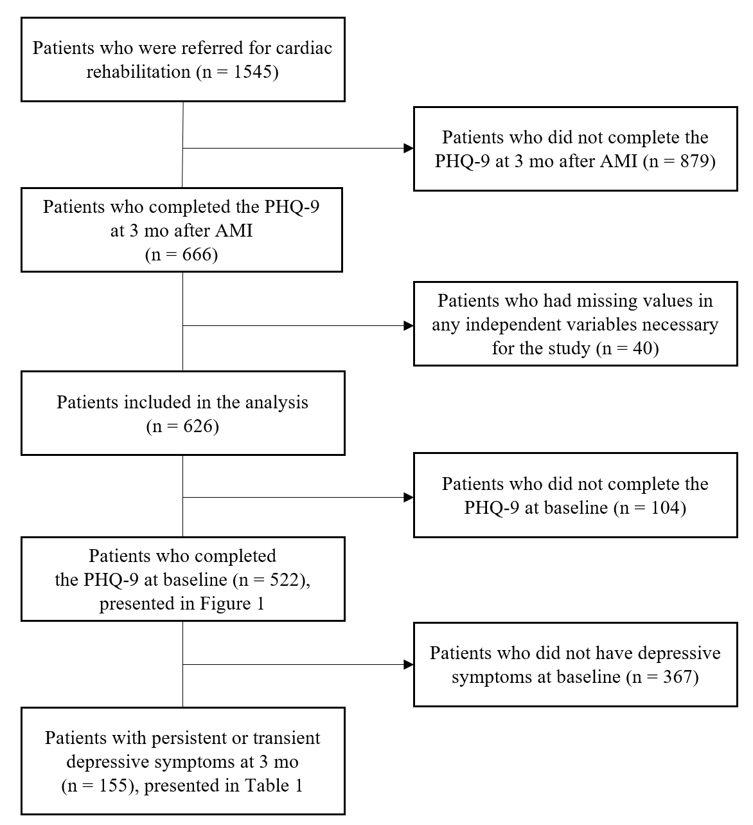
Supplement Digital Content 1. Flow diagram for participant selection.

