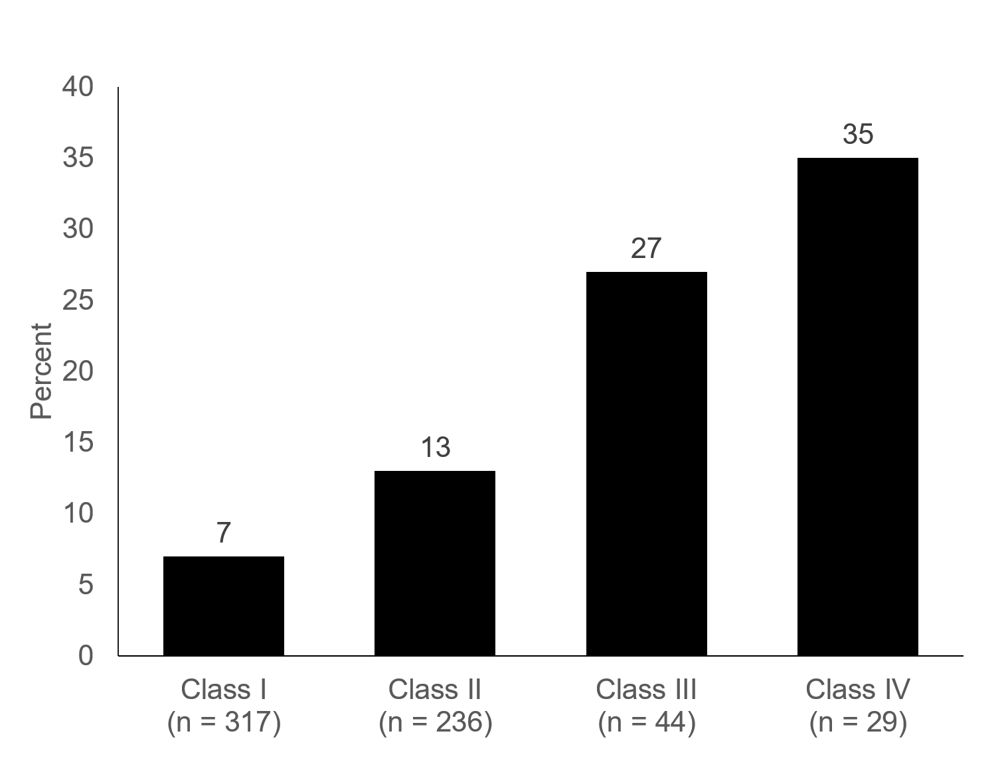
Supplementary Digital Content 2. The proportion of patients with depressive symptoms based on the functional capacity classification measured by Korean Activity Status Index at 3 mo after myocardial infarction

