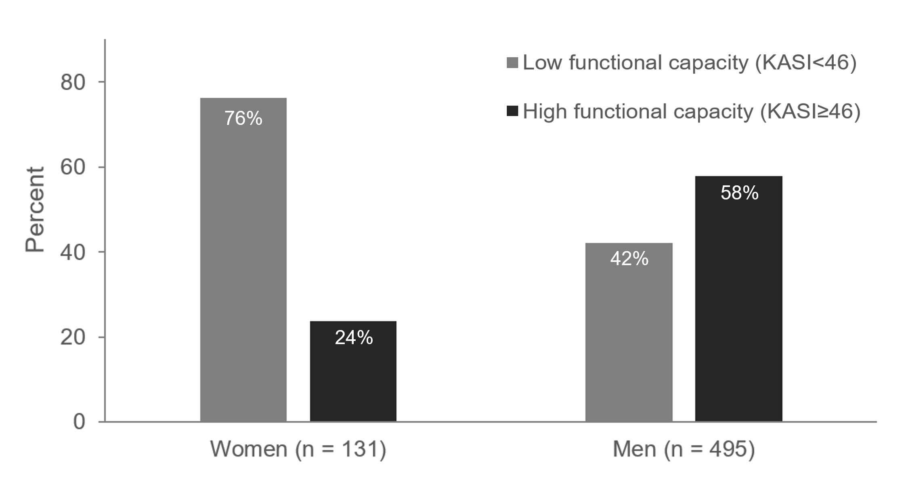
Supplemental Digital Content 4. Difference of functional capacity by sex in patients 3 mo after myocardial infarction (N = 626).
Functional capacity was dichotomized as Korean Activity Scale/Index (KASI) class I and II-IV. P Value < .001 (Pearson chi-squared test)

