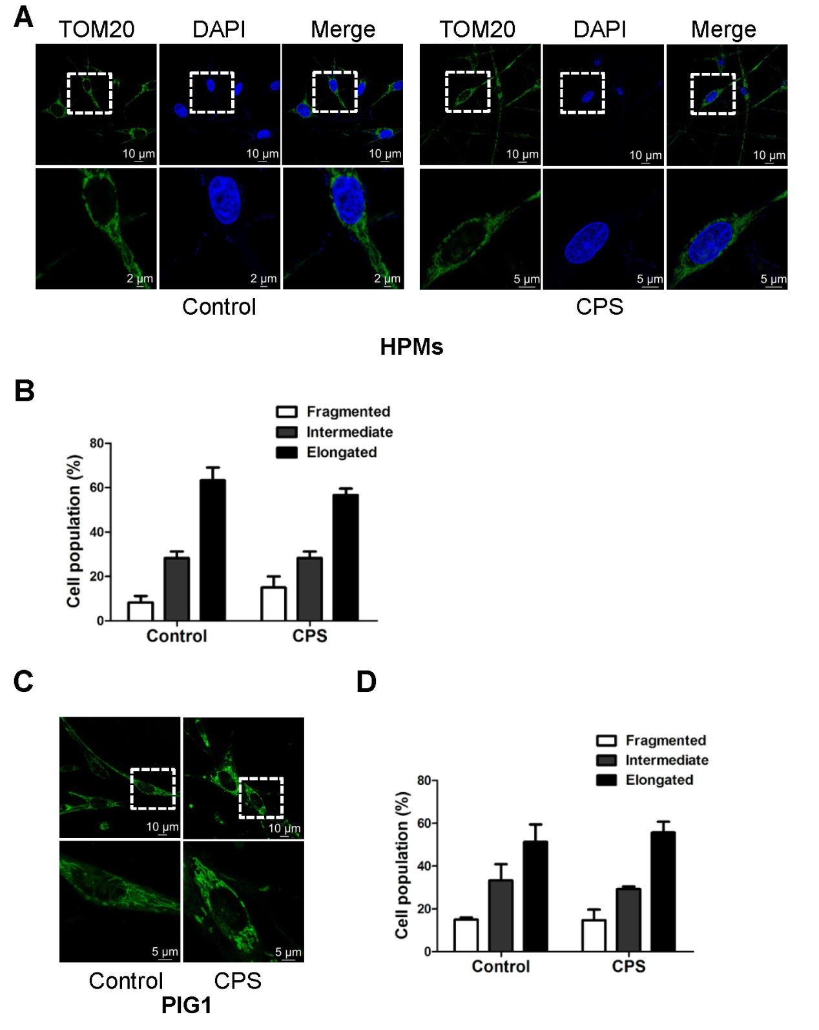
Supplementary Figure 3 CPS didn’t promote mitochondrial fission in melanocytes. Normal human primary melanocytes (HPMs) and PIG1 cell line were treated with or without CPS (120μM) for 16h. Mitochondrial network was displayed by TOM20 staining (A) or MitoTracker green FM staining (C). Representative confocal microscope images of the mitochondrial network are shown in A and C. The proportion of cells (n = 100 cells for each sample) with fragmented, intermediate and elongated mitochondria was quantified in B and D. The data are presented as mean ± SD of three independent experiments.

