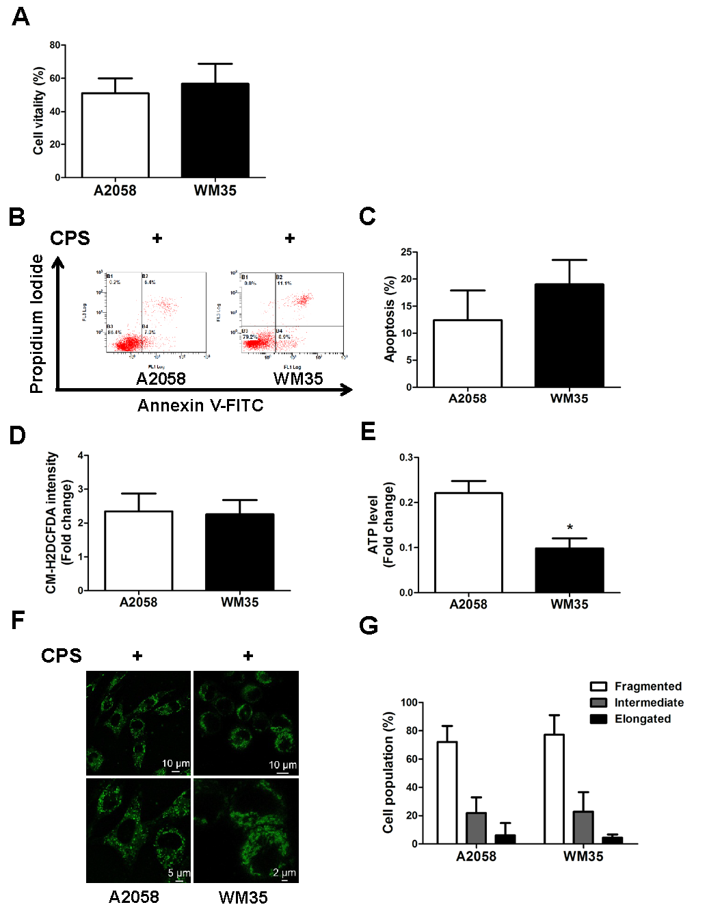
Supplementary Figure 4 Comparison of the effects of CPS on the cell vitality, cell apoptosis, mitochondrial fission, intracellular ROS and ATP levels between A2058 and WM35 cell lines. A2058 and WM35 cells were treated with or without CPS (120 μmol/L) for 16 hours. (A) The cell vitality was determined by CCK8 assay. (B and C) Cell apoptosis was analyzed with flow cytometry. (D) The intracellular ROS levels were analyzed by flow cytometry analysis. (E) ATP level was detected using ATP Assay Kit. (F and G) Mitochondrial network was displayed with MitoTracker green FM staining. Representative confocal microscope images of the mitochondrial network are shown in F. The proportion of cells (n = 100 cells for each sample) with fragmented, intermediate and elongated mitochondria was quantified in G. The data are presented as mean ± SD of three independent experiments. *P<0.05.

