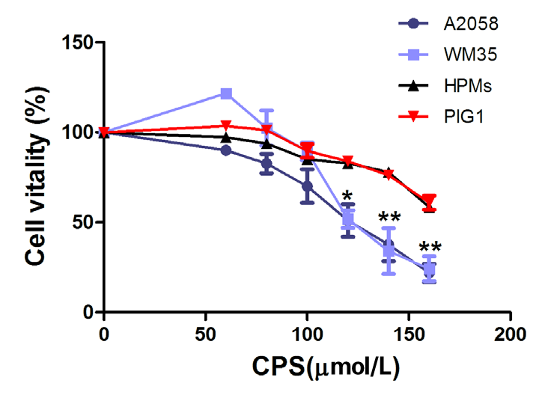
Supplementary Figure 1 Inhibitory effect of capsaicin on cell vitality in human melanoma cell lines and melanocytes. Cells were treated with various concentrations of capsaicin (0, 60, 80, 100, 120, 140 and 160 μmol/L) for 16 hours. A cell counting kit‑8 assay was performed to assess cell vitality. HPMs, human primary melanocytes; *P<0.05, **P<0.01 compared with 0 μmol/L.

