ONLINE SUPPLEMENTARY MATERIALS

1.1 Assessment of tray motion

Tray motion data from 13 young adults and 8 older adults were analyzed. Data from all other subjects were unavailable due to a technical issue of data not being synchronized or not recorded.
The acceleration resultant vector was calculated for each subject and trial by the following equation
$$\sqrt[2]{a_{x}^{2}+a_{y}^{2}+a_{z}^{2}}$$
where x, y, and z represent the three axes of the triaxial accelerometer. This variable was selected as the resultant vector is proportional to the resultant force applied to the tray. Sample entropy quantifies the regularity of that force. Standard deviation of the resultant vector was also calculated.
There was a main effect of the condition for both regularity (p>0.0001; Figure S1 top) and standard deviation (p=0.002; Figure S1 bottom). No group effect was found. In summary, the presence of glasses of water on top of the tray made the motion of tray more irregular (higher sample entropy); however, at the same time participants tried to make it less variable (lower standard deviation). Opaque tray conditions were more regular than the clear tray. This could be due to more cautions devoted to applying more regular and less variable force in the absence of a vision of the feet.

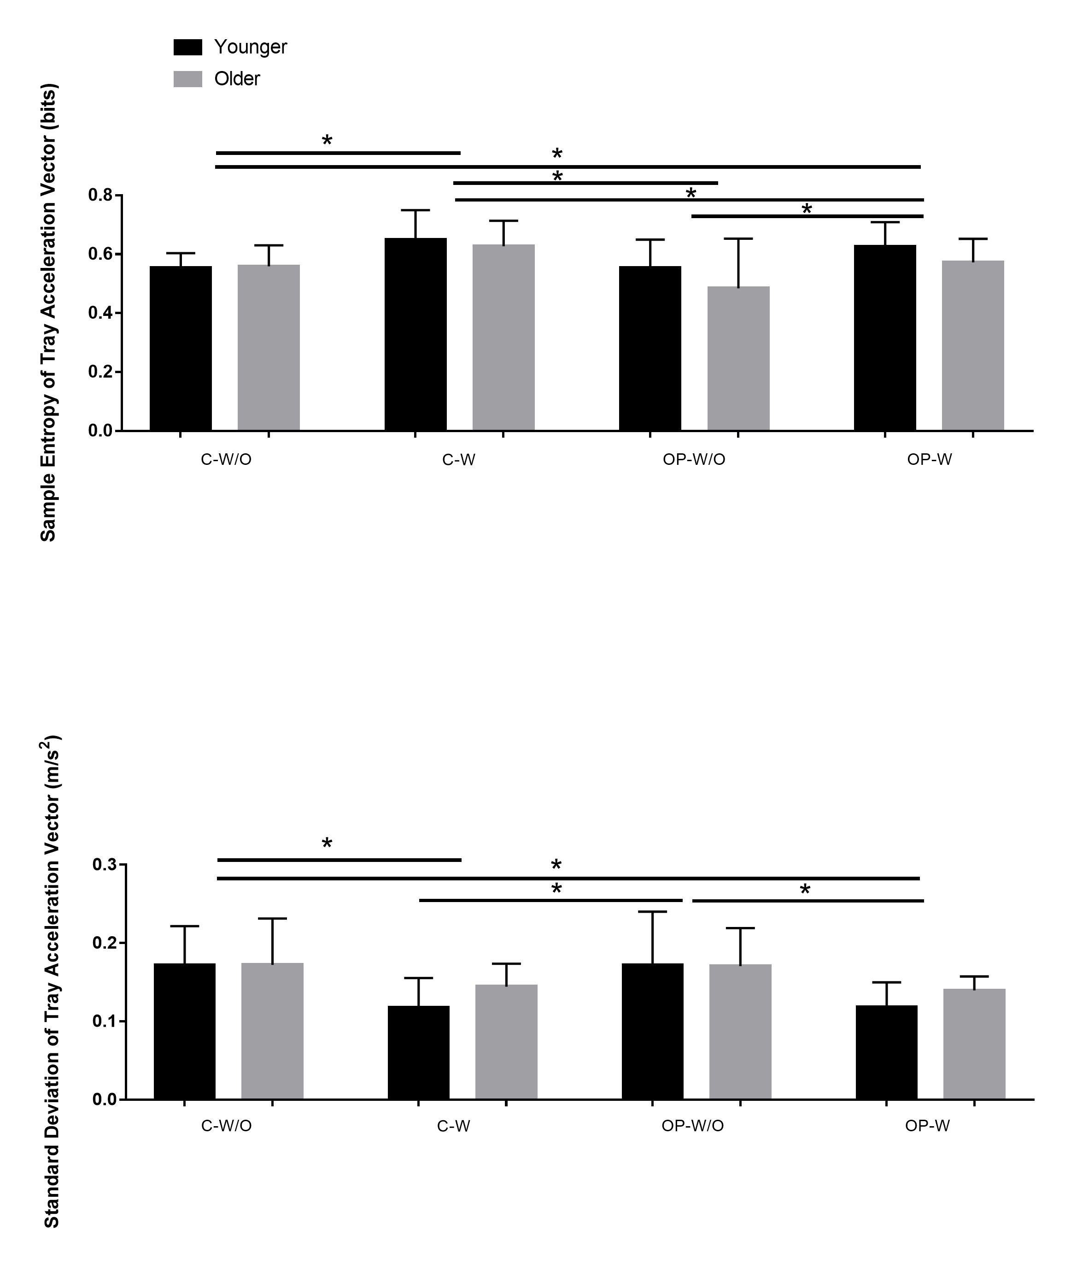
Figure S1. Sample entropy (Top) and standards deviation (Bottom) of the acceleration resultant vector for the tray motion during high cognitive load situations. Comparison have been performed between groups across different conditions including: Clear Tray(C-W/O), Clear Tray and glasses(C-W), Opaque Tray (OP-W/O), Opaque Tray and glasses (OP-W). Horizontal bars plus asterisk note significant differences, which were found from post-hoc testing.

2.1 Assessment of high cognitive load cost

Three combinations of high cognitive load costs were calculated:
1) the tray effect (clear tray without glasses vs. no tray),
2) effect of glasses or task difficulty (clear tray with vs. clear tray without glasses), and
3) effect of vision or reduced visual information (clear tray without glasses vs. opaque tray without glasses)
using the following equation:

$$High cognitive load cost=\frac{lower cognitive load performance-higher cognitive load performance}{ lower cognitive load performance}*100$$
The comparison of high cognitive load cost between two groups of participants were compared using T-TESTs (Table S1 (a-f)). Statistics did not reveal any significant differences between older and younger adults for any of the gait variables including mean, standard deviation, and sample entropy of step length and step width (p>0.05).

Table S1. High cognitive load costs comparison between older and younger groups for: (a) Step Length Mean, (b) Step Length Sample Entropy, (c) Step Length Standard Deviation, (d) Step Width Mean, (e) Step Width Sample Entropy, (f) Step Width Standard Deviation. Level of significance (Sig. (2-tailed): p-value)
(a)
 |  | t | df | Sig. (2-tailed) | Mean Difference | Std. Error Difference
Tray-Effect | Equal variances assumed | -.285 | 25 | .778 | -.011 | .040
 | Equal variances not assumed | -.280 | 21.727 | .782 | -.011 | .041
Effect of Glass(Task Difficulty) | Equal variances assumed | -.558 | 25 | .582 | -.018 | .032
 | Equal variances not assumed | -.523 | 15.926 | .608 | -.018 | .034
Effect of Vision(Reduced visual information) | Equal variances assumed | -.340 | 25 | .737 | -.010 | .030
 | Equal variances not assumed | -.321 | 16.502 | .753 | -.010 | .032

(b)
 |  | t | df | Sig. (2-tailed) | Mean Difference | Std. Error Difference
Tray-Effect | Equal variances assumed | -.343 | 25 | .735 | -.020 | .060
 | Equal variances not assumed | -.344 | 24.002 | .734 | -.020 | .060
Effect of Glass(Task Difficulty) | Equal variances assumed | -.435 | 25 | .667 | -.039 | .090
 | Equal variances not assumed | -.453 | 24.676 | .655 | -.039 | .087
Effect of Vision(Reduced visual information) | Equal variances assumed | -1.768 | 25 | .089 | -.134 | .076
 | Equal variances not assumed | -1.788 | 24.559 | .086 | -.134 | .075

(c)
 |  | t | df | Sig. (2-tailed) | Mean Difference | Std. Error Difference
Tray-Effect | Equal variances assumed | .565 | 25 | .577 | .067 | .118
 | Equal variances not assumed | .547 | 19.938 | .590 | .067 | .122
Effect of Glass(Task Difficulty) | Equal variances assumed | .088 | 25 | .931 | .015 | .169
 | Equal variances not assumed | .091 | 24.831 | .928 | .015 | .163
Effect of Vision(Reduced visual information) | Equal variances assumed | 1.275 | 25 | .214 | .353 | .277
 | Equal variances not assumed | 1.182 | 14.762 | .256 | .353 | .299

(d)
 |  | t | df | Sig. (2-tailed) | Mean Difference | Std. Error Difference
Tray-Effect | Equal variances assumed | -.639 | 25 | .529 | -.031 | .049
 | Equal variances not assumed | -.591 | 14.492 | .564 | -.031 | .052
Effect of Glass(Task Difficulty) | Equal variances assumed | .919 | 25 | .367 | .029 | .031
 | Equal variances not assumed | .861 | 15.813 | .402 | .029 | .033
Effect of Vision(Reduced visual information) | Equal variances assumed | .880 | 25 | .387 | .030 | .034
 | Equal variances not assumed | .828 | 16.352 | .419 | .030 | .036

(e)

 |  | t | df | Sig. (2-tailed) | Mean Difference | Std. Error Difference
Tray-Effect | Equal variances assumed | -.356 | 25 | .725 | -.0130 | .036
 | Equal variances not assumed | -.376 | 23.312 | .710 | -.0130 | .034
Effect of Glass(Task Difficulty) | Equal variances assumed | 1.195 | 25 | .243 | .047 | .039
 | Equal variances not assumed | 1.205 | 24.388 | .240 | .047 | .039
Effect of Vision(Reduced visual information) | Equal variances assumed | .131 | 25 | .897 | .004 | .031
 | Equal variances not assumed | .136 | 24.858 | .893 | .004 | .030

(f)
 |  | t | df | Sig. (2-tailed) | Mean Difference | Std. Error Difference
Tray-Effect | Equal variances assumed | -.844 | 25 | .407 | -.056 | .066
 | Equal variances not assumed | -.892 | 23.348 | .382 | -.056 | .063
Effect of Glass(Task Difficulty) | Equal variances assumed | 1.345 | 25 | .191 | .082 | .061
 | Equal variances not assumed | 1.356 | 24.353 | .188 | .082 | .060
Effect of Vision(Reduced visual information) | Equal variances assumed | .022 | 25 | .983 | .001 | .073
 | Equal variances not assumed | .021 | 20.910 | .983 | .001 | .075

