Supplemental Material:

Supplemental Figure 1: Distribution of Raw Sleep Related Impairment Scores (range 4-20). Scores >9 (dashed line) are considered to indicate sleep related impairment.
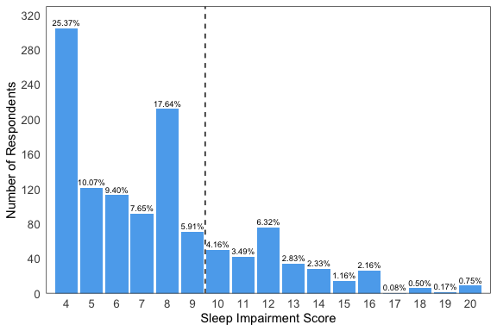

Supplemental Figure 2: Distribution of Raw Self-Valuation Scores (range 0-16)
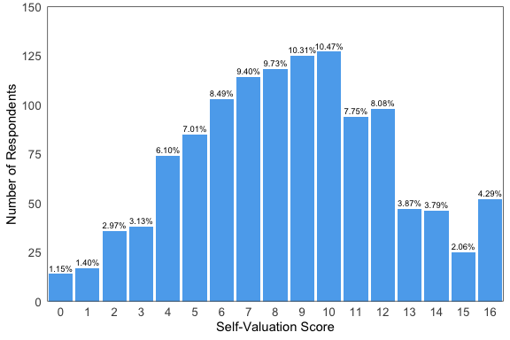

Supplemental Table 1: Factors Associated with Burnout on MV Analyses¹
 | OR | P
Age Group (vs. <30)
30-39 | 0.746 (0.158-3.252) | 0.702
40-49 | 1.016 (0.215-4.442) | 0.984
50-59 | 0.731 (0.153-3.23) | 0.685
60+ | 0.699 (0.137-3.326) | 0.658
Gender: Male (vs. Female) | 0.956 (0.683-1.339) | 0.791
Relationship Status (vs. Single)
Married | 0.806 (0.48-1.36) | 0.415
Partnered | 1.091 (0.478-2.475) | 0.835
Children: Yes (vs. No) | 0.777 (0.493-1.23) | 0.278
Work hours | 1.011 (0.992-1.03) | 0.250
Position (vs. Department Head/Director)
CEO | 0.921 (0.566-1.493) | 0.738
C-Suite | 0.669 (0.397-1.116) | 0.127
SVP | 0.557 (0.191-1.473) | 0.256
VP | 1.41 (0.875-2.269) | 0.157
Manager | 1.875 (1.034-3.391) | 0.038
Other | 1.247 (0.029-35.212) | 0.905
Sleep Impairment | 1.294 (1.191-1.408) | <0.001
Self-Valuation | 0.627 (0.572-0.684) | <0.001
¹ Input variables: age, sex, relationship status, children (yes/no) hours worked per week, position (collapse “other c-suite” to single category), Sleep impairment score (range 0-10), self-valuation score (range 0-10).

Supplemental Table 2: Factors Associated with Professional Fulfillment on MV Analysis¹
 | OR | P
Age Group (vs. <30)
30-39 | 1.314 (0.344-5.771) | 0.699
40-49 | 1.833 (0.48-8.056) | 0.392
50-59 | 1.727 (0.449-7.636) | 0.442
60+ | 1.384 (0.341-6.396) | 0.659
Gender: Male (vs. Female) | 0.79 (0.585-1.064) | 0.122
Relationship Status (vs. Single)
Married | 1.342 (0.842-2.14) | 0.215
Partnered | 1.019 (0.49-2.117) | 0.959
Children: Yes (vs. No) | 1.266 (0.846-1.893) | 0.250
Work hours | 1.012 (0.995-1.029) | 0.171
Position (vs. Department Head/Director)
CEO | 2.363 (1.533-3.672) | <0.001
C-Suite | 1.499 (0.967-2.332) | 0.071
SVP | 2.085 (0.9-5.035) | 0.092
VP | 1.199 (0.783-1.841) | 0.405
Manager | 0.695 (0.41-1.174) | 0.175
Other | 1.654 (0.1-44.704) | 0.726
Sleep Impairment | 0.882 (0.817-0.95) | 0.001
Self-Valuation | 1.428 (1.324-1.544) | <0.001
¹ Input variables: age, sex, relationship status, children (yes/no) hours worked per week, position (collapse “other c-suite” to single category), Sleep impairment score (range 0-10), self-valuation score (range 0-10).

