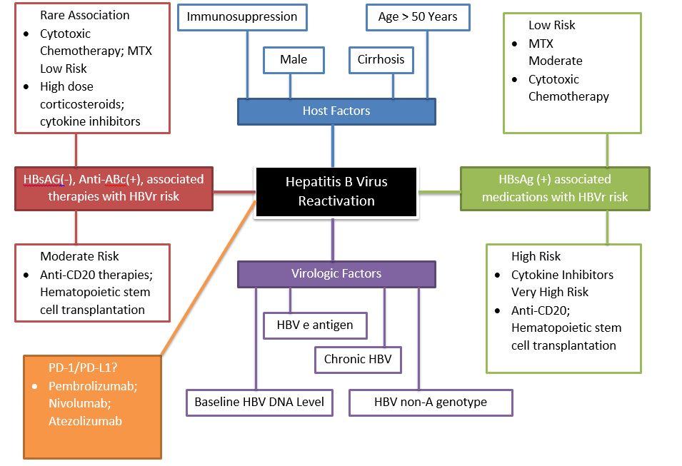
Figure S1. Potential risk factors for HBVr in cancer patients. Risk factors for HBVr in cancer patients can be subdivided into host and virologic risk factors. Host risk factors are based on prospective studies in cancer patients and include immunosuppressive diseases and therapies, male gender, older age, and presence of cirrhosis [34,35]. While these risk factors are more likely to be found in HBVr patients, the pathophysiologic explanation is not known. Virologic factors include known history of chronic HBV, positive HBV e antigen, higher baseline HBV DNA level, and HBV non-A genotype. Medications may put patients at risk of HBVr with likelihood of reactivation dependent on the medication and presence of HBV surface antigen and HBV core antibody. Low risk: <1% risk; Moderate risk: 1-10% risk; High Risk: >11% risk; Very High Risk: >21% [2, 34, 35,].
MTX: Methotrexate; HBsAG: Hepatitis Surface Antigen; Anti-ABc-anti-core antibodies; Anti-CD20 therapy: Rituximab; HBV: Hepatitis B Virus; DNA: Deoxyribonucleic acid; HBVr: Hepatitis B Reactivation

