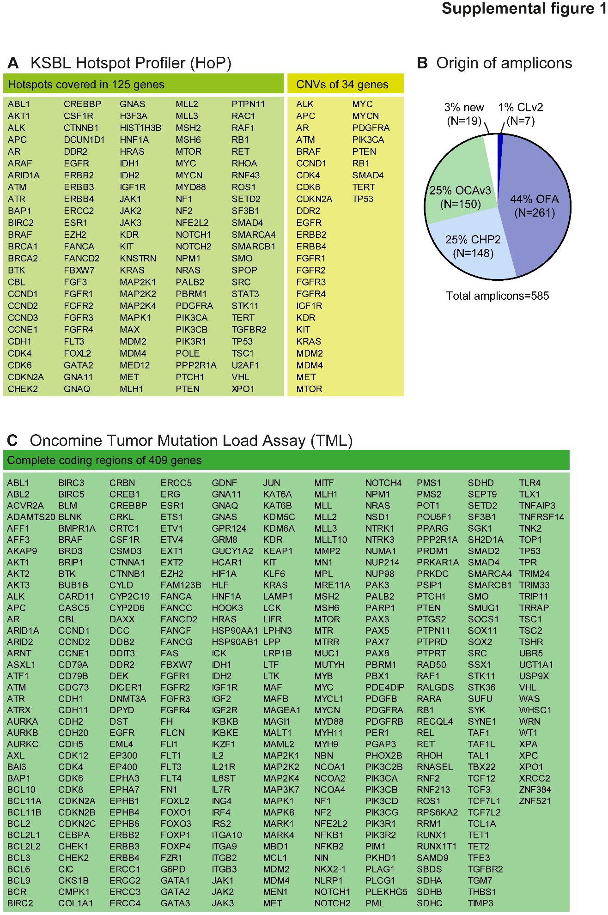

Supplemental Figure 1
DNA sequencing panel information. List of genes covered by the custom-adapted panel (A) and the origin of the amplicons used to generate this panel (B). List of genes with near complete coverage of their coding sequence, analyzed by the Oncomine™ Tumor Mutation Load Assay (C). OFA, Oncomine Focus Assay; OCAv3, Oncomine Comprehensive Assay v3; CHP2, Ion AmpliSeq Cancer Hotspot Panel v2; CLv2, AmpliSeq Colon and Lung Cancer Research Panel v2; new, novel amplicons not included in any NGS panel provided by Thermo Fisher Scientifc.

