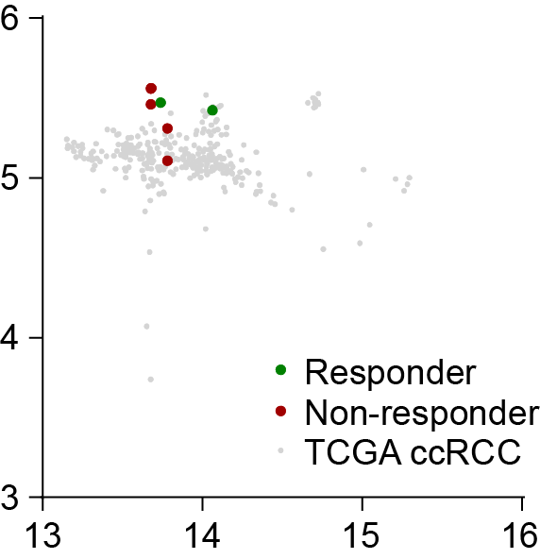

Supplemental Figure 2
For methylation analysis the UMAP plot was generated with www.epidip.org depciting ccRCC responder (green) and non-responder (red) in the ccRCC cluster of the references samples (grey). Note that responders and non-responders do not separate).

