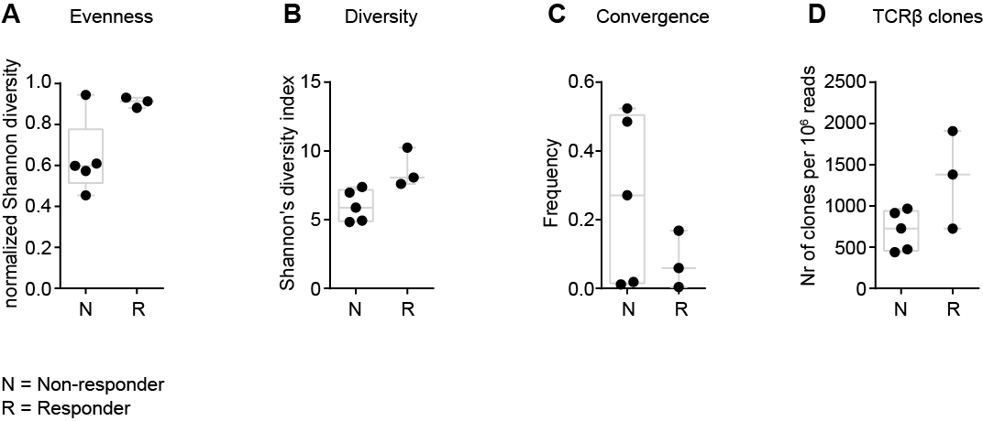

Supplemental Figure 3
Profile of the TCR repertoire. Evenness (A), diversity (B), convergence (C) and number (D) of T cell clones as a result of the VDJ region sequencing analysis.

