Supplementary Figure S3.
Kaplan–Meier survival curves. A. Progression-free survival (PFS) in all 25 patients assessed in the study. Of the 25 patients, two patients were censored at days 84 and 180, respectively. B. PFS in DTH-positive patients (n = 18) (red line) and others (DTH-negative or not evaluated patients, n = 7) (blue dash-line). Two patients were not fully assessed DTH after vaccination. C. PFS in patients with increases in whole %WT1-CTLs of greater than twofold (n = 14) (red line) and less than twofold (n = 11) (blue dash-line).
Abbreviations: Pts, patients; CI, confidence interval; DTH, delayed-type hypersensitivity; NE, not evaluated

A.

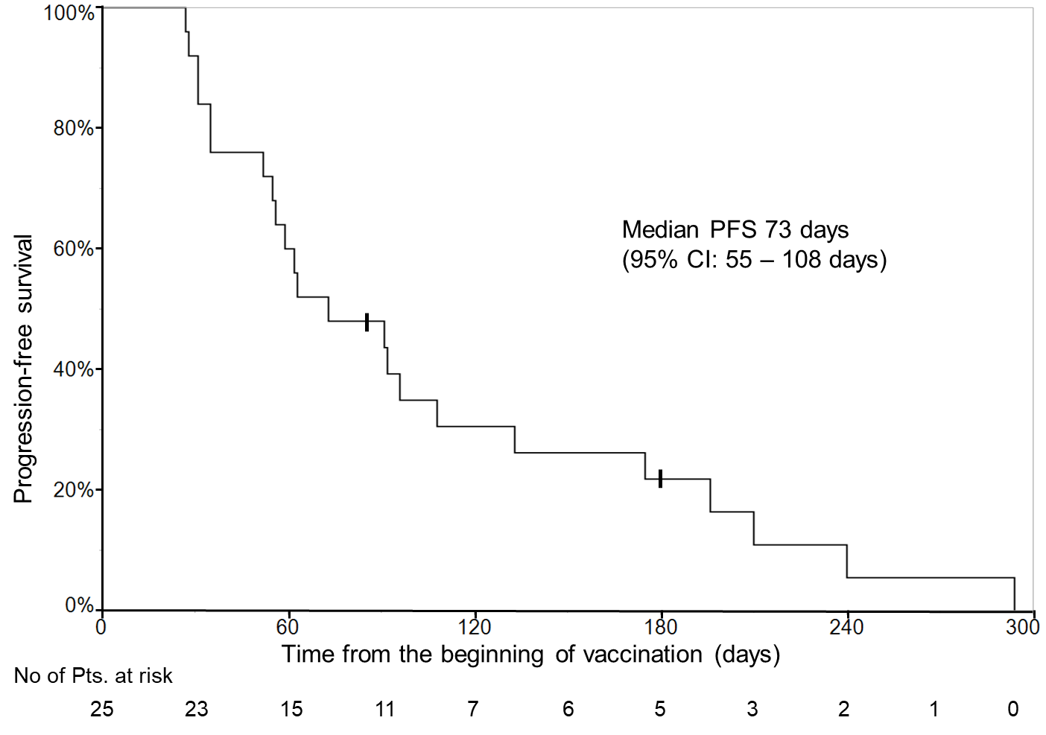

B.
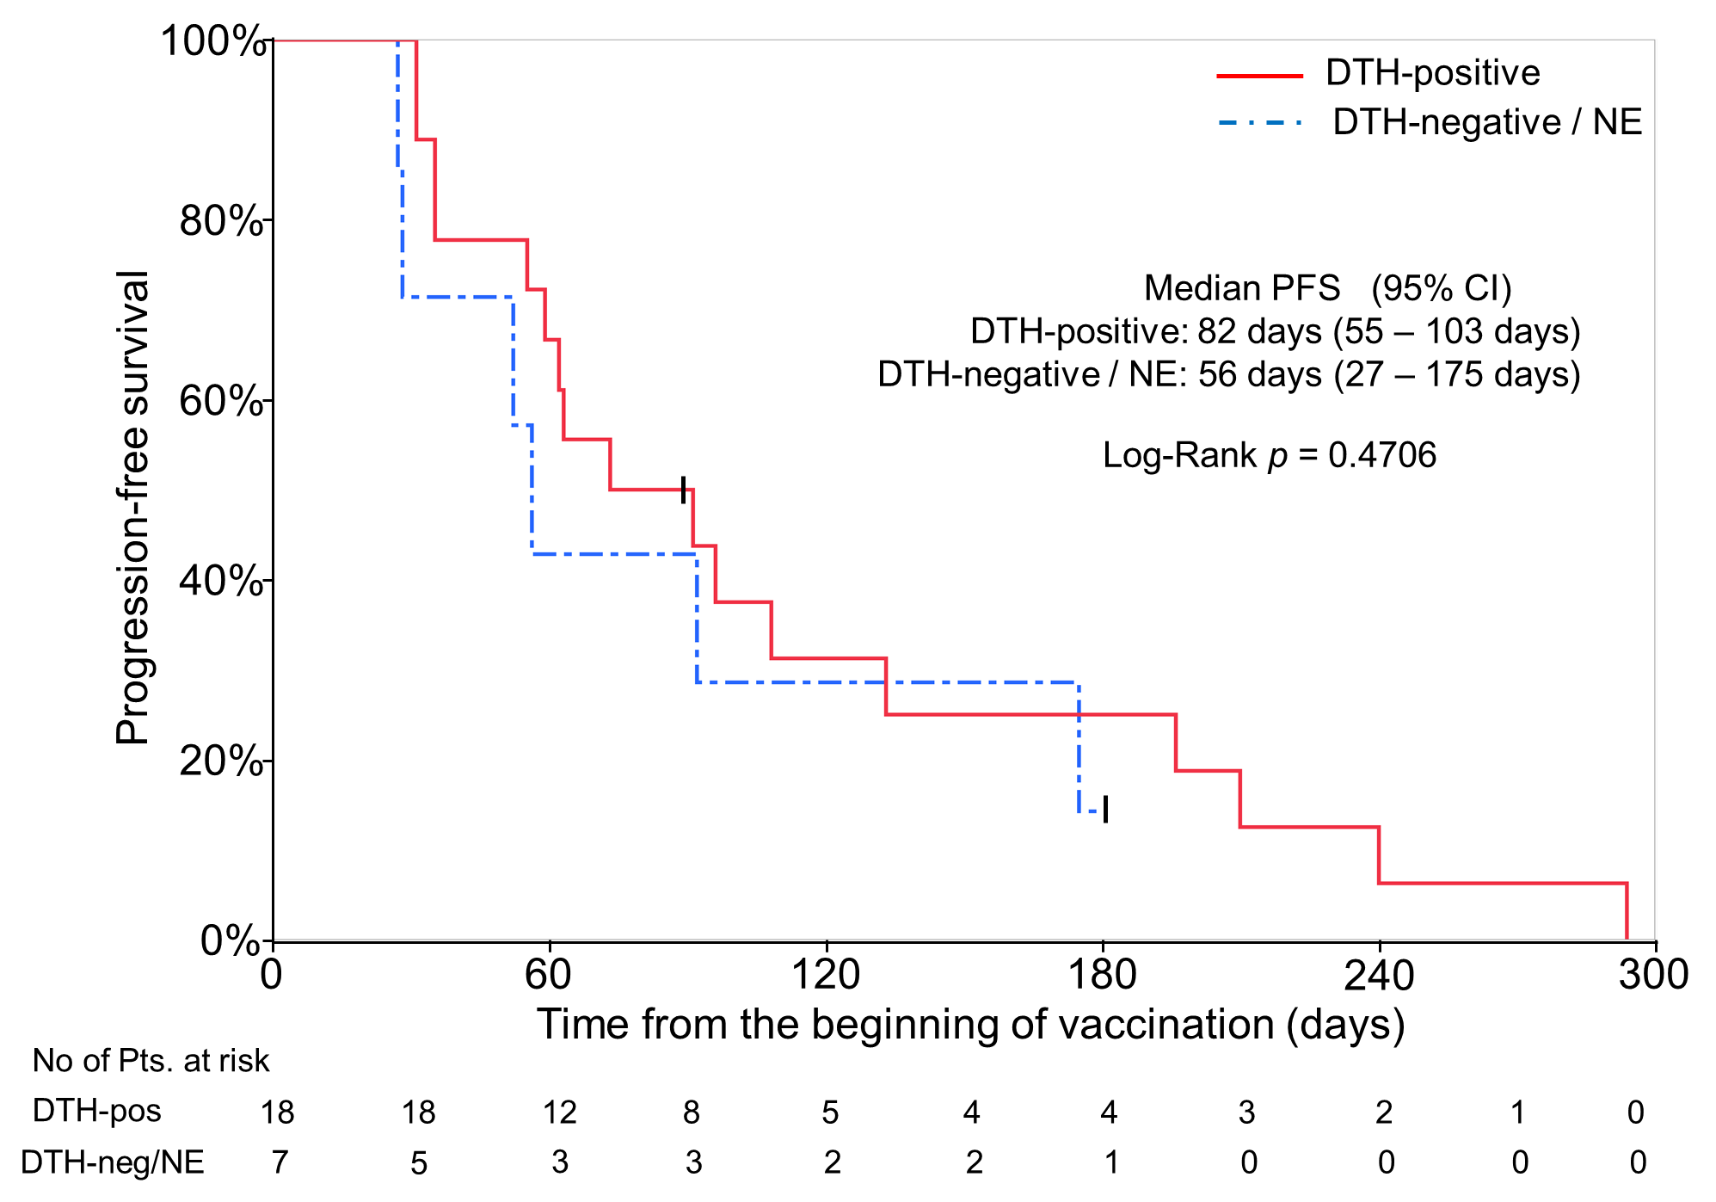
C.
