Supplementary Figure S6.

Increase in WT1₂₃₅-IgG levels during the vaccination period. Each line represents the time-series of WT1₂₃₅-IgG levels in individual patients (n = 25) during the 3-month study treatment course. The vertical and horizontal axes represent titer of WT1₂₃₅-IgG and the treatment course, respectively.

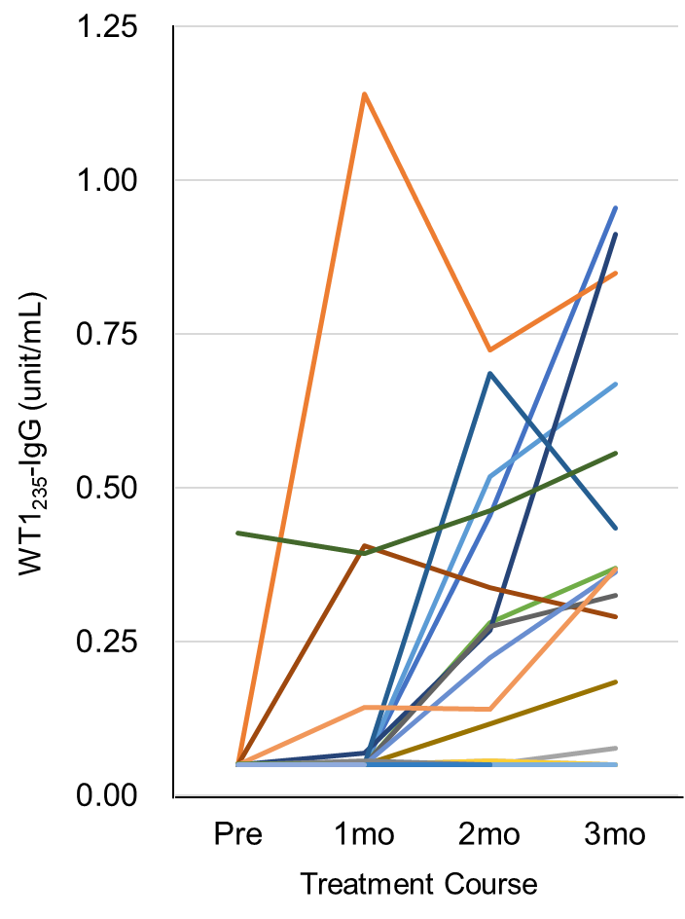
Median < 0.05 < 0.05 0.141 0.375
(unit/mL)

