Supplementary Figure 1. Overall survival and progression-free survival according to the number of risk factors by IMDC groups (1-2 factors = intermediate risk; 3-6 factors = poor risk).

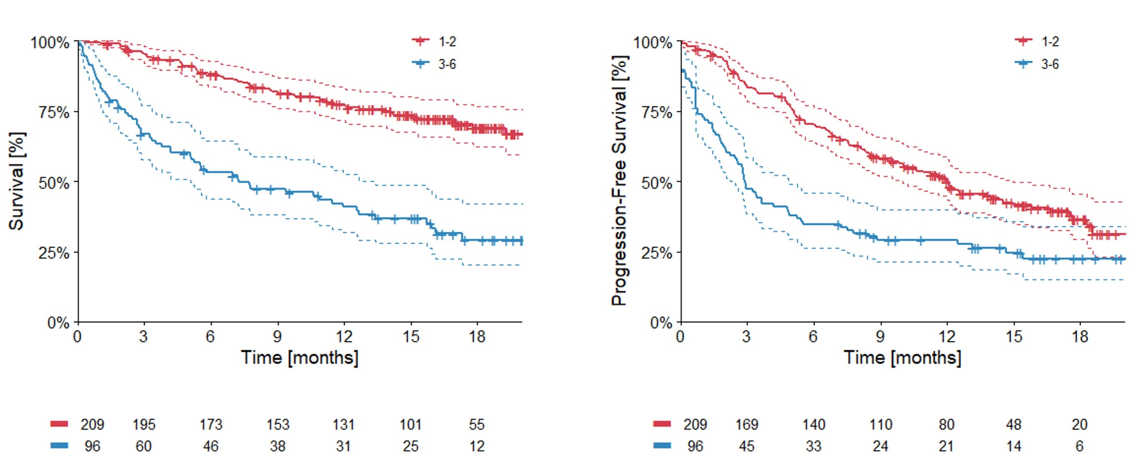

Supplementary Figure 2. Overall survival and progression-free survival according to the drug model (drug score 0-1 = Favorable group; drug score 2-4 = Unfavorable group) in the intermediate risk population by IMDC.

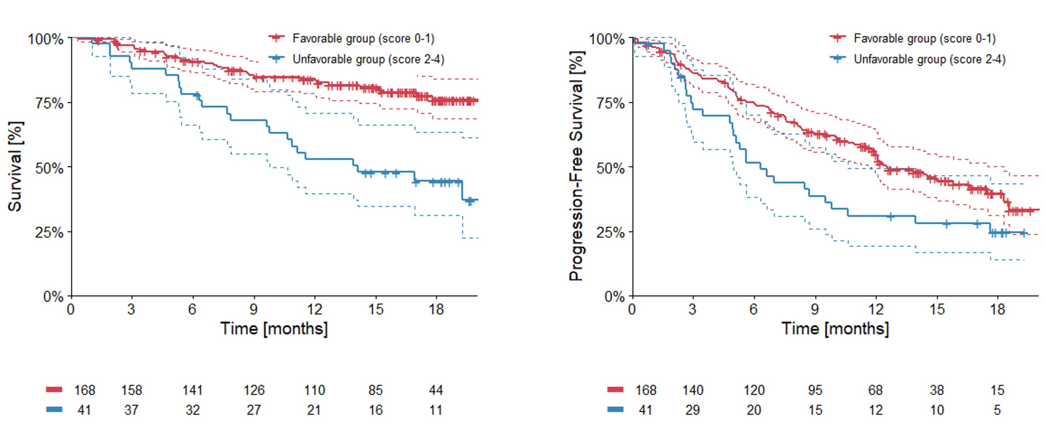

Supplementary Figure 3. Overall survival and progression-free survival according to the drug model (drug score 0-1 = Favorable group; drug score 2-4 = Unfavorable group) in the poor risk population by IMDC.

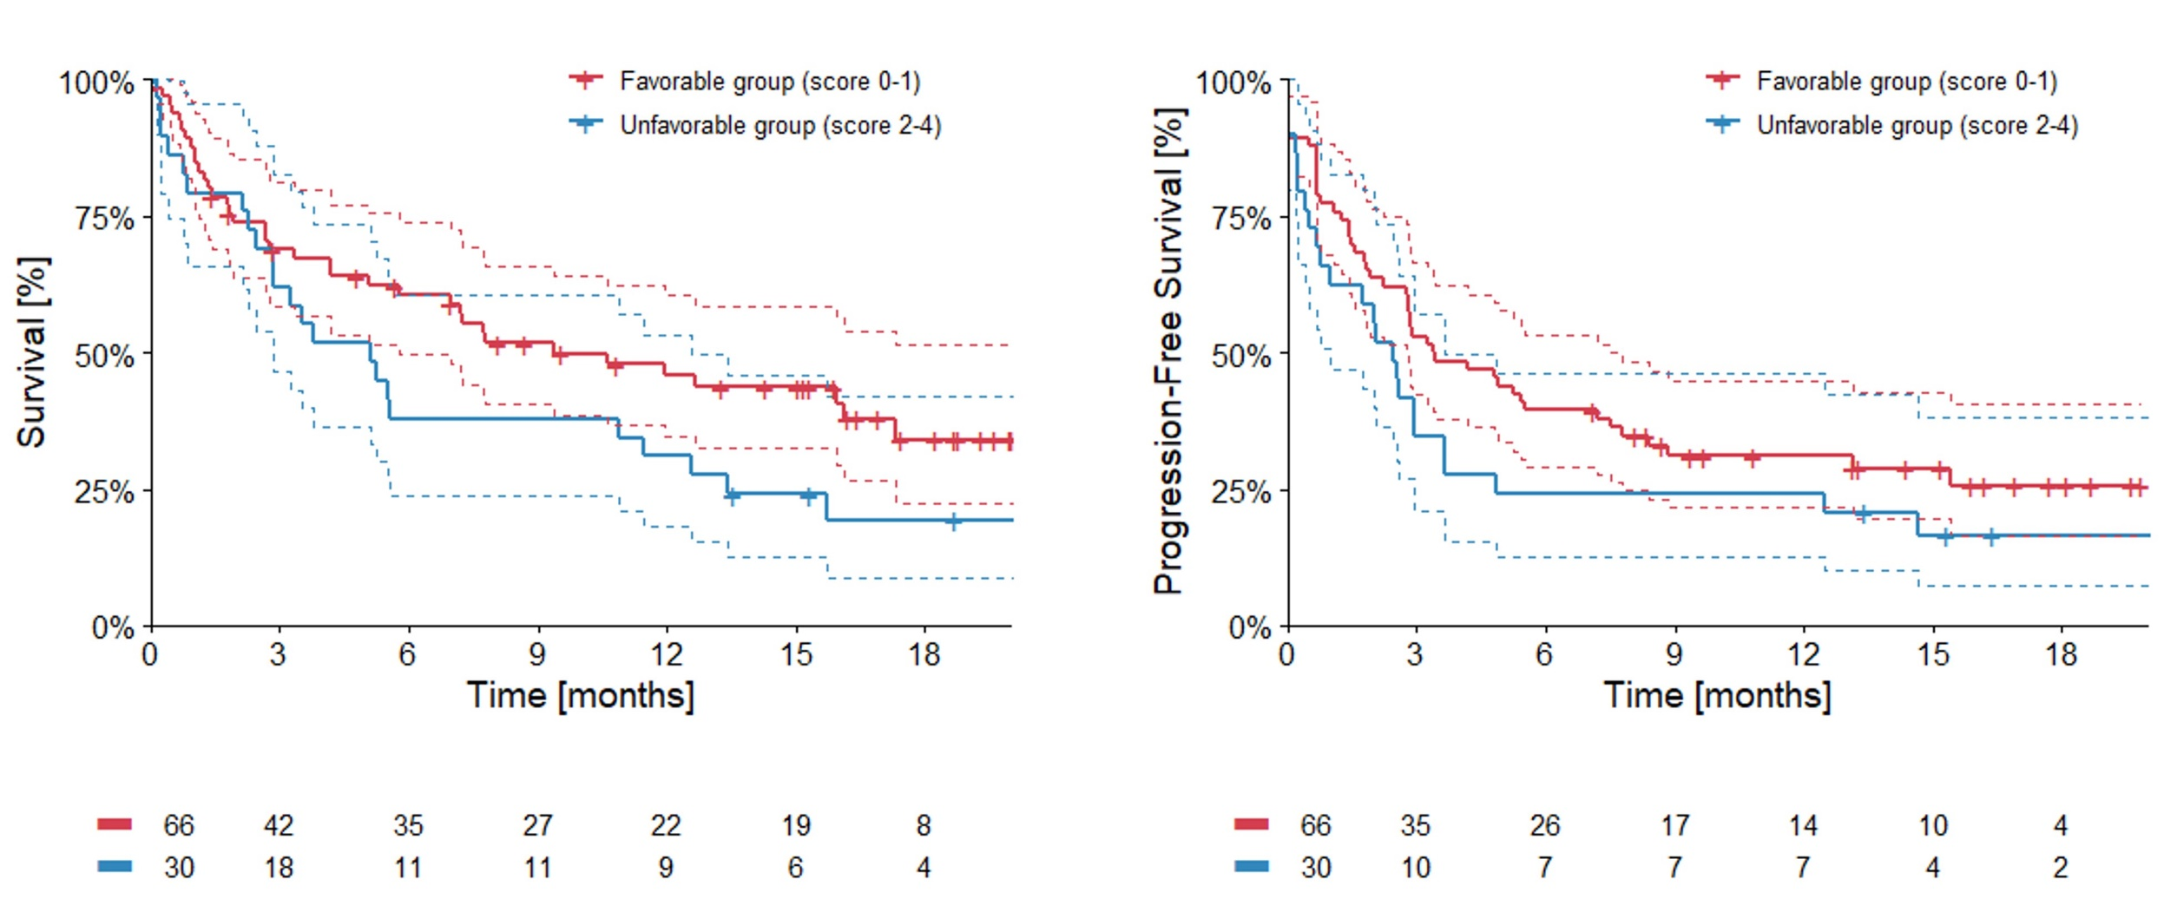

Supplementary Figure 4. Overall survival according to every single class of drugs among corticosteroids (A), antibiotics (B) and proton pump inhibitors (C).

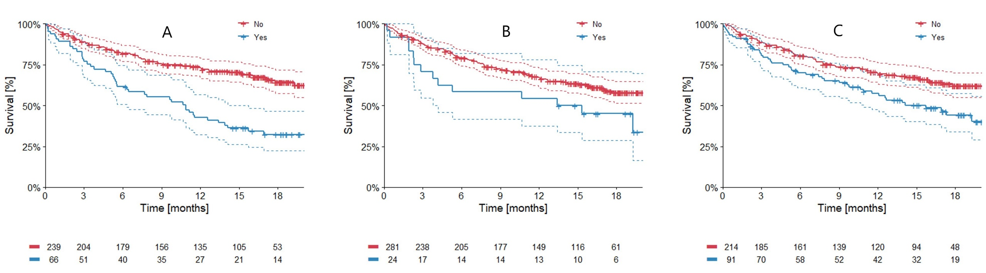

Supplementary Figure 5. Progression-free survival according to every single class of drugs among corticosteroids (A), antibiotics (B) and proton pump inhibitors (C).

