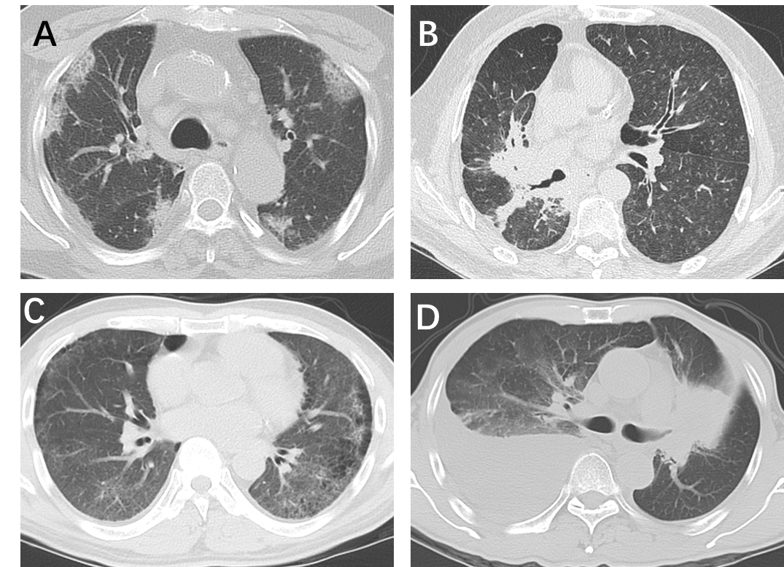
Supplementary Fig 1. Radiographic patterns of CIP. (A) COP-like pattern: patchy alveolar consolidations and ill-defined GGOs observed at subpleural. (B) HP-like pattern: diffuse GGOs and centrilobular micronodules observed at bilateral lungs. (C) NSIP-like pattern: GGOs with reticulations observed at subpleural. (D) AIP/ARDS-like pattern: diffuse GGOs with alveolar consolidation and pleural effusion observed at the right lung. AIP/ARDS, acute interstitial pneumonia /acute respiratory distress syndrome; COP, cryptogenic organizing pneumonia; HP, hypersensitivity pneumonitis; NSIP, nonspecific interstitial pneumonia; GGOs, ground-glass opacities.

