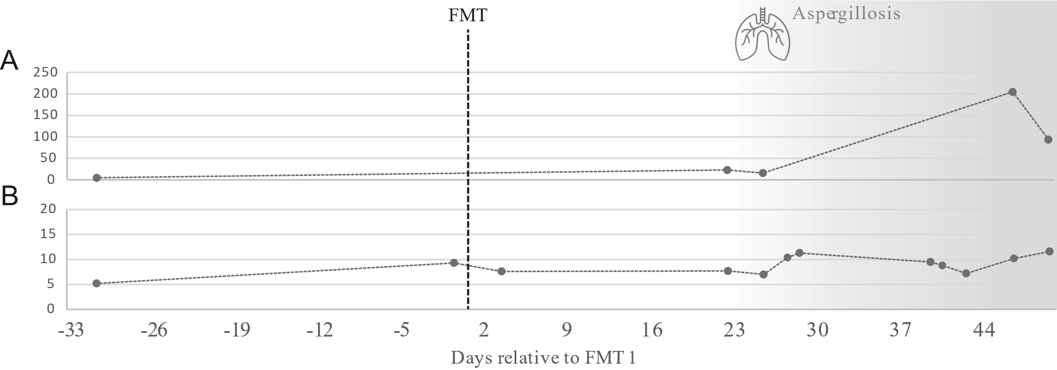
Supplemental figure 6. C-reactive protein (mg/l) (A) and leukocyte count (*10⁹/l) (B) for patient one in the course of faecal microbiota transplantation for immune-mediated colitis.

