Supplemental Digital Content item 3. Figure showing the time at which the analyzed EEG epochs were selected.
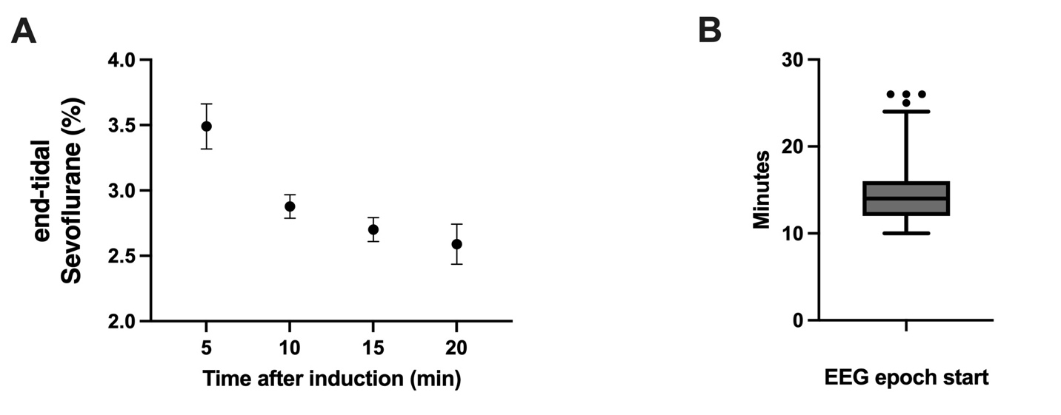
A. Average end-tidal Sevoflurane concentration over time after anesthesia induction. The average was calculated across subjects and sessions. The 95% confidence interval is displayed at each point. B. The minute at which the EEG epoch analyzed started. The box plot represents the median and the 95% confidence interval, and 4 outliers are also shown.

