Supplemental Digital Content item 7. Figure showing individual spectrograms from Cluster 1 (No alpha drop).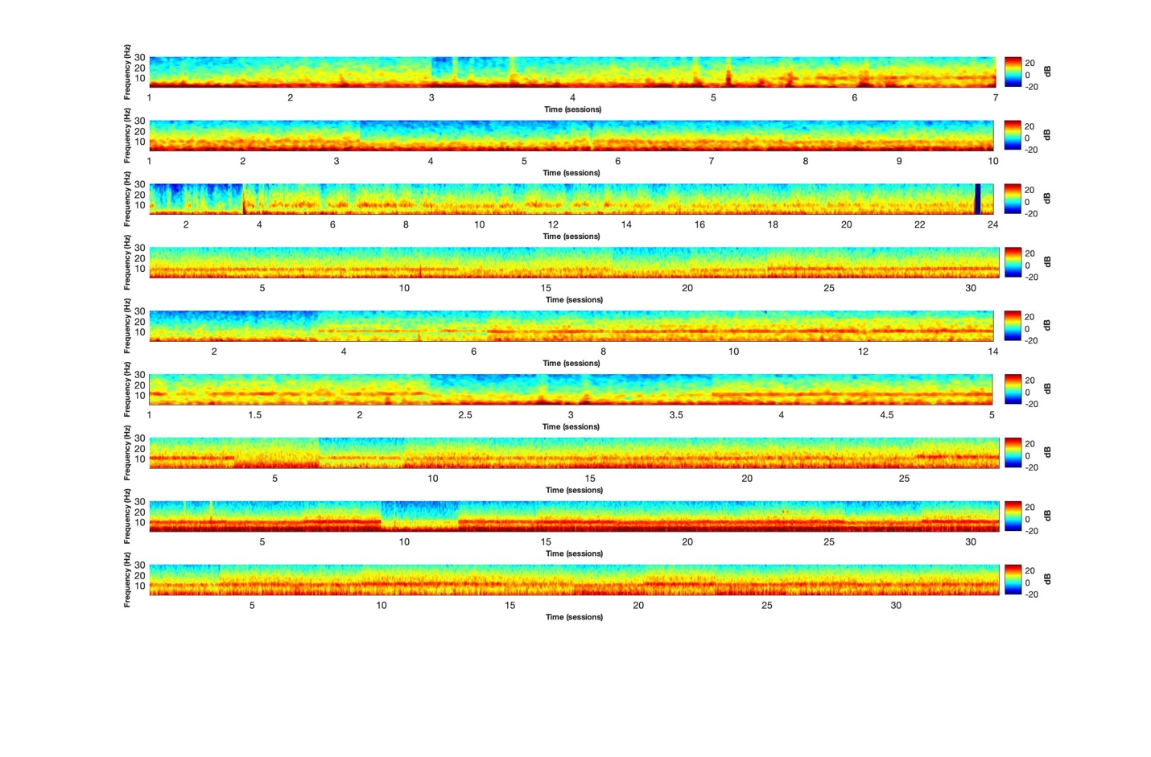
Each spectrogram corresponds to an individual subject.

