**DAILY NURSE LEADER STANDARD WORK**

**Continuous Work**

**VMTs** complete audits on every sitter in the inpatient setting q12hrs

**VMTs** triage camera needs and attend staffing meetings with charge nurses at 1100, 1600, 0300

**CVM Clinical Nurse Oversight Manager** sends audits and daily snapshot of all sitters and VMTs in the inpatient setting via email by 0700

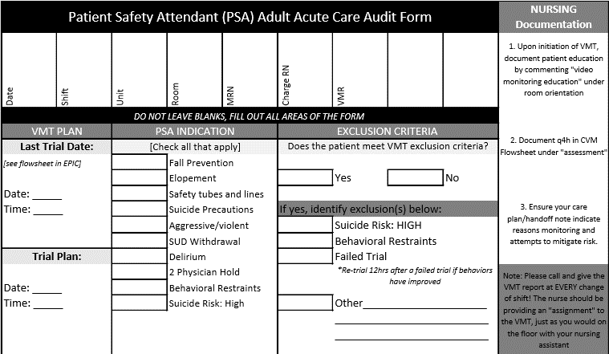

Mark daily MESSES **RED** if;

* CVM has been present for >48hrs without consideration for trialing off.
* A sitter is present without CVM 2-hr Mandatory Trial
* A sitter is present 12hrs after a failed CVM trial and does not have a re-trial plan.
* If CVM is requested and you were put on the waitlist.



Mark daily MESSES **GREEN** if;

* CVM is present after a 2-hr mandatory trial success.
* A sitter is present after a 2-hr trial fail, with a re-trial plan, and documented assessment q4h.
* A sitter is present for a patient who meets CVM exclusion criteria (ex: high risk suicide)



**MESSES:** Methods, Equipment, Supplies, Staffing, Experience (patient), and Safety

**NURSE LEADER ADULT INPATIENT HUDDLE REPORT OUT**

**Nurse Leader** discusses high-risk patients at the **UNIT LEVEL** with primary charge nurse and promotes appropriate use of CVM and Sitters. If barriers identified, addresses in real-time and/or escalate at adult inpatient huddle for additional support.

**CVM Oversight Manager and Nurse Leader** tracks barriers and/or identifies counter-measures with VMT & Charge Nurse Staff