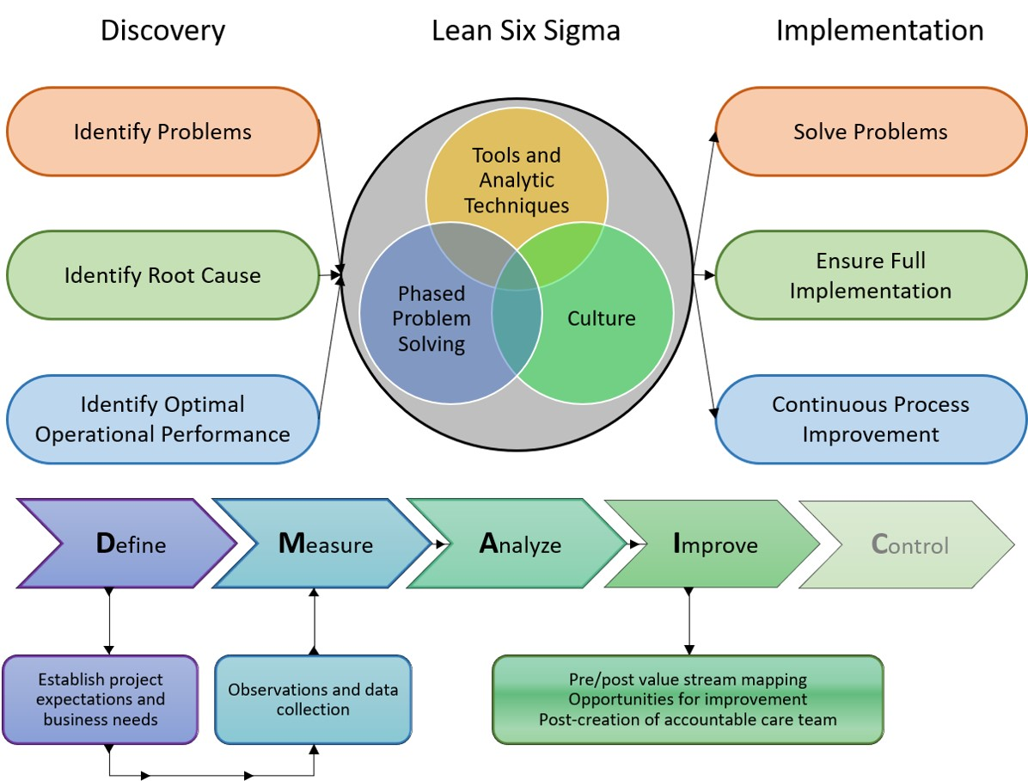Figure 1. Lean Six Sigma Conceptual Framework (author adapted from https://www.sixsigma- institute.org/What_Is_Six_Sigma.php)

